VISITHOUGHTS: A WEB APPLICATION FOR CUSTOMERS FEEDBACK WITH SENTIMENT ANALYSIS OF CvSU-CCAT CAMPUS

An Undergraduate Thesis Manuscript

Submitted to the Faculty of the

Department of Computer Studies of

Cavite State University - CCAT Campus

Rosario, Cavite

In partial fulfilment

of the requirements for the degree,

Bachelor of Science in Computer Science

ELGENE JOHN V. REYES  
KARL DOHNEYZEL A. DELACRUZ

JAN PAOLO A. CANO

January 2024

APPROVAL SHEET



**BIOGRAPHICAL DATA**

Elgene John V. Reyes was born on September 15, 2000, in General Trias, Cavite. He is the eldest of two children of Mr. Edgardo Reyes Jr. and Ms. Judylane Villaflor and currently resides in Tanza, Cavite.

He completed his elementary education with honors at Tejeros Convention Elementary School in Rosario, Cavite, 2013 and finished junior high school at Cavite State University-CCAT Campus in Rosario, Cavite, in 2017.

For his senior high school, he attended St. Mary Magdalene School in Kawit, Cavite, where he graduated with high honors in 2019.

He pursued a Bachelor of Science in Computer Science and graduated from Cavite State University-CCAT Campus in 2024.

**BIOGRAPHICAL DATA**

Karl Dohneyzel A. Dela Cruz was born on November 18, 2000 in Bacoor City, Cavite. He is the eldest of five children of Mr. Dahnyzel A. Dela Cruz and Ms. Jesheryl T. Abodeso, living in Bacoor City, Cavite.

He completed his Elementary education at Sineguelasan Elementary School in Bacoor, Cavite, in 2013. He then attended Junior High School at Bacoor National High School-Tabing Dagat in Bacoor, Cavite, graduating in 2017. In 2019, he completed his Senior High School at City of Bacoor Senior High School-Dulong Bayan, located within Sineguelasan Elementary School, with honors.

He earned his Bachelor of Science in Computer Science from Cavite State University-CCAT Campus in 2024.

**BIOGRAPHICAL DATA**

Jan Paolo A. Cano was born in Tondo, Manila, on January 16, 2001. He is the second child of Mr. Ruben A. Cano Jr. and Mrs. Catrina A. Cano. Currently, he resides in General Trias, Cavite.

In 2013, he completed his elementary education at David P. Jimenez Elementary School in Rosario, Cavite. He graduated with honors from Bagbag National High School in Rosario, Cavite, in 2017, completing his junior high school education. His senior high school education was completed at Rosario Institute in Rosario, Cavite, in 2019.

In 2024, he earned his Bachelor of Science degree in Computer Science from Cavite State University-CCAT Campus.

**ABSTRACT**

ELGENE JOHN V. REYES, KARL DOHNEYZEL A. DELACRUZ, JAN PAOLO A. CANO. VISITHOUGHTS: A WEB APPLICATION FOR CUSTOMERS FEEDBACK WITH SENTIMENT ANALYSIS OF CvSU-CCAT CAMPUS. An Undergraduate Thesis Manuscript. Department of Computer Studies. Cavite State University-CCAT Campus, Rosario, Cavite. January 2024. Adviser: Dr. Christopher G. Estonilo.

The VisiThoughts web application was developed for the Cavite State University-CCAT Campus (CvSU-CCAT Campus) to analyze customer comments using sentiment analysis. The application proved the efficient implementation of the specialized Natural Language Toolkit (NLTK) algorithm. This advanced system was a great help to visitors, department heads, and administrators because it made it easy to collect detailed input from several offices on the CvSU-CCAT Campus. The research spanned from June 2023 to January 2024 at the CvSU-CCAT Campus. It was divided into four phases: 1) identified the essential requirements and functionalities of the web application through the following: a) conducted a thorough analysis of the feedback collection method and analysis needs of various offices and units within Cavite State University-CCAT Campus; b) identified the essential features and functionalities that should be incorporated into the VisiThoughts web application to meet the identified needs; and c) defined the user interface design and user experience guidelines to ensure a user-friendly and accessible platform; 2) developed the VisiThoughts web application using Lexicon-based approach; 3) evaluated the application in order to determine if it complied with the modified ISO-IEC 25010 standards; and 4) implemented the web application in CvSU-CCAT Campus.

The evaluation of the system involved 31 participants, including five (5) IT experts and twenty-six end users. The results of the assessment revealed an impressive average score of 4.88 from the IT experts, characterized as ‘Excellent’, and an average score of 4.69 from the end users, also interpreted as ‘Excellent’.

ACKNOWLEDGMENT

This research resulted from the unwavering support and direction of many people who made significant contributions to the planning and execution of this study. The following people have the authors' sincere gratitude and appreciation:

Above all, we thank God Almighty for providing us with thoughts, understanding, and discernment, which have helped us overcome the many theories, concepts, and obstacles we have come across in our studies.

Dr. Lauro B. Pascua, campus administrator, for his support and inspiration.

Dr. Ariel G. Santos, director of instructors, for his advice and assistance.

Prof. Aries M. Gelera, director for research and extension, and Prof Karlo Jose E. Nabablit, the current department chairperson, thank you for all of your guidance and support during this study and for your constant encouragement.

Dr. Christopher G. Estonilo, thesis adviser, for his unwavering patience and direction as we developed our concepts and systems, which enabled us to conduct significant research.

Mr. Jeffrid D. Laxamana, technical critic, for his invaluable time, ideas, and technical advice in helping us improve our system and

To their loving parents, who have always supported and helped them throughout this journey. This modest endeavor is dedicated to each of them with heartfelt gratitude.

**EJVR, KDADC, JPAC**

**TABLE OF CONTENTS**

APPROVAL SHEET ii

BIOGRAPHICAL DATA iii

ABSTRACT vi

ACKNOWLEDGMENT viii

TABLE OF CONTENTS ix

LIST OF TABLES xii

LIST OF APPENDICES xiii

LIST OF FIGURES xiv

INTRODUCTION 1

1.1 Project Context 1

1.2 Purpose and Description 4

1.3 Objectives of the Study 5

1.4 Scope and Limitations 6

1.5 Concept of the Study 8

1.6 Definition of Terms 9

2 REVIEW OF RELATED LITERATURE 11

2.1 Importance of Feedback 11

2.2 Sentiment Analysis in Interpreting Feedback 12

2.3 Lexicon-based Approach for Sentiment Analysis 13

2.4 Effectiveness of Web Application for Collecting Feedback 14

2.5 Python in sentiments analysis 15

2.6 Bootstrap, HTML, CSS, and Java Script for creating web application 16

2.7 ISO EIC 25010 17

2.8 SQLite as web server for web applications 18

2.9 Importance and benefits of using Django in creating web application with sentiment analysis 19

2.10 Automating Large Scale Healthcare Service Feedback Analysis: Using Natural Language Processing and Topic Modelling (Preprint) 20

2.11 Opinion mining technique for developing student feedback analysis system using lexicon-based approach (OMFeedback) 20

2.12 Web-Based Student Opinion Mining System Using Sentiment Analysis 21

2.13 Sentiment Analysis for University Students’ Feedback 21

2.14 Sentiresearch: Lexicon- based web application for indonesian sentiment analysis 22

2.15 Synthesis 23

3 MATERIALS AND METHODOLOGY 25

3.1 Materials 25

*3.1.1* *Software* 25

*3.1.2* *Hardware* 26

*3.1.3* *Data* 26

3.2 Methodology 26

*3.2.1* *Data Analysis* 27

*3.2.2* *Development of the Application* 27

*3.2.3* *Evaluation of the Application* 30

*3.2.4* *Deployment Plan* 36

4 RESULTS AND DISCUSSION 37

4.1 Results of the data analysis and model building 37

4.2 Results of the application development 40

4.3 Results of the application evaluation 49

*4.3.1* *Functional Testing* 49

*4.3.2* *Software Evaluation from the End Users* 51

*4.3.3* *Software Evaluation from the Web Developers* 54

5 SUMMARY, CONCLUSIONS, AND RECOMMENDATIONS 58

5.1 Summary 58

5.2 Conclusions 59

5.3 Recommendations 60

6 REFERENCES 61

APPENDICES 64

LIST OF TABLES

|  |  |  |
| --- | --- | --- |
| **Table** | **Title** | **Page** |
| 3-1 | Module Name………………………………………………… | 29 |
| 3-2 | Evaluation Criteria for End-Users……………………………. | 30 |
| 3-3 | Evaluation Criteria for Developers…………………………… | 32 |
| 3-4 | Score descriptive interpretation………………………………. | 36 |
| 3-5 | Implementation plan for the deployment of the system……… | 36 |
| 4-1 | The summary of Functional Testing…………………………. | 50 |
| 4-2 | Perception of the end user on the usability of the website…… | 52 |
| 4-3 | Perception of the end user on the effectiveness of the website. | 53 |
| 4-4 | Perception of the end user on the efficiency of the website….. | 53 |
| 4-5 | Perception of the end user on the satisfaction of the website… | 54 |
| 4-6 | Perception of the end user on the context coverage of the website ……………………………………………………….. | 54 |
| 4-7 | Summary of results of the website evaluation assessed by the end users ……………………………………………………... | 55 |
| 4-8 | Perception of the IT experts on the functionality of the website………………………………………………………... | 55 |
| 4-9 | Perception of the IT experts on the performance of the website………………………………………………………... | 56 |
| 4-10 | Perception of the IT experts on the usability of the website…. | 56 |
| 4-11 | Perception of the respondents on security……………………. | 57 |
| 4-12 | Perception of the IT experts on the maintainability of the website………………………………………………………... | 57 |
| 4-13 | Perception of the IT experts on the portability of the website.. | 58 |
| 4-14 | Summary of results of the website evaluation assessed by the IT experts……………………………………………………... | 58 |

LIST OF FIGURES

|  |  |  |
| --- | --- | --- |
| **Figure** | **Title** | **Page** |
| 1-1 | Conceptual Framework of the study…………………………... | 9 |
| 3-1 | Use Case Diagram of the VisiThoughts………………………. | 27 |
| 3-6 | Software development model…………………………………. | 28 |
| 4-1 | Welcome page………………………………………………… | 31 |
| 4-2 | Welcome transition page……………………………………… | 42 |
| 4-3 | Form input personal details page……………………………… | 42 |
| 4-4 | Form satisfactory level page………………………………….. | 43 |
| 4-5 | Form comment section page………………………………….. | 44 |
| 4-6 | Form appreciation page……………………………………….. | 44 |
| 4-7 | Admin starting page…………………………………………... | 45 |
| 4-8 | Admin login page……………………………………………... | 45 |
| 4-9 | Admin head dashboard page………………………………….. | 46 |
| 4-10 | Admin department records for sentiment……………………... | 47 |
| 4-11 | Admin client feedback copied form…………………………... | 48 |
| 4-12 | Admin option page……………………………………………. | 48 |
| 4-13 | Admin setting page…………………………………………… | 49 |
| 4-14 | Admin staff management page………………………………... | 50 |

LIST OF APPENDICES

|  |  |  |
| --- | --- | --- |
| **Appendix** | **Title** | **Page** |
| A. | Routing Slip…………………………………………………... | 67 |
| B. | Request for Adviser and Technical…………………………… | 68 |
| C. | Request for Outline Defense………………………………….. | 69 |
| D. | Request for Final Defense…………………………………….. | 70 |
| E. | Certification of English Critic………………………………… | 71 |
| F. | Other Appendices…………………………………………….. | 72 |
| G. | Evaluation for Developers……………………………………. | 76 |
| H. | Sample Evaluation for Developers……………………………. | 79 |
| I. | Evaluation for End Users……………………………………... | 82 |
| J. | Sample Evaluation for End Users……………………………... | 84 |
| K. | User’s Manual………………………………………………… | 86 |
| L. | Curriculum Vitae……………………………………………... | 96 |
| N. | Source Code…………………………………………………... | 99 |

# INTRODUCTION

VISITHOUGHTS: A WEB APPLICATION FOR CUSTOMERS FEEDBACK WITH SENTIMENT ANALYSIS OF CVSU-CCAT CAMPUS

**ELGENE JOHN V. REYES**

**KARL DOHNEYZEL A. DELACRUZ**

**JAN PAOLO A. CANO**

|  |
| --- |
| An undergraduate thesis presented to the faculty of the Department of Computer Studies at the Cavite State University-CCAT Campus, Rosario, Cavite. In partial fulfillment of the requirements for the degree of Bachelor of Science in Computer Science with Contribution No. [CS-0000-00-000]. Prepared under the supervision of Dr. Christopher G. Estonilo and Prof. Jeffrid D. Laxamana. |

1. **INTRODUCTION**

## Project Context

In today's competitive educational landscape, providing high-quality services to customers is of utmost importance for institutions to thrive and succeed. Cavite State University CCAT Campus recognizes the significance of customer feedback in improving and sustaining the quality of services offered by its various offices and departments. However, the institution's ability to gather valuable insights from its customers needs efficient feedback collection.

According to Suciptawati et al. (2019), maintaining customer satisfaction and delivering high-quality service are critical elements of business success. The growth and success of a company heavily rely on its ability to meet customer needs effectively. It is widely acknowledged that providing excellent service quality leads to customer satisfaction, which, in turn, enhances customer retention and fosters loyalty. In addition, according to Shah et al. (2022), collecting and analyzing customer feedback through online channels has become vital for businesses in retaining existing customers and attracting new ones. Businesses can assess and enhance their offerings by utilizing customer feedback to stay competitive. This feedback mechanism provides valuable insights into customers' preferences and needs and encourages them to share their opinions on products or services. Businesses can identify dissatisfied customers and address their concerns by implementing feedback systems.

To address this issue, the researchers propose developing a responsive web application that will cater to all offices and units of the Cavite State University CCAT Campus. This web application aims to provide an accessible and user-friendly platform for customers and visitors to share their feedback, comments, evaluations, suggestions, and even complaints regarding the services offered by the university and its departments and offices.

The main objective of this research project is to create a system that will enable the collection and analysis of customer feedback across different offices and units of the university. By implementing sentiment analysis techniques, the system will be capable of determining the percentage of negative and positive feedback received by each office or unit. This analysis will provide valuable insights into the areas that require improvement and those performing well.

Additionally, customers will be directed to the proposed web application using QR codes. This approach aims to streamline feedback, ensuring customers can quickly provide input.

In terms of methodology, the research will involve developing and implementing a responsive web application compatible with various devices and platforms. The system will be developed using a Lexicon-based approach. According to Gupta et al. (2020), the lexicon-based approach is used in semantic analysis. This approach determines the sentiment orientation of an entire document or a set of sentences by examining the semantic orientation of the lexicons used. The semantic orientation can be categorized as positive, negative, or neutral. By leveraging the semantic orientation of the lexicons, this technique enables the analysis of sentiment in text at a broader level. The researchers will also conduct user testing and evaluation to ensure the effectiveness and usability of the web application.

While this research project holds significant potential for enhancing the quality of services at the Cavite State University CCAT Campus, anticipated challenges and limitations need to be acknowledged. These may include technical constraints, such as ensuring the security and reliability of the web application, as well as the need for proper training and support for staff members handling the feedback and response process.

In summary, this research project aims to develop a responsive web application that will enable customers and visitors of the Cavite State University CCAT Campus to provide feedback, comments, evaluations, and complaints regarding the services offered by various offices and units. By implementing sentiment analysis, the system will facilitate data-driven decision-making processes and contribute to the continuous improvement of service quality. However, it is crucial to address potential challenges and limitations to ensure the proposed solution's successful implementation and long-term sustainability.

## Purpose and Description

This research project aimed to develop a responsive web application that enables customers and visitors of Cavite State University CCAT Campus to provide feedback, evaluations, and complaints regarding the services offered by various offices and units. The system aims to analyze the feedback received and generate valuable insights for decision-making processes by implementing sentiment analysis techniques.

The primary beneficiaries of this research project were Cavite State University CCAT Campus and its stakeholders, including students, faculty, staff, and administration. By collecting customer feedback systematically and efficiently, the university can identify areas for improvement and take appropriate actions to enhance the quality of services offered across different offices and units. This contributed to a better overall experience for the university community.

The development of a responsive web application for collecting customer feedback had significant potential for positively impacting education and service industries. By implementing sentiment analysis techniques, the system can provide valuable insights into the strengths and weaknesses of various offices and units within the university. This data-driven approach to decision-making can lead to more targeted improvements, optimized resource allocation, and enhanced customer satisfaction.

The significance of this research project extends beyond the Cavite State University CCAT Campus. Educational institutions such as the campus satellites and service-oriented organizations can also benefit from the proposed web application. The web application can serve as a model for similar initiatives, promoting a culture of continuous improvement and customer-centricity. Additionally, the research project can contribute to advancing sentiment analysis techniques by showcasing their practical application in a real-world setting.

Overall, the successful implementation of this research project can have a transformative impact on the quality of services provided by Cavite State University CCAT Campus and serve as a benchmark for other institutions aiming to enhance customer satisfaction and service excellence.

## Objectives of the Study

The general objective of this study was to develop a responsive web application, VisiThoughts, for collecting customer feedback and conducting sentiment analysis in Cavite State University CCAT Campus.

Specifically, the study aimed to:

1. identify the key requirements and functionalities of the web application through:
2. conducting a thorough analysis of the feedback collection method and analysis needs of various offices and units within Cavite State University CCAT Campus;
3. identifying the essential features and functionalities that should be incorporated into the VisiThoughts web application to meet the identified needs; and
4. defining the user interface design and user experience guidelines to ensure a user-friendly and accessible platform.
5. develop the VisiThoughts web application using Lexicon-based approach.
6. evaluate the application in order to determine if it complies with the modified ISO-IEC 25010 standards.
7. implement the system in CvSU-CCAT Campus.

## Scope and Limitations

The scope of the study encompassed the development and implementation of a responsive web application called ‘VisitThoughts’ designed explicitly for the Cavite State University CCAT Campus. The primary objective was to create a user-friendly platform where customers and visitors can provide feedback, comments, evaluations, and complaints about the services offered by different offices and units of the university. The web application incorporated sentiment analysis techniques to enhance decision-making processes to analyze the feedback received and generate valuable insights. The development process involved creating a web application that is accessible and compatible with various devices and platforms. The application featured feedback submission forms.

Additionally, integrating QR codes simplified the feedback process, allowing customers to access the web application conveniently. To ensure the effectiveness and usability of the VisitThoughts web application, user testing and evaluation were conducted, incorporating user feedback to make necessary improvements. The study aims to provide a comprehensive solution for collecting customer feedback and leveraging sentiment analysis to enhance service quality at Cavite State University CCAT Campus.

The study acknowledges several limitations that were considered during the development and implementation of the VisitThoughts web application:

The findings and insights generated through sentiment analysis are specific to Cavite State University CCAT Campus. While the system may serve as a model for similar initiatives, the applicability of the results to other educational institutions or service-oriented organizations may vary.

Next, encouraging active user participation and ensuring a sufficient volume of feedback may present a challenge. Efforts should be made to engage customers and visitors, promoting their willingness to provide feedback and contribute to improving services.

Another limitation of this study was that the VisitThoughts web application relies on internet connectivity for users to access and submit feedback. This means that individuals with internet access or in areas with reliable internet connectivity may need help providing feedback through the application. However, departments or units can ask for the customer’s email for this intervention. Then, the department or units send the link, which can direct the customers or visitors to the feedback form.

Additionally, the study assumes that the feedback submitted through VisitThoughts is written in English. They may also not effectively capture a context-specific sentiment or sarcasm since they use a lexicon-based approach. Suppose a significant portion of the user base prefers or is more comfortable providing feedback in a different language. In that case, the application may need to capture their input or accurately analyze their sentiments effectively.

## Concept of the Study

The conceptual framework outlines the key components and steps to achieve the study's objectives, as shown in Figure 1. The conceptual framework was divided into four (4) phases: (1) Data gathering, (2) Development, (3) Evaluation, and (4) Implementation. The first phase of the conceptual framework involves conducting a thorough analysis of the feedback collection and analysis needs of various offices and units within Cavite State University CCAT Campus. The second phase, which was the development stage, focuses on creating the VisiThoughts web application using the Python programming language, HTML, CSS, Bootstrap, MySQL, and JS using a Lexicon-based approach following the RAD (Rapid Application Development) methodology. The third stage was the evaluation stage; the VisiThoughts application was assessed to determine its compliance with the modified ISO-IEC 25010 standards. The final stage of the framework was implementing the VisiThoughts system in the Cavite State University CCAT Campus.

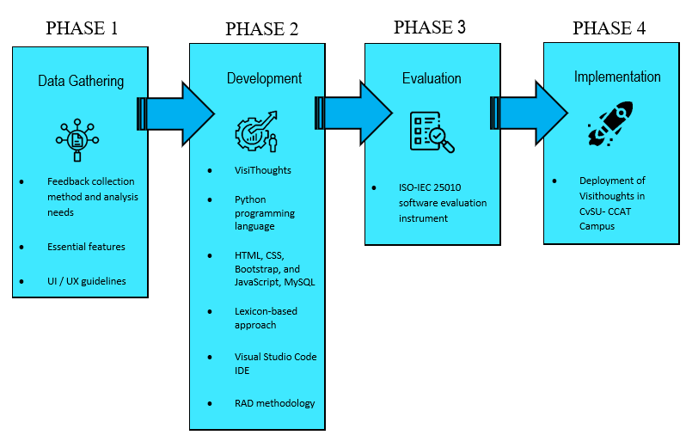

Figure 1‑1 Conceptual framework of the study

## Definition of Terms

To understand the study, the below terms are operationally defined:

**Sentiments Analysis*.*** Refers to the process of analyzing and determining the sentiment or emotional tone expressed in the feedback. By leveraging sentiment analysis techniques, the project aims to categorize the feedback as positive, negative, or neutral.

**Web application*.*** A web application refers to a software application that is accessed and utilized through a web browser or internet connection. The web application will be responsive, compatible with different devices and platforms, ensuring accessibility and user-friendliness.

**Feedback*.*** Feedback refers to the opinions, comments, evaluations, and complaints shared by customers and visitors regarding the services provided by Cavite State University CCAT Campus. By obtaining feedback, the university can identify areas for improvement, address concerns or issues raised by customers, and enhance the quality of services offered. The feedback received through the web application contributed to data-driven decision-making processes and continuous service improvement efforts.

# REVIEW OF RELATED LITERATURE

This chapter presented the related literatures, studies and systems that the researcher considered in strengthening the claim and importance of the present study.

## Importance of Feedback

According to Morgan et al. (2006), customer feedback is crucial to business performance and improvement. Managers commonly use customer feedback data to set goals and monitor performance on customer satisfaction and loyalty scores. Different customer feedback metrics, such as average customer satisfaction scores and the number of "net promoters," have been advocated and examined to determine their value in predicting future business performance (Morgan et al., 2006). Collecting and analyzing customer feedback is essential because it allows organizations to continuously learn and adapt their offerings to customer preferences (Ordenes et al., 2014). With customers' increasing use of multiple communication channels to provide feedback, organizations face the challenge of developing efficient and effective processes to collect and analyze all the information (Ordenes et al., 2014). Feedback helps promote professional and personal growth, adding value to customer satisfaction (Kerdpitak, 2021). Listening to customers, analyzing the problem, and identifying better solutions are part of the feedback process (Kerdpitak, 2021). However, customers may withhold feedback due to underestimating the other side's desire for feedback. Organizations must implement well-designed complaint-handling procedures and avoid pressuring customers to evaluate their services (Obradović et al., 2022).

## Sentiment Analysis in Interpreting Feedback

Sentiment analysis is crucial in interpreting feedback across various domains, including investment behavior, product quality assessment, marketing analysis, and customer satisfaction. Businesses and researchers can gain valuable insights into customer opinions, attitudes, and needs by analyzing the sentiment expressed in user reviews and feedback. For product managers, sentiment analysis can assist in interpreting customer feedback and improving the quality of products. By analyzing user reviews, sentiment analysis models can classify the sentiment expressed in the reviews, providing valuable information about customer satisfaction and areas for improvement (Khalid et al., 2020). In marketing analysis, sentiment analysis is used to understand customer perspectives and opinions. It helps assess the sentiment toward individuals, events, products, and topics, providing insights into customer attitudes and preferences (Kayıkçı, 2022).

Similarly, sentiment analysis is also valuable in the hospitality and tourism industry, where online review platforms serve as valuable sources of customer feedback. By applying sentiment analysis techniques, marketers can obtain firsthand information about customers' feedback and needs (Rita et al., 2022). Furthermore, education has applied sentiment analysis to analyze student feedback and satisfaction. Using sentiment-based approaches, aggregated sentiment scores can be used as inputs to fuzzy logic modules for analyzing student feedback and improving satisfaction (Asghar et al., 2019). In social media, sentiment analysis is crucial for understanding user evaluation and content generation. By decomposing user reviews into different dimensions and incorporating them into econometric models, sentiment analysis helps measure service quality, shape user evaluation, and drive content generation (Duan et al., 2015). However, it is essential to note that while sentiment analysis models can achieve high accuracy, many of them lack interpretability. This poses a challenge in terms of trust and explainability of the system. To address this issue, implementing explainable artificial intelligence (XAI) techniques can enhance the interpretability of sentiment analysis models (Adak et al., 2022).

## Lexicon-based Approach for Sentiment Analysis

The lexicon-based approach for sentiment analysis is a popular method that uses sentiment lexicons to determine the sentiment polarity of text. Sentiment lexicons are dictionaries or lists of words associated with sentiment labels or scores, indicating whether the words have a positive or negative sentiment. This approach relies on the assumption that the sentiment of a text can be inferred from the sentiment of its constituent words (Htait et al., 2021).

One study by Yang et al. (2020) applied the lexicon-based approach to sentiment analysis of e-commerce product reviews in Chinese. They used a sentiment lexicon and deep learning techniques to analyze the sentiment expressed in the reviews (Yang et al., 2020). Another study by Chundi et al. (2023) proposed a lexicon-based approach called NBLex for sentiment analysis of Kannada-English code-switch text. This study used the lexicon-based approach to perform sentiment analysis in a multilingual context (Chundi et al., 2023).

The lexicon-based approach can be compared with other methods, such as machine learning-based approaches. Dhaoui et al. compared the sentiment analysis method based on lexicon and machine learning using the LIWC2015 lexicon and RTextTools machine learning package (Yang et al., 2020). They found that the lexicon-based approach achieved comparable performance to the machine learning-based approach.

In addition to sentiment lexicons, other lexicons can enhance sentiment analysis. For example, Navarrete et al. (2021) proposed a novel approach to creating a labeling lexicon for improving emotion analysis in the text. They used Plutchik's eight emotions as labels in the lexicon to capture a broader range of emotional expressions (Navarrete et al., 2021).

## Effectiveness of Web Application for Collecting Feedback

The effectiveness of web applications for collecting feedback has been studied in various domains. Mofidi et al. (2019) proposed an integrated model that collects occupants' feedback through participatory sensing using smartphones or web-based applications in office productivity and energy cost optimization. The authors defined productivity as "the extent to which activities have provided performance regarding system goals." This suggests that web applications can effectively gather feedback from occupants to optimize office productivity and energy costs.

Selvam et al. (2022) highlighted the critical issues in feedback collection in the context of web-based learning applications. They emphasized the importance of test components that evaluate the user, provide information about user performance, encourage the user, and focus on user interaction with the computer. This indicates that web-based applications can effectively collect feedback by incorporating these essential functions.

In the context of student feedback collection, Wambsganss et al. (2022) discussed the limitations of static and old-fashioned web surveys. They emphasized the need for interactive and engaging designs to meet the expectations of young students. This suggests that web applications with interactive features can effectively collect feedback from students and improve their satisfaction rates.

Nguyen et al. (2019) conducted a systematic review of eHealth interventions addressing HIV/STI prevention. They found that web-based interventions, smartphone applications, SMS/Text messages, and live-chat/chat room approaches allow real-time monitoring, tailored feedback, and interactive person-to-person conversations. These features are critical for building rapport between interventionists and participants, indicating the effectiveness of web applications in collecting feedback for HIV/STI prevention.

Lobchuk et al. (2023) conducted usability testing of a web-based empathy training portal. They collected feedback through various application features, such as self-awareness exercises, instruction, feedback, and self-evaluation with video feedback. This study demonstrates the effectiveness of web applications in collecting feedback for training purposes.

## Python in sentiments analysis

Python is an essential programming language for creating sentiment analysis web applications. Sentiment analysis is a natural language processing (NLP) technique that involves extracting opinions, emotions, and attitudes expressed in text (Devi, 2023). With its extensive libraries and frameworks, Python has become one of the most popular programming languages for NLP tasks, including sentiment analysis (Devi, 2023).

Python's versatility and ease of use make it suitable for implementing sentiment analysis algorithms and machine learning models (Hassan et al., 2020). Researchers have developed sentiment analysis algorithms in Python using data mining and machine learning techniques. Python libraries like MonkeyLearn and SVM algorithms have been used for sentiment analysis in various domains, including the hotel industry and environmental management (Saura et al., 2019).

Python's data analysis capabilities are also valuable for sentiment analysis in the financial sector. In a study comparing traditional and digital methodologies for brand communication analysis in the financial sector, sentiment analysis using Python allowed for more accessible and faster data analysis than traditional methods (Saura et al., 2019).

## Bootstrap, HTML, CSS, and Java Script for creating web application

Bootstrap, HTML, CSS, and JavaScript are essential for creating web applications. Bootstrap is a popular framework that combines CSS, HTML, and JavaScript to create responsive webpages (Rahayuda et al., 2021). It provides templates and components that developers can use to design web pages that adapt to different screen sizes and devices (Wang et al., 2023). Using Bootstrap, developers can easily create a consistent and visually appealing user interface for their web applications.

HTML (Hypertext et al.) is the standard markup language for creating web pages. It provides the structure and content of a webpage (Bajaj et al., 2014). CSS (Cascading Style Sheets) is used to style and format the HTML elements, improving the presentation and visual appeal of the webpage (Bhargav N & Jayanthi N, 2021). Conversely, JavaScript is a programming language that adds interactivity and dynamic behavior to web pages (Bajaj et al., 2014). It allows developers to manipulate HTML elements, handle events, and perform calculations and data processing on the client side.

Together, these technologies enable the creation of modern web applications. HTML provides the structure, CSS enhances the presentation, and JavaScript adds interactivity and functionality to the web pages (Bajaj et al., 2014). As a framework, Bootstrap simplifies the process of designing responsive web layouts and ensures a consistent user experience across different devices (Santoso, 2019).

## ISO EIC 25010

ISO/IEC 25010 is a widely used evaluation tool for assessing the quality of web applications. It is a quality-in-use model with five characteristics; each further divided into sub-characteristics. These characteristics contribute to the overall interaction outcome when a product is used in a specific sense of use. The ISO/IEC 25010 model encompasses the entire human-machine system, including the computer systems and the software products in use (Abana et al., 2022).

The ISO/IEC 25010 model is comprehensive and covers various aspects of software quality. It includes functional suitability, reliability, performance efficiency, usability, compatibility, security, maintainability, and portability (Malaya et al., 2022). These characteristics provide a holistic view of a web application's quality, considering its functional and non-functional aspects, such as performance, security, and maintainability.

ISO/IEC 25010, as an evaluation tool, allows for a standardized and systematic assessment of web applications. It provides a framework for measuring and evaluating the quality of a web application based on international standards (Malaya et al., 2022). Organizations can use ISO/IEC 25010 to ensure that their web applications meet the desired quality standards and deliver a satisfactory user experience.

Several studies have utilized ISO/IEC 25010 for evaluating web applications. For example, in evaluating a rice seed analyzer application, ISO/IEC 25010 was used to assess the effectiveness of the application based on its quality characteristics (Abana et al., 2022).

Similarly, in evaluating an information management system, ISO/IEC 25010 was used to calculate the quality aspect of the system (Malaya et al., 2022).

The ISO/IEC 25010 model has also been extended to incorporate new characteristics and concepts, such as information quality, learnability, actual usability, and user experience (Lew et al., 2010). This extension allows for a more flexible and integrated approach to evaluating web applications, considering their technical aspects, usability, and user experience.

## SQLite as web server for web applications

SQLite is a capable web application server when used in conjunction with Python and the Django framework. Several studies have demonstrated the successful implementation of web applications using SQLite as the database tool integrated with Django (Guebila et al., 2021). For example, a literature web application was developed using Python, Django, and SQLite, and a recommendation system was implemented to provide accurate suggestions (Kozuyla et al., 2021). Another study developed a web-based leave management system using web technologies such as HTML, CSS, Python, and Django, with the database designed using SQLite (Mayowa et al., 2022). A web application for storing information about students' theses was also developed using Python, Django, and SQLite (Karpei et al., 2021). These examples highlight the versatility and effectiveness of SQLite in web application development when combined with Python and the Django framework.

## Importance and benefits of using Django in creating web application with sentiment analysis

Django is a popular web development framework that offers several benefits for creating web applications with sentiment analysis. One of the key advantages of using Django is its ability to handle complex database-driven sites (Alkot, 2022). This is particularly useful for web applications that involve sentiment analysis, as they often require storing and retrieving large amounts of data related to user profiles, sentiment scores, and text analysis results.

In creating a web application for sentiment analysis, Django's Model-View-Template (MVT) architecture is highly beneficial (Dhanalakshmi et al., 2023). The MVT architecture separates the application's data models, user interface, and business logic, making managing and maintaining the codebase easier. This separation allows developers to focus on implementing the sentiment analysis algorithms and user interface components without worrying about the underlying database operations and request handling.

Additionally, Django provides a robust and secure authentication system, which is crucial for web applications that involve user-profiles and sensitive data (Dhanalakshmi et al., 2023). This feature ensures only authorized users can access and modify the sentiment analysis results and other related information. It also allows user roles and permissions to be implemented, enabling different access levels for job seekers, recruiters, and administrators (P et al., 2023).

Furthermore, Django offers a wide range of built-in tools and libraries that can facilitate sentiment analysis tasks. For example, Django's form-handling capabilities can create user-friendly interfaces for inputting and submitting text for sentiment analysis (Dhanalakshmi et al., 2023). The framework also supports integration with external libraries and APIs, which can be leveraged to incorporate state-of-the-art sentiment analysis algorithms and models into the web application (Atzeni et al., 2022).

Regarding scalability and performance, Django provides features such as caching, database optimization, and load balancing, which are essential for handling large volumes of data and user requests in real time (Dhanalakshmi et al., 2023). These features ensure that the sentiment analysis web application can handle high traffic and deliver fast response times, even when processing complex sentiment analysis tasks.

## Automating Large Scale Healthcare Service Feedback Analysis: Using Natural Language Processing and Topic Modelling (Preprint)

The related system focuses on developing a data analysis and interactive visualization pipeline for patient feedback in England's National Health Service (NHS). The system uses natural language processing and machine learning techniques to analyze free-text clinical service reviews from patients. It incorporates sentiment analysis and topic modeling to derive meaningful insights from the feedback data. The system also includes an interactive web application that presents the analyzed data on a geographic representation, making it easily accessible to the general public.

## Opinion mining technique for developing student feedback analysis system using lexicon-based approach (OMFeedback)

The related system focuses on online assessment systems used for evaluating the performance of lecturers in Institutions of Higher Learning (IHLs). It addresses the issue of paying attention to the qualitative part of the assessment, which includes students' opinions, due to the challenges of manually analyzing unstructured texts. The feedback system utilizes an opinion-mining technique supported by a lexicon-based approach to analyze students' feedback automatically. It uses the Vader Lexicon, a database of English sentiment words, to determine the polarity of words and quantify the sentiment tendency of students' feedback. By analyzing these sentiment words, including intensifier words and additional features like capitalization and emoji characters, the system generates results for the lecturer teaching assessment, indicating the level of positive, negative, or neutral opinions. The system aims to provide valuable information to IHLs for improving lecturers' teaching skills and course materials.

## Web-Based Student Opinion Mining System Using Sentiment Analysis

The related system described focuses on developing a student opinion mining system to streamline the process of collecting and analyzing feedback from students in educational institutions. The system aims to provide a faster and easier feedback-gathering method while ensuring confidentiality. It utilizes tools such as Python, Scikit-learn, Textblob, Pandas, and SQLite for development and Django for hosting the application on a local host server. The system employs sentiment analysis techniques, using a dataset from online feedback forms distributed to students. Feature selection using the chi-square method and sentiment classification using the support vector machine algorithm are implemented. The application aims to assist university administrators and lecturers in identifying the strengths and weaknesses of lecturers based on the textual evaluations provided by students.

## Sentiment Analysis for University Students’ Feedback

The system focuses on developing a system to automatically categorize students' feedback in higher education institutions in Vietnam. Automating the feedback analysis process, the system aims to save time, human resources, and costs. The study begins by creating a dataset of university students' feedback over two years and organizing them into three classes: Positive, Negative, and Neutral. A Vietnamese sentiment dataset with 5000 classified sentences is built for training and testing. Three classifiers, Naïve Bayes, Maximum Entropy, and Support Vector Machine, are utilized on the annotated data. The results indicate that the Maximum Entropy algorithm performs better than Naïve Bayes and Support Vector Machine, achieving an accuracy score of 91.36%. Based on these findings, the system is implemented to detect students' opinions, allowing for adjustments and improvements in lectures, facilities, and curriculum to enhance the quality of education over time.

## Sentiresearch: Lexicon- based web application for indonesian sentiment analysis

The related system focuses on developing a system to automatically categorize students' feedback in higher education institutions in Vietnam. Automating the feedback analysis process, the system aims to save time, human resources, and costs. The study begins by creating a dataset of university students' feedback over two years and organizing them into three classes: Positive, Negative, and Neutral. A Vietnamese sentiment dataset with 5000 classified sentences is built for training and testing. Three classifiers, Naïve Bayes, Maximum Entropy, and Support Vector Machine, are utilized on the annotated data. The results indicate that the Maximum Entropy algorithm performs better than Naïve Bayes and Support Vector Machine, achieving an accuracy score of 91.36%. Based on these findings, the system is implemented to detect students' opinions, allowing for adjustments and improvements in lectures, facilities, and curriculum to enhance the quality of education over time.

Compared to our study, the related system focuses on automating the categorization of students' feedback, specifically in higher education institutions in Vietnam. It aims to improve efficiency by automatically analyzing feedback and providing insights for quality improvement. On the other hand, our study revolves around developing the responsive web application "VisiThoughts" for collecting customer feedback in the context of the Cavite State University CCAT Campus. Our study aims to enhance the quality of services offered by various offices and units within the university by implementing sentiment analysis techniques. Both systems involve feedback analysis and aim to improve the quality of education or services; the research also used a lexicon-based approach, python, and Django in developing their system.

## Synthesis

The literature and studies referenced in the research were intended to provide backing for the development of the study. The overarching theme across various contexts is the significance of feedback collection and sentiment analysis in different domains. Customer feedback was emphasized as a crucial asset for businesses, enabling them to predict performance, adapt offerings, and enhance overall customer satisfaction. Sentiment analysis is pivotal for interpreting feedback and providing valuable insights into opinions and attitudes.

The discussion extended to the methodologies employed in sentiment analysis, such as the lexicon-based approach, highlighting its versatility, applicability across languages and domains, and potential for comparative evaluations with other methods. Additionally, the need for explainability in sentiment analysis models was addressed, emphasizing the implementation of eXplainable Artificial Intelligence (XAI) techniques to enhance trust.

These technologies' application was exemplified in creating a web application named ‘VisiThoughts’ for Cavite State University-CCAT Campus. This application aimed to collect customer feedback, employ sentiment analysis techniques and enhance the quality of services within the university. This acknowledges the uniqueness of this study compared to related systems, emphasizing the specific focus on an educational institution, distinct functionalities, and the potential impact on service quality improvement.

# MATERIALS AND METHODOLOGY

This section discussed the materials, hardware and software, data, and the methodology that will be using by the researcher.

## Materials

### *Software*

Front-End Technologies:

* + - HTML: Markup language for creating the structure of web pages.
    - CSS: Style sheet language for designing the visual presentation of web pages.
    - JavaScript: Programming language for implementing interactivity and client-side functionality.
    - Bootstrap: Bootstrap is the most popular CSS Framework for developing responsive and mobile-first websites.

Back-End Technologies:

* Server-Side Language: Python for implementing the back-end logic.
* Web Framework: Django (Python), to help structure and streamline your back-end code.
* Database: MySQL provides a robust and scalable solution for storing and synchronizing data in real-time. With its robust support for standard SQL syntax and efficient handling of concurrent transactions, MySQL offers a powerful and reliable database management system.
* Sentiment Analysis Library: A lexicon-based sentiment analysis library or tool will be required to analyze the sentiment of user feedback.
* NLTK (Natural Language Toolkit): A Python library that provides various tools and resources for natural language processing, including sentiment analysis.

### *Hardware*

In this section, described the hardware that used for the development and testing of the responsive web application. The hardware requirements include:

*Development Computer*: A computer system capable of running IDE and supporting the necessary software development tools.

*Android/Computer Devices*: Devices such as smartphones and Personal Computer running the Android and windows operating system. These devices used for testing and evaluating the responsive web application. The specifications of said devices were yet to be determined upon development.

### *Data*

In this section, the researchers indicated the data source, data type, year of acquisition, and other pertinent details. The data required for developing the responsive web application was gathered from the Cavite State University-CCAT Campus. Data such as the name and services offered of the different departments and offices present on the Campus, the basic information of the staff like their name and position in the departments, the different services that the departments offered, and gathered from Cavite State University – CCAT Campus through document request/documentation or interview.

## Methodology

The major phases of the conceptual framework are discussed in the methodology.

### *Data Analysis*

The study involved processing and analyzing the gathered data to extract meaningful insights and make informed decisions for developing VisiThougths. The data analysis process primarily focuses on analyzing the gathered data in the CvSU-CCAT Campus to determine the departments, units, offices, staff, and services needed for web application development.

### *Development of the Application*

The following discussed the design of the software, system, application, or processes and how the application developed using the software development model RAD (Rapid Application Development). It also includes the functional testing.

1. **Design of the Software, System, Application, Product or Processes**

Figure 3-1 shows the use case diagram of the system. There are 3 actors such as the User or Visitor, the Chairperson or Unit Head, and the Admin.

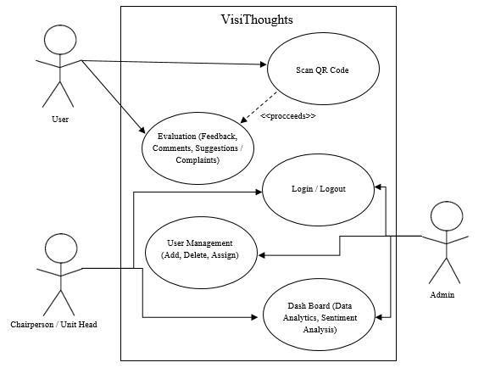

Figure 3‑1 Use Case Diagram of the VisiThoughts

1. **Software Development Model**

The application was developed using the Rapid Application Development Model (RAD) shown in Figure 3-2. Also, to test the application, the researchers used functional testing. The RAD (Rapid Application Development) model was an iterative and incremental software development approach focusing on quickly building and refining prototypes based on testing, assessment, and feedback. In developing the web application system, here is how the RAD model was applied in developing the VisiThoughts. In requirement planning, identify specific requirements for the web application, focusing on feedback processing and sentiment analysis using a lexicon-based approach. Clearly define the features and functionalities related to sentiment analysis.

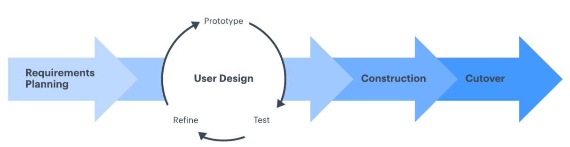

Figure 3‑2 Software development model

In the user design cycle, develop the web application prototype that includes the core feature of sentiment analysis, and the system receives input text for analysis and displays sentiment results. Testing: the researchers test the prototype, specifically evaluating the accuracy of sentiment analysis results. Identify any issues or improvements needed in the initial implementation. Iterate: the researchers, based on testing results, iterate on the sentiment analysis algorithm, refine the prototype, and ensure that the analysis accurately determines whether the text is positive, neutral, or negative.

In rapid construction the researchers begin rapid construction of the web application, incorporating refined sentiment analysis. Develop additional features and components necessary for the complete web application. Maintain the ability to revisit the user design phase if substantial feedback or changes are required through evaluation. Sample users' and web developers' feedback triggers design and sentiment analysis adjustments. Use feedback to drive further improvements in subsequent iterations.

In cutover, the researchers prepare for the web application's final deployment and launch, ensuring all features and functionalities, including sentiment analysis, are thoroughly tested and ready for production. In summary, the RAD model allows for a dynamic and iterative web application development approach.

1. **Functional Testing**

Table 3‑1 Module Name

|  |  |  |  |  |  |
| --- | --- | --- | --- | --- | --- |
| **Module** | **Account** | | | | |
| **Test Case** | **Action** | **Expected System Response** | **Number of Execution** | **Results** | **Status** |
|  |  |  |  |  |  |
|  |  |  |  |  |  |
|  |  |  |  |  |  |

The system was tested using functional testing as shown in Table 3-1.

### *Evaluation of the Application*

Table 3‑2 Evaluation Criteria for End-Users

|  |  |  |  |  |  |
| --- | --- | --- | --- | --- | --- |
| **Indicator** | **5** | **4** | **3** | **2** | **1** |
| **A. Usability** | | | | | | |
| 1. Appropriateness recognizability - degree to which users recognize the appropriateness of the website based on their needs |  |  |  |  |  | |
| 1. Learnability - degree to which the website provides self-explanatory user-interface; entry fields contain default/placeholder texts; and error messages provided are understandable |  |  |  |  |  | |
| 1. Operability - degree to which the website is easy to operate, control, and can be used appropriately |  |  |  |  |  | |
| 1. User error protection - the website is able to perform user entry validation and allows the user to recover from errors |  |  |  |  |  | |
| 1. User interface aesthetics - degree to which the user interface enables pleasing and satisfying interaction with the user |  |  |  |  |  | |
| **B. Effectiveness** | | | | | | |
| 1. The website allows the users to achieve specified goals when used in specified contexts |  |  |  |  |  | |
| ***Table 3-2 contd.*** | | | | | | |
| **C. Efficiency** | | | | | | |
| 1. The degree to which resources are consumed with accuracy and completeness of helping users achieve the goals |  |  |  |  |  | |
| **D. Satisfaction** | | | | | | |
| 1. Usefulness - degree to which the user is satisfied on perceived achievement of pragmatic goals including the results and consequences of using the website |  |  |  |  |  | |
| 1. Trust - degree to which a user or other stakeholders are confident that the website will behave as it is intended |  |  |  |  |  | |
| 1. Pleasure - degree to which a user gains pleasure upon fulfillment of personal needs |  |  |  |  |  | |
| 1. Comfort - degree to which the user is satisfied with physical comfort |  |  |  |  |  | |
| **E. Context Coverage** | | | | | | |
| 1. Content completeness - degree to which the website can be used effectively, efficiently, and satisfactorily in all specified contexts of use |  |  |  |  |  | |
| 1. Flexibility - degree to which the website can be used effectively, |  |  |  |  |  | |
| ***Table 3-2 contd.*** |  |  |  |  |  | |
| efficiently, and satisfactorily in contexts beyond those initially specified in the requirements |  |  |  |  |  | |

The system was evaluated in order to determine if it complies with the modified ISO-IEC 25010 standards. Table 3-2 are the evaluation criteria for end-users, and Table 3-3 are the evaluation criteria for the web developers or IT experts.

Table 3‑3 Evaluation Criteria for Developers

|  |  |  |  |  |  |
| --- | --- | --- | --- | --- | --- |
| **Indicator** | **5** | **4** | **3** | **2** | **1** |
| **A. Functional Suitability** | | | | | |
| 1. Functional completeness - degree to which the set of functions covers all the specified tasks and user objectives |  |  |  |  |  |
| 1. Functional correctness - degree to which the functions provide the correct results with precision |  |  |  |  |  |
| 1. Functional appropriateness - degree to which the functions facilitate the accomplishment of specified tasks and objectives |  |  |  |  |  |
| **B. Performance Efficiency** | | | | | |
| 1. Time behavior - degree to which the responses, processing times, and throughput rates of the website meet the requirements when performing its functions |  |  |  |  |  |
| 1. Resource utilization - degree to which the amounts and the types of resources used by the website meet the requirements when performing its functions |  |  |  |  |  |
| ***Table 3-3 contd.*** |  |  |  |  |  |
| 1. Capacity - degree to which the maximum limitations of the website or its components meet the requirements |  |  |  |  |  |
| **C. Usability** | | | | | |
| 1. Appropriateness recognizability - degree to which users recognize the appropriateness of the website based on their needs |  |  |  |  |  |
| 1. Learnability - degree to which the website enables the user to learn how to use the software effectively |  |  |  |  |  |
| 1. Operability - degree to which the website is easy to operate, control, and be used appropriately |  |  |  |  |  |
| 1. User error protection - degree to which the website protects the user from making errors |  |  |  |  |  |
| 1. User interface aesthetics - degree to which the user interface enables pleasing and satisfying interaction with the user |  |  |  |  |  |
| 1. Accessibility - degree to which the website can be used in a specific context with the widest range of characteristics and capabilities to achieve a specific goal |  |  |  |  |  |
| **D. Security** | | | | | |
| ***Table 3-3 contd.*** |  |  |  |  |  |
| 1. Confidentiality -degree to which the website ensures that the data are only accessible by those who have authorized access |  |  |  |  |  |
| 1. Integrity - degree to which the website prevents unauthorized access to and or modifications of computer programs or data |  |  |  |  |  |
| 1. Non-repudiation - degree to which actions or events can be proven to have taken place to avoid repudiation later on |  |  |  |  |  |
| 1. Accountability - degree to which the actions of an entity can be uniquely accounted to the entity |  |  |  |  |  |
| 1. Authenticity - degree to which the identity of a subject or resource can be proven to be the one being claimed |  |  |  |  |  |
| **E. Maintainability** | | | | | |
| 1. Modularity - degree to which the website consists of discrete components so that a change on one component pose minimal impact to other components |  |  |  |  |  |
| 1. Reusability - degree to which an asset can be used in more than one system or in building other assets |  |  |  |  |  |
| ***Table 3-3 contd.*** |  |  |  |  |  |
| 1. Analyzability - degree of effectiveness and efficiency on possibly assessing the impact of an intended change to one or more parts of the website; diagnosing deficiencies or causes of failures; and or identifying parts of the website to be modified |  |  |  |  |  |
| 1. Modifiability - degree to which the website can be effectively and efficiently modified without introducing defects or degrading existing quality |  |  |  |  |  |
| 1. Testability - degree in which test criteria can be efficiently and effectively established and the software or components can be tested to determine whether test criteria were met |  |  |  |  |  |
| **F. Portability** | | | | | |
| 1. Adaptability - degree to which the website can be effectively and efficiently adapted for different or evolving hardware, software, or other operational or usage environments. |  |  |  |  |  |

Table 3‑4 Score descriptive interpretation

|  |  |
| --- | --- |
| SCORE | DESCRIPTIVE INTERPRETATION |
| 4.51 – 5.00 | Excellent |
| 3.51 – 4.50 | Very Satisfactory |
| 2.51 – 3.50 | Satisfactory |
| 1.51 – 2.50 | Unsatisfactory |
| 1.00-1.50 | Requires Improvement |

Table 3-4 shows the score descriptive interpretation used in interpreting the results.

### *Deployment Plan*

Table 3‑5 Implementation plan for the deployment of the system

|  |  |  |  |
| --- | --- | --- | --- |
| **Strategy** | **Activities** | **Person Involved** | **Duration** |
| Approval from the Campus Administrator | Letters for the Administrator | Researchers, Administrator | 1 Day |
| System’s Installation | Installation of the System and required software | Researchers, Administrator | 5 Hours |
| Information Distribution | Manuals | Researchers | 1 Day |
| End-User Training | Hands on Training and Lectures | Department Chairperson and Unit Heads, Faculty, Staff, and Students, Stakeholders | 3 Days |

The researchers deployed the responsive web application in all Department and Offices of Cavite State University-CCAT Campus provided with their services, activities, persons involved, and duration as shown in Table 3-5.

# RESULTS AND DISCUSSION

This chapter offers a comprehensive review of the results obtained during the different stages of the system's development.

## Results of the data analysis and model building

*Lexicon-Based Approach*: A lexicon-based approach to sentiment analysis involved using a predefined set of words or phrases with associated sentiment scores to determine the sentiment expressed in a piece of text. In this approach, a sentiment lexicon, which was essentially a dictionary of words or expressions along with their corresponding sentiment polarity (positive, negative, or neutral), used to analyze the sentiment of a given document, sentence, or even individual words.

*NLTK Vader Library*: The Natural Language Toolkit (NLTK) Vader library was widely used tool for sentiment analysis in natural language processing. It adopts a lexicon-based approach, relying on a pre-built sentiment lexicon and a set of rules to determine the sentiment of a given text.

*Sentiment Lexicon*: The core component of the NLTK Vader library was its sentiment lexicon. This lexicon comprises a vast collection of words, each assigned a sentiment score indicating the degree of positivity, negativity, or neutrality. The lexicon was pre-constructed through the amalgamation of human-labeled data and empirical analysis.

*Scoring Mechanism*: Words in the lexicon were assigned polarity scores ranging from highly negative to highly positive. The cumulative score of words in a given text determines the overall sentiment.

*Intensifiers and Negators*: The NLTK Vader lexicon accounts for intensifiers and negators, which modify the sentiment of adjacent words. This helps capture nuances in sentiment, such as the impact of words like "very" or the reversal effect of negations like "not."

*Development*: The integration of the NLTK Vader library into the Django web application streamlines the sentiment analysis process. By leveraging a lexicon-based approach, the model efficiently analyzes user comments, providing a clear and interpretable sentiment label. The combination of preprocessing, lexicon-based sentiment analysis, and score aggregation allows for a robust understanding of sentiment in user feedback, contributing to enhanced user engagement and improved decision-making within the web application.

1. *Data Preprocessing*: Upon receiving user comments through the Django form, the initial step was to preprocess the text for better analysis. The following preprocessing steps are applied:

a) *Lowercasing*: Convert all text to lowercase to ensure uniformity and avoid discrepancies due to case differences.

b) *Punctuation Removal*: Stripping away punctuation ensures that the sentiment analysis focuses on the content words, reducing noise in the text.

c) *Tokenization*: Breaking down the comments into individual words, or tokens, was a fundamental step for further analysis. Tokenization was essential for understanding the sentiment of each word in the comment.

2. *NLTK Vader Sentiment Analysis*: The NLTK Vader library was then employed to conduct sentiment analysis on the preprocessed text. The library utilizes a pre-built sentiment lexicon, which consists of words with associated sentiment scores. Each word in the tokenized comment was matched with its sentiment score from the lexicon.

*Scoring Mechanism*: The sentiment analyzer in NLTK Vader calculates sentiment scores for each comment. These scores include a positive score, a negative score, a neutral score, and a compound score that represents the overall sentiment intensity.

3. *Aggregating Sentiment Scores*: Following sentiment analysis, the next step was to aggregate the sentiment scores and determine an overall sentiment label for the comment. The approach taken involves comparing the negative and positive scores.

*Comparing Scores*: If the negative score was higher than the positive score, the comment was labeled as having a negative sentiment. Conversely, if the positive score was higher, the sentiment is classified as positive. In cases where the positive and negative scores are equal, the comment was considered neutral.

4. *Returning Sentiment Label*: Based on the aggregated sentiment score, the final step was to return a sentiment label to the Django web application. This label was utilized for various purposes, such as categorizing feedback or generating insights into user sentiments.

Practical Considerations for Applying Sentiment Analysis Results in the Web Application:

1. *User Feedback Sorting and Prioritization*: Utilize sentiment labels to automatically categorize and prioritize user feedback. Positive feedback can be highlighted for visibility, while negative feedback may be flagged for urgent attention.

2. *Feedback Dashboard*: Implement dashboards that visually represents the sentiment gathered through feedback. This allows administrators to quickly view sentiments and feedbacks to produce and use the information.

3. *Product or Service Improvement Insights*: Analyze common themes in negative comments to identify areas for improvement. Use sentiment analysis to inform product or service development strategies and prioritize enhancements that align with user feedback.

Potential Improvements and Modifications:

1. *Handling Sarcasm and Irony*: Develop strategies to better handle sarcasm and irony in user comments. This could involve exploring more advanced sentiment analysis models that consider contextual cues for nuanced expressions.

2. *User Feedback Integration into Decision-Making*: Explore ways to integrate sentiment analysis results directly into decision-making processes. For instance, use sentiment trends to inform business strategy or guide marketing campaigns.

## Results of the application development

Figure 4-1 shows the welcome page of the system, this page shows that the clients will need to proceed to evaluate and use the form.



Figure 4‑1 Welcome page

Figure 4-2 shows the transition of the welcome page. This page indicates that clients should proceed with the assessment and utilization of the form.



Figure 4‑2 Welcome Transition page

Figure 4-3 shows the users info page. This page delineates the requirement for users to input their personal details, serving the dual purpose of information gathering and establishing their identity as clients.

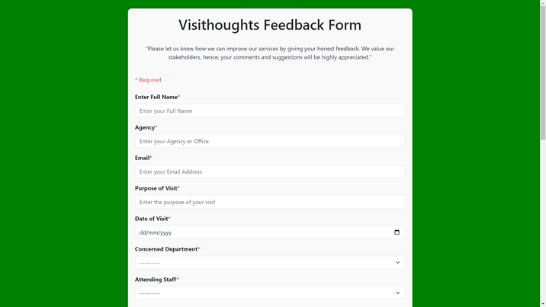

Figure 4‑3 Form input personal details page

Figure 4-4 shows the presents users with a slider interface for the evaluation process. This page instructs users to assess the performance of the staff services by simply utilizing a slider mechanism to indicate their level of satisfaction.

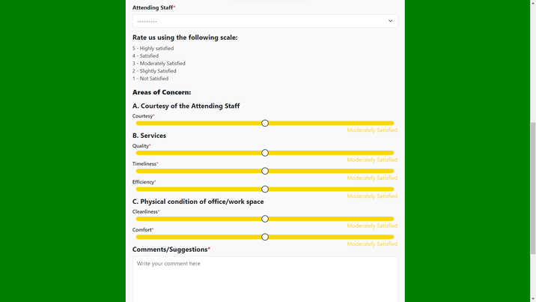

Figure 4‑4 Form satisfactory level page

Figure 4-5 shows the comment section satisfactory level of the users for the evaluation process. This page features a comment section within the form where clients are required to provide feedback, expressing either positive or negative sentiments based on their satisfaction.

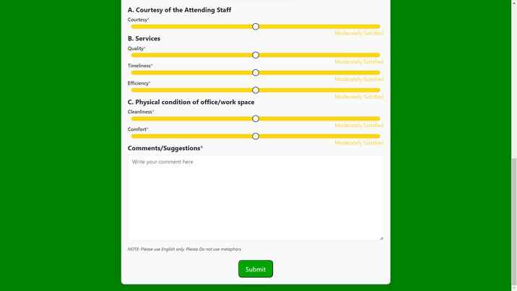

Figure 4‑5 Form comment section page

Figure 4-6 shows an appreciation page upon the completion of the client's feedback form. This page expresses gratitude for the client's time and valuable input in providing feedback, emphasizing the significance of their opinions in assessing the service quality of each office.

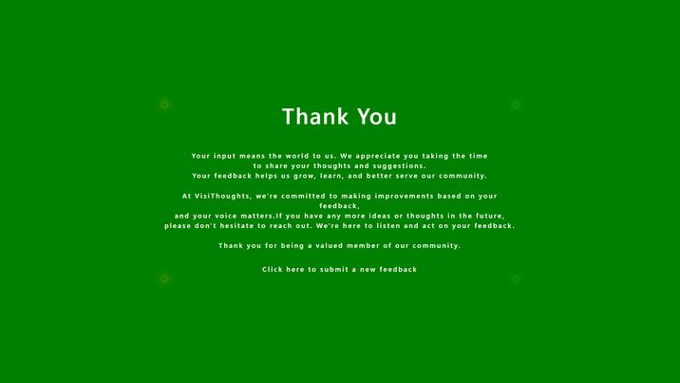

Figure 4‑6 Form appreciation page

Figure 4-7 shows the starting page of the admin users. This page indicates that administrators are required to initiate the login process by clicking the start button in order to access their accounts and manage their schedules within the system.



Figure 4‑7 Admin starting page

Figure 4-8 shows the admin login page. This page serves as the gateway for administrators to securely log in, providing a streamlined and secure means for them to enter their account information and gain authorized entry to the system's functionalities.

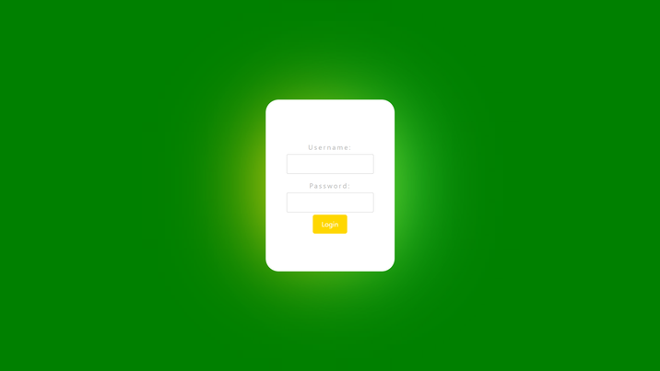

Figure 4‑8 Admin login page

Figure 4-9 shows the admin head dashboard page. This page allows administrators to conveniently categorize specific details according to their preferences, particularly with respect to dates, whether for an overarching assessment of the campus or for individual evaluations of each department and staff member. Additionally, the platform provides insights into satisfaction evaluations and sentiment analysis results, offering a comprehensive overview of the data at hand.

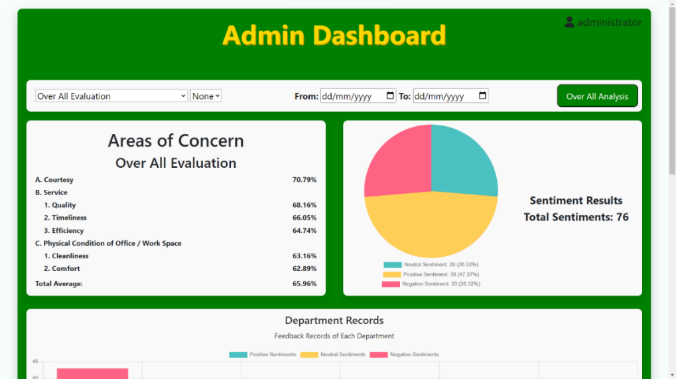

Figure 4‑9 Admin head dashboard page

Figure 4-10 shows the Department record page. This page displays the sentiment status of each department within the CvSU-CCAT Campus, offering the capability to assess overall sentiments categorized into positive, negative, and neutral classifications. The presentation is designed to ensure clarity for administrators, employing distinct color coding for each result to mitigate any potential confusion.

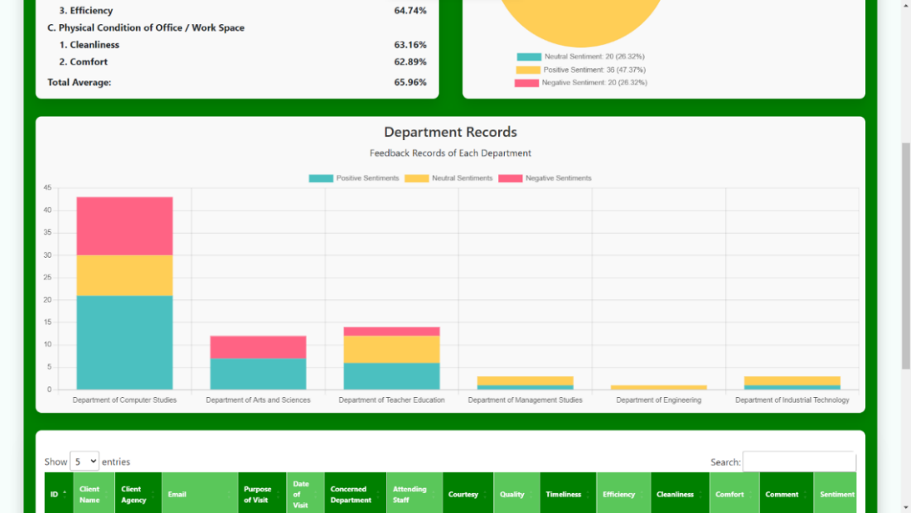

Figure 4‑10 Admin department records for sentiment

Figure 4-11 shows the feedback of the client page. This page presents a comprehensive compilation of client feedback, enabling administrators to efficiently retrieve specific information through a search functionality. This feature allows administrators to streamline the process of obtaining relevant data by searching for specific keywords within the feedback dataset.

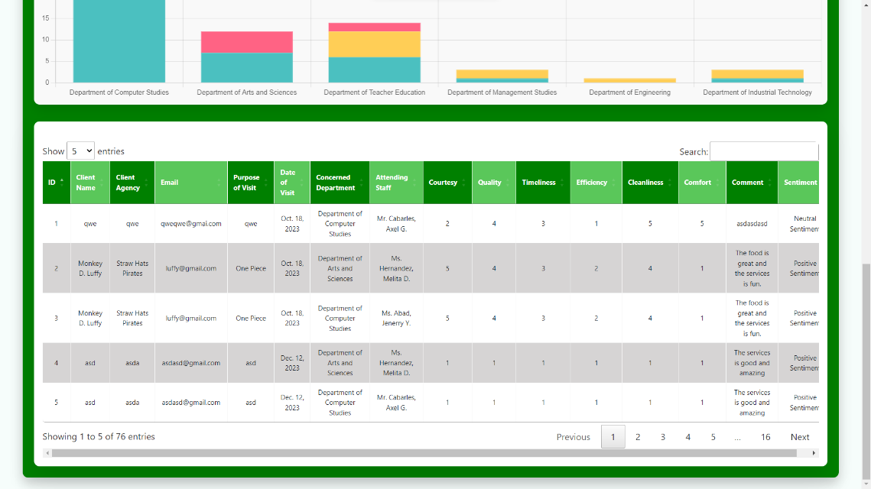

Figure 4‑11 Admin client feedback copied form

Figure 4-12 shows the admin option page. The system provides administrative functionalities, encompassing options such as exporting data to collate results for sentiment analysis submissions, managing staff details by facilitating edits to personnel information within various offices, and offering a logout option for the seamless exit from the system.

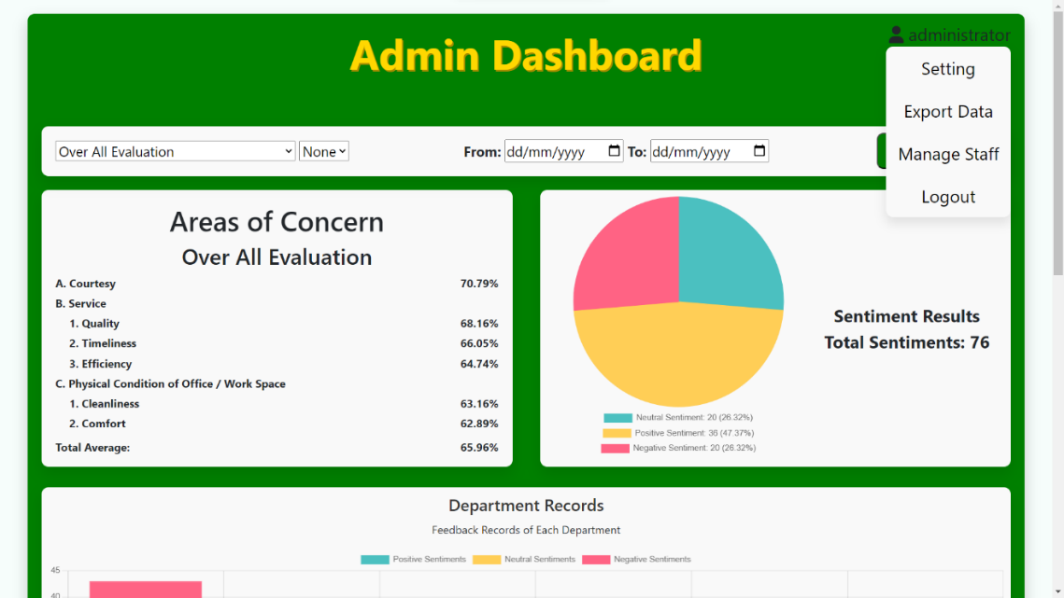

Figure 4‑12 Admin option page

Figure 4-13 shows the admin setting page. This page allows administrators to enhance security by providing the capability to modify their username or password as needed. This functionality empowers administrators to proactively manage and fortify the security of their accounts within the system.

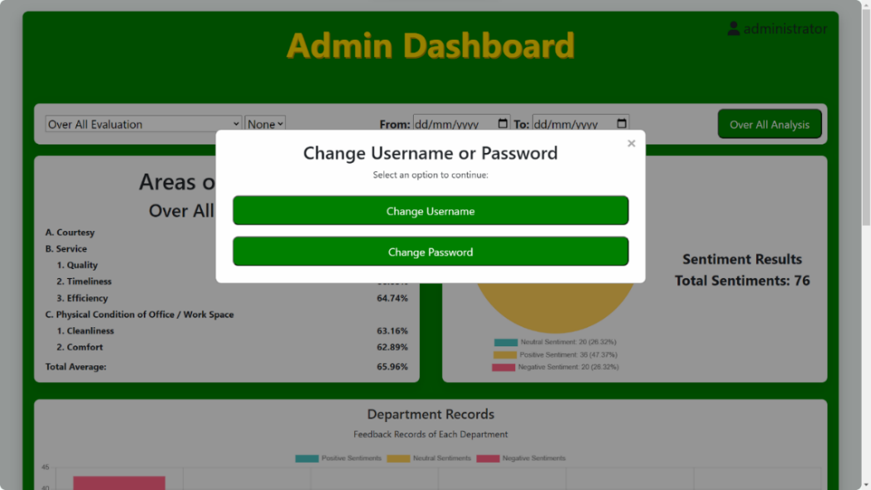

Figure 4‑13 Admin setting page

Figure 4-14 shows the admin manage staff option page. This show administrator to incorporate, revise, and refresh the particulars pertaining to staff members across various offices at CvSU-CCAT Campus. This functionality serves as a valuable tool, particularly in the event of official updates to the staff roster, ensuring that the system remains current by aligning with the most recent information regarding personnel within each office.

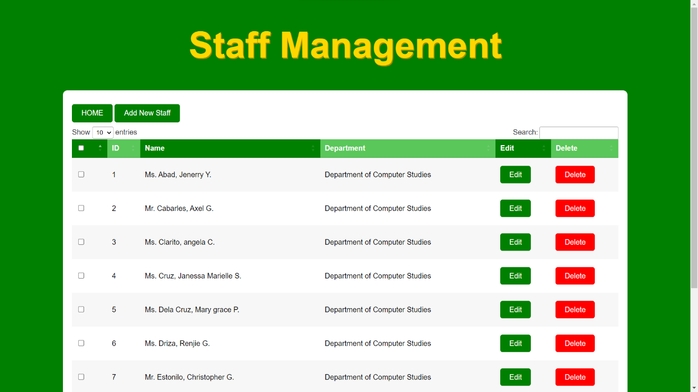

Figure 4‑14 Admin staff management page

## Results of the application evaluation

### *Functional Testing*

Table 4‑1 The summary of Functional Testing

|  |  |  |  |  |  |
| --- | --- | --- | --- | --- | --- |
| **Module** | **Account** | | | | |
| **Test Case** | **Action** | **Expected System Response** | **Number of Execution** | **Results** | **Status** |
| Feedback form Submit | Submit registration | Receives feedback record and show appreciation message | 1 second after submission | Receives feedback record and show appreciation message | Passed |
| Login account | Submit login request | Display dashboard according to login credential | 1 second after hitting login | Validates login credential and proceeds to dashboard. | Passed |
|  |  |  |  |  |  |
| Dashboard Staff, Department, and Date Filtering | Query feedback data or records based on the inputted criteria | Show feedback records according to criteria | 1 second after hitting custom analysis button | Filter displayed data according to criteria | Passed |
| Search | Query data based on the inputted text | Show data based on the inputted text | Real-time | Display data related to inputted words | Passed |
| Pie chart and Bar graph Sentiment Filtering | Filter sentiments | Change the pie chart and bar graph data | Real-time | Pie chart and bar graph data according to selected legends | Passed |
| ***Table 4-1 contd.*** | |  |  |  |  |
| Change password | Submit Change password request | There will be a successful message pop up and request is accepted | 1 second | The system accepts the request and display pop up message | Passed |
| Change username | Submit change username request | There will be a pop up successful message and request is accepted | 1 second | The system accepts the request and display pop up message | Passed |
| Export data | Export data based on the displayed records | Export file containing the data | 1 sec after hitting export data | Export .txt file containing the data that is currently shown in the dashboard | Passed |
| Add new staff | Submit add new staff request | Staff information added to the database | 1 second | New staff information added in the database. | Passed |
| Edit staff | Submit edit new staff request | Staff information update to the database | 1 second | Staff information is updated. | Passed |
| Delete staff | Submit delete request | Delete staff | 1 second | Staff Deleted | Passed |
| Logout | Submit logout request | Logout the user and end the session | 1 second after hitting login | Logout the accounts | Passed |

Table 4-14 shows the summary of functional testing of VISITHOUGHTS. The indicators were rated as follows: Feedback form Submit, Login account, Dashboard Staff, Department, and Date Filtering, Search, Pie chart and Bar graph Sentiment Filtering, change password, Change username, Export data, Add new staff, Edit staff, Delete staff, Logout, passed.

### *Software Evaluation from the End Users*

Table 4‑2 Perception of the end user on the usability of the website

|  |  |  |
| --- | --- | --- |
| **USABILITY** | **AVERAGE SCORE** | **DESCRIPTIVE INTEPRETATION** |
| 1. Appropriateness Recognizability | 4.76 | Excellent |
| 2. Learnability | 4.76 | Excellent |
| 3. Operability | 4.76 | Excellent |
| 4. User error protection | 4.5 | Excellent |
| 5. User interface aesthetics | 4.69 | Excellent |
| **TOTAL** | **4.69** | **EXCELLENT** |

Table 4-2 shows the perception of the respondents on usability of the website. The indicators were scored as follows: appropriateness recognizability, 4.76; learnability, 4.76; operability, 4.76; user error protection, 4.5; and user interface aesthetics, 4.69. The total average score is 4.69. It indicates that users can easily recognize the website based on their specific needs, promoting a cohesive grasp of its functionalities and supporting uncomplicated navigation and control.

Table 4‑3 Perception of the end users on the effectiveness of the website

|  |  |  |
| --- | --- | --- |
| **EFFECTIVENESS** | **AVERAGE SCORE** | **DESCRIPTIVE INTEPRETATION** |
| 1. Effectiveness | 4.76 | Excellent |
| **TOTAL** | **4.76** | **EXCELLENT** |

The perceptions of the respondents in the effectiveness of the system were shown in Table 4-3. The total score of 4.76 indicates that the website successfully met its objectives when utilized in particular contexts.

Table 4‑4 Perception of the end users on the efficiency of the website

|  |  |  |
| --- | --- | --- |
| **EFFICIENCY** | **AVERAGE SCORE** | **DESCRIPTIVE INTEPRETATION** |
| 1. Efficiency | 4.73 | Excellent |
| **TOTAL** | **4.73** | **EXCELLENT** |

The perceptions of the respondents in the efficiency of the system were shown in Table 4-4. It gets a total score of 4.73 indicates that the website effectively and thoroughly assisted users with precision.

Table 4‑5 Perception of the end users on the satisfaction of the website

|  |  |  |
| --- | --- | --- |
| **SATISFACTION** | **AVERAGE SCORE** | **DESCRIPTIVE INTEPRETATION** |
| 1. Usefulness | 4.69 | Excellent |
| 2. Trust | 4.50 | Excellent |
| 3. Pleasure | 4.65 | Excellent |
| 4. Comfort | 4.61 | Excellent |
| **TOTAL** | **4.61** | **EXCELLENT** |

The perception of the respondents in the satisfaction of the system was shown in Table 4-5. The indicators were rated as follows: usefulness, 4.69; trust, 4.5; pleasure, 4.65; and comfort, 4.61. The cumulative score of 4.61 suggests that the website was considered valuable, reliable, and adept at satisfying the physical comfort and personal requirements of its users.

Table 4‑6 Perception of the end users on the context coverage of the website

|  |  |  |
| --- | --- | --- |
| **CONTEXT COVERAGE** | **AVERAGE SCORE** | **DESCRIPTIVE INTEPRETATION** |
| 1. Content completeness | 4.69 | Excellent |
| 2. Flexibility | 4.69 | Excellent |
| **TOTAL** | **4.69** | **EXCELLENT** |

The perception of the respondents in the context coverage of the website was shown in Table 4-6. The content completeness achieved a score of 4.69, and concurrently, the flexibility of the website also attained a score of 4.69. This confirms that the website has effectively fulfilled the requirements for both extensive content coverage and operational adaptability.

Table 4‑7 Summary of results of the website evaluation assessed by the end users

|  |  |  |
| --- | --- | --- |
| **CRITERIA** | **AVERAGE SCORE** | **DESCRIPTIVE INTEPRETATION** |
| 1. Usability | 4.69 | Excellent |
| 2. Effectiveness | 4.76 | Excellent |
| 3. Efficiency | 4.73 | Excellent |
| 4. Satisfaction | 4.61 | Excellent |
| 5. Context Coverage | 4.69 | Excellent |
| **TOTAL** | **4.69** | **EXCELLENT** |

The summary of the results of the evaluation of the website assessed by the end users was shown in Table 4-7. In general, survey participants conveyed a positive view of the website, describing it as easy to use, productive, efficient, and adept at fulfilling user requirements with thorough content. As a result, the website received an overall score of 4.69, indicating an Excellent rating.

### *Software Evaluation from the Web Developers*

Table 4‑8 Perception of the IT experts on the functionality of the website

|  |  |  |
| --- | --- | --- |
| **FUNCTIONAL SUITABILITY** | **AVERAGE SCORE** | **DESCRIPTIVE INTEPRETATION** |
| 1. Functional completeness | 4.80 | Excellent |
| 2. Functional correctness | 4.80 | Excellent |
| 3. Functional appropriateness | 5.00 | Excellent |
| **TOTAL** | **4.93** | **EXCELLENT** |

The perception of the respondents regarding the functional suitability of the website was reflected in Table 4-8. The indicators were rated as follows: functional completeness, 4.80; functional correctness, 4.80; and functional appropriateness, 5.00. The total score of 4.93 suggested that the website's intent was precise, suitable, and completely operational.

Table 4‑9 Perceptions of the IT experts on the performance of the website

|  |  |  |
| --- | --- | --- |
| **PERFORMANCE EFFICIENCY** | **AVERAGE SCORE** | **DESCRIPTIVE INTEPRETATION** |
| 1. Time behavior | 5.00 | Excellent |
| 2. Resource utilization | 5.00 | Excellent |
| 3. Capacity | 5.00 | Excellent |
| **TOTAL** | **5.00** | **EXCELLENT** |

The perception of the respondents regarding performance efficiency was shown in Table 4-9. The indicators were scored as follows: time behavior, 5.00; resource utilization, 5.00; and capacity, 5.00. The total score of 5.00 Indicates that the website's purpose was effective in terms of performance.

Table 4‑10 Perception of the IT experts on the usability of the website

|  |  |  |
| --- | --- | --- |
| **USABILITY** | **AVERAGE SCORE** | **DESCRIPTIVE INTEPRETATION** |
| 1. Appropriateness recognizability | 4.60 | Excellent |
| 2. Learnability | 4.80 | Excellent |
| ***Table 4-10 contd.*** |  |  |
| 3. Operability | 4.80 | Excellent |
| 1. User error protection | 4.60 | Excellent |
| 1. User interface aesthetics | 4.20 | Very Satisfactory |
| 1. Accessibility | 4.80 | Excellent |
| **TOTAL** | **4.63** | **EXCELLENT** |

The perception of the respondents’ regarding usability was shown in Table 4-10. The indicators were rated as follows: appropriateness recognizability, 4.60; learnability, 4.80; operability, 4.80; user error protection, 4.60; user interface aesthetics, 4.20; and accessibility, 4.80. The mean of 4.63 suggests that the website's intent was easily understandable, free from errors, and visually appealing to users.

Table 4‑11 Perception of the respondents on security

|  |  |  |
| --- | --- | --- |
| **SECURITY** | **AVERAGE SCORE** | **DESCRIPTIVE INTEPRETATION** |
| 1. Confidentiality | 4.80 | Excellent | |
| 2. Integrity | 4.80 | Excellent | |
| 3. Non-repudiation | 4.80 | Excellent | |
| 4. Accountability | 4.80 | Excellent | |
| 5. Authenticity | 4.80 | Excellent | |
| **TOTAL** | **4.80** | **EXCELLENT** | |

The perception of the respondents’ regarding security was shown in Table 4-11. The indicators were rated correspondingly: confidentiality, 4.80; integrity, 4.80; non-repudiation, 4.80; accountability, 4.80; and authenticity, 4.80. The score of 4.80 suggests that the website safeguards against unauthorized access, ensuring that only users with granted permission can access the data.

Table 4‑12 Perception of the IT experts on the maintainability of the website

|  |  |  |
| --- | --- | --- |
| **MAINTAINABILITY** | **AVERAGE SCORE** | **DESCRIPTIVE INTEPRETATION** |
| 1. Modularity | 4.80 | Excellent | |
| 2. Reusability | 5.00 | Excellent | |
| 3. Analyzability | 5.00 | Excellent | |
| 4. Modification | 5.00 | Excellent | |
| 5. Testability | 5.00 | Excellent | |
| **TOTAL** | **4.96** | **EXCELLENT** | |

The perception of the respondents’ regarding maintainability was shown in Table 4-12. The indicators were rated as follows: modularity, 4.80; reusability, 5.00; analyzability, 5.00; modifiability, 5.00; testability, 5.00. The mean of 4.96 suggests that users with permission can effectively and efficiently modify the website's purpose without causing harm to the system.

Table 4‑13 Perception of the IT experts on the portability of the website

|  |  |  |
| --- | --- | --- |
| **PORTABILITY** | **AVERAGE SCORE** | **DESCRIPTIVE INTEPRETATION** |
| 1. Adaptability | 5.00 | Excellent | |
| **TOTAL** | **5.00** | **EXCELLENT** | |

The perception of the respondents’ regarding portability was shown in Table 4-13. The indicators were rated as follows: adaptability, 5.00. The mean of 5.00 suggests that the website has the capability to adjust to various devices or browsers it was accessed on.

Table 4‑14 Summary of results of the website evaluation assessed by the IT experts

|  |  |  |
| --- | --- | --- |
| **CRITERIA** | **AVERAGE SCORE** | **DESCRIPTIVE INTEPRETATION** |
| 1. Functional Suitability | 4.93 | Excellent | |
| 2. Performance Efficiency | 5.00 | Excellent | |
| 3. Usability | 4.63 | Excellent | |
| 4. Security | 4.80 | Excellent | |
| 5. Maintainability | 4.96 | Excellent | |
| 6. Portability | 5.00 | Excellent | |
| **TOTAL** | **4.88** | **EXCELLENT** | |

Table 4-14 shows the overall summary of the results of the website evaluation assessed by the IT experts. Consequently, the website scored a total of 4.88, described as Excellent.

# SUMMARY, CONCLUSIONS, AND RECOMMENDATIONS

## Summary

The research spanned from June 2023 to December 2023 to streamline the feedback process at Cavite State University - CCAT Campus. This involved developing a web application to render the feedback form easily accessible, timely, and paperless for clients. The primary objective was to collect feedback efficiently and thoroughly analyze clients' evaluations and comments. Specifically, the study aims to: 1. identify the essential requirements and functionalities of the web application through: a) conducting a thorough analysis of the feedback collection method and analysis needs of various offices and units within Cavite State University CCAT Campus. b) identifying the essential features and functionalities that should be incorporated into the VisiThoughts web application to meet the identified needs. c)defining the user interface design and user experience guidelines to ensure a user-friendly and accessible platform. 2. develop the VisiThoughts web application using a Lexicon-based approach. 3. evaluate the application to determine if it complies with the modified ISO-IEC 25010 standards.4. implement the system in the CvSU-CCAT Campus.

The evaluation of the system involved 31 participants, including five (5) IT experts and twenty-six (26) end users. The assessment results revealed an impressive average score of 4.88 from the IT experts, characterized as "Excellent," and an average score of 4.69 from the end users, also interpreted as "Excellent." These findings affirmed that the developed web application system had demonstrated its capability to deliver satisfaction, reliability, and effectiveness in evaluation analysis.

## Conclusions

The VisiThoughts web application, created for the CvSU-CCAT Campus to analyze customer comments using sentiment analysis, was proof of the efficient implementation of the specialized Natural Language Toolkit (NLTK) algorithm. This advanced system was a great help to visitors, department heads, and administrators because it made it easy to collect detailed input from several offices on the Cavite State University-CCAT campus. The incorporation of VisiThoughts has been crucial in improving office services by showcasing the outcomes of comprehensive assessments, efficiently gathering client input, and emphasizing remarks. The flexibility provided to clients, which allowed them to provide feedback via mobile phones or the central system using the university's standardized feedback form, improves the system's accessibility. VisiThoughts findings contribute considerably to the continued refinement of services, but they were also personalized for submission and presentation to each separate office, promoting a continual cycle of improvement.

VisiThoughts stressed user-friendliness by incorporating interactive language, simplifying evaluators' interpretation of the feedback form. The slider tool simplifies the procedure further, allowing evaluators to complete the form quickly. Furthermore, the system emphasized data security by requiring users to agree to terms and conditions, reducing potential data violations, and assuring a secure user experience. VisiThoughts, in general, achieves its study objectives and emerges as a potent tool for ongoing service enhancement at the CvSU-CCAT Campus. The study represented significant progress in the continuous improvement of services within an educational institution and a substantial contribution to interactive systems and evaluation analysis.

## Recommendations

In light of the evaluation feedback received from both end users and IT experts, the following recommendations are proposed:

1. Enhance the clarity and specificity of the terms and conditions.
2. Implement access limitations to the form to bolster security measures.
3. Provide comprehensive instructions throughout all sections of the form, with particular emphasis on sliders for improved user guidance.

# 6 REFERENCES

Alade, Samuel Mayowa, Adejumo, Samuel, Alade, Temitope John. (2022). Retrieved from https://ijcat.com/archieve/volume11/issue4/ijcatr11041006.pdf

Alejandra Segura Navarrete, Claudia Martinez-Araneda, Christian Vidal-Castro, Clemente Rubio-Manzano. (2021). Retrieved from https://www.emerald.com/insight/content/doi/10.1108/EL-04-2020-0110/full/html

Amal Htait, Leif A. Azzopardi. (2021). Retrieved from https://dl.acm.org/doi/10.1145/3471158.3472254

Amrutha Mohanan. K. V, Hema. E. K, Monisree. S, Audline Beena. S. P. (2019). Retrieved from https://www.ijtsrd.com/engineering/computer-engineering/11240/raspberry-pibot-manipulated-with-skid-steered-mechanism-for-multi-environment-surveillance/amrutha-mohanan-k-v

Anirban Adak, Biswajeet Pradhan, and Nagesh Shukla . (2022). Retrieved from https://www.mdpi.com/2304-8158/11/10/1500

Ara Rivina N. Malaya, Emely A. Munar, Floribeth Panay Cuison, Enrico G. Dacanay. (2022). Retrieved from https://ijeecs.iaescore.com/index.php/IJEECS/article/view/30145

Bhargav N, Dr. Jayanthi P N. (2021). Retrieved from https://jusst.org/real-time-office-seat-allocation-system-using-spring-mvc-framework/

Cailing Wang, Yiming Wang, Jing Zhang. (2023). Retrieved from https://www.spiedigitallibrary.org/conference-proceedings-of-spie/12635/2679069/Development-and-deployment-of-a-responsive-library-platform-based-on/10.1117/12.2679069.short?SSO=1

Chayanan Kerdpitak. (2021). Retrieved from http://jsju.org/index.php/journal/article/view/879

DEVI, D. G. (2023). Retrieved from http://magesticts.com/13.html

DHANALAKSHMI G, DAPHNE PATRICIA P, ANU SOWMIYAA A, ARUNA RAJESWARI K K. (2023). Retrieved from https://journals.innovareacademics.in/index.php/ijet/article/view/47235

Ertie Abana, Benedict Sy. (2022). Retrieved from https://ijeecs.iaescore.com/index.php/IJEECS/article/view/29103

Farhad Mofidi, Hashem Akbari. (2019). Retrieved from https://www.sciencedirect.com/science/article/abs/pii/S0378778818319704?via%3Dihub

Fersini, E. (2017). Retrieved from https://www.sciencedirect.com/topics/computer-science/sentiment-orientation

Francisco Villarroel Ordenes, Babis Theodoulidis, Jamie Burton, Thorsten Gruber, Mohamed Zaki. (2014). Retrieved from https://journals.sagepub.com/doi/10.1177/1094670514524625

I Gede Surya Rahayuda, Ni Putu Linda Santiari. (2021). Retrieved from http://openjournal.unpam.ac.id/index.php/informatika/article/view/10077

Jose Ramon Saura, B. R.-M. (2019). Retrieved from https://ieeexplore.ieee.org/document/8667819

Jose Ramon Saura, Felipe Debasa, Ana Reyes-Menendez. (2019). Retrieved from Jose Ramon Saura 1, Felipe Debasa 2, Ana Reyes-Menendez

Karpei & Kormuzhanin, 2021. (2021). Retrieved from https://disk.yandex.by/i/I7Eipk7W_l_c5Q

Kartik Bajaj, Karthik Pattabiraman, Ali Mesbah. (2014). Retrieved from https://dl.acm.org/doi/10.1145/2597073.2597083

Kayıkçı, Ş. (2022). Retrieved from https://link.springer.com/article/10.1007/s11042-022-11929-w

Kozuyla & Sushko. (2021). Retrieved from http://samit.khpi.edu.ua/article/view/249608

Li Yang, Ying Li, Jin Wang, R. Simon Sherratt, . (2020). Retrieved from https://ieeexplore.ieee.org/document/8970492

Long Hoang Nguyen, Bach Xuan Tran, Luis E. C. Rocha, Huong Lan Thi Nguyen, Cui Yang, Carl A. Latkin, Anna Thorson & Susanne Strömdahl . (2019). Retrieved from https://link.springer.com/article/10.1007/s10461-019-02626-1

Madiha Khalid, Imran Ashraf, Arif Mehmood, Saleem Ullah, Maqsood Ahmad, and Gyu Sang Choi. (2020). Retrieved from https://www.mdpi.com/2076-3417/10/8/2788

Manjula Selvam, M. Ramachandran, Prabakaran Nanjundan, Malarvizhi Mani. (2022). Retrieved from http://restpublisher.com/wp-content/uploads/2023/01/10.46632-jitl-1-1-3.pdf

Marina Obradović , Fakultet organizacijskih znanosti, Sveučilište u Beogradu, Beograd, Srbija. (2022). Retrieved from https://hrcak.srce.hr/clanak/416501

Marouen Ben Guebila, Camila M Lopes-Ramos, Deborah Weighill, Abhijeet Rajendra Sonawane, Rebekka Burkholz, Behrouz Shamsaei, John Platig, Kimberly Glass, Marieke L Kuijjer, John Quackenbush. (2022). Retrieved from https://disk.yandex.by/i/I7Eipk7W_l_c5Q

Michelle Lobchuk, Lisa Hoplock; Nicole Harder, Marcia Friesen, Julie Rempel, Prachotan Reddy Bathi,. (2023). Retrieved from https://formative.jmir.org/2023/1/e41222

Mohammed Al Ani, George Garas, James Hollingshead, Drostan Cheetham, Thanos Athanasiou, Vanash Patel. (2022). Retrieved from https://karger.com/mpp/article/31/4/342/825089/Which-Electronic-Health-Record-System-Should-We

Muhammad Zubair Asghar, Ikram Ullah , Shahab Shamshirband, Fazal Masud Kundi , Ammara Habib. (2019). Retrieved from https://www.preprints.org/manuscript/201907.0006/v1

N L P Suciptawati, N L P S P Paramita, and I P Aristayasa. (2019). Retrieved from https://iopscience.iop.org/article/10.1088/1742-6596/1321/2/022055/pdf

Neha Gupta, Rashmi Agrawal. (2020). Retrieved from https://www.sciencedirect.com/topics/computer-science/sentiment-orientation

Paulo Rita, Celeste Vong, Flávio Pinheiro, João Mimoso. (2022). Retrieved from (https://www.emerald.com/insight/content/doi/10.1108/EJMBE-11-2021-0295/full/html

Philip Lew, Luis Olsina & Li Zhang . (2010). Retrieved from https://link.springer.com/chapter/10.1007/978-3-642-13911-6_15

Rai, Z. S. (2022). Retrieved from https://ijarsct.co.in/Paper5743.pdf

Ramesh Chundi, Vishwanath R. Hulipalled, Jay Bharthish Simha. (2023). Retrieved from https://ijai.iaescore.com/index.php/IJAI/article/view/22559

Reda Alkot, Sayed Ahmed Sayed. (2022). Retrieved from https://bsge.journals.ekb.eg/article_284700.html

Rossano Atzeni, Matteo Massidda, Giorgio Fotia, Paolo Uva. (2022). Retrieved from https://onlinelibrary.wiley.com/doi/10.1002/humu.24495

Saeed-Ul Hassan, Aneela Saleem, Saira Hanif Soroya, Iqra Safder, Sehrish Iqbal, Saqib Jamil, Faisal Bukhari, Naif Radi Aljohani, Raheel Nawaz. (2020). Retrieved from https://journals.sagepub.com/doi/10.1177/0165551520930917

Thiemo Wambsganss, Naim Zierau, Matthias Söllner, Tanja Käser, Kenneth R Koedinger, J. M. Leimeister. (2022). Retrieved from https://dl.acm.org/doi/10.1145/3555619

Wenjing Duan, Yang Yu, Qing Cao, Stuart Levy. (2015). Retrieved from https://journals.sagepub.com/doi/10.1177/193896551562048

# APPENDICES

**APPENDICES**

**APPENDIX A**

**ROUTING SLIP**

**APPENDIX B**

**REQUEST FOR ADVISER AND TECHNICAL CRITIC**



**APPROVAL C**

**REQUEST FOR OUTLINE DEFENSE**



**APPROVAL D**

**REQUEST FOR FINAL DEFENSE**



**APPENDIX E**

**CERTIFICATION OF ENGLISH CRITIC**

**APPENDIX F**

**OTHER APPENDICES**

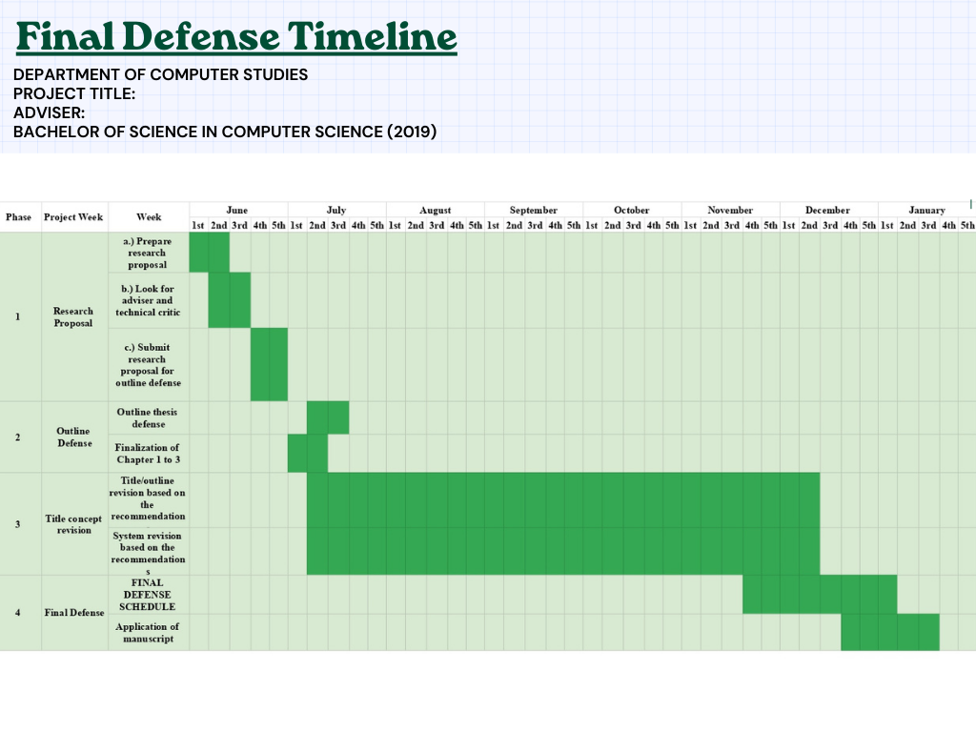

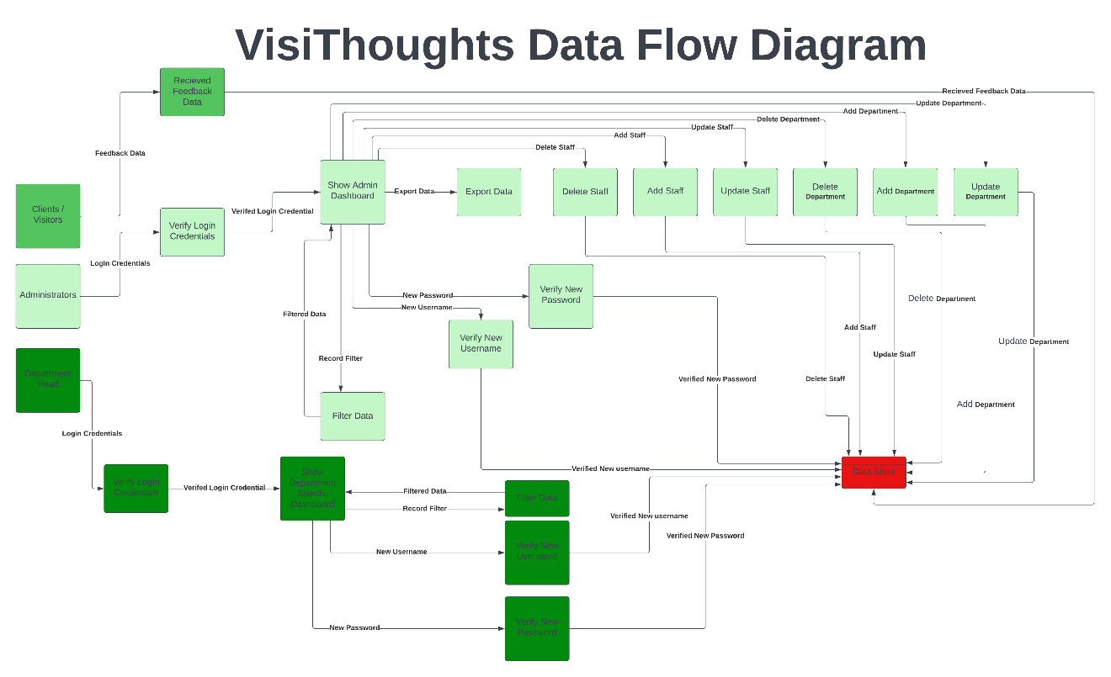GanttChart

Data Flow Diagram

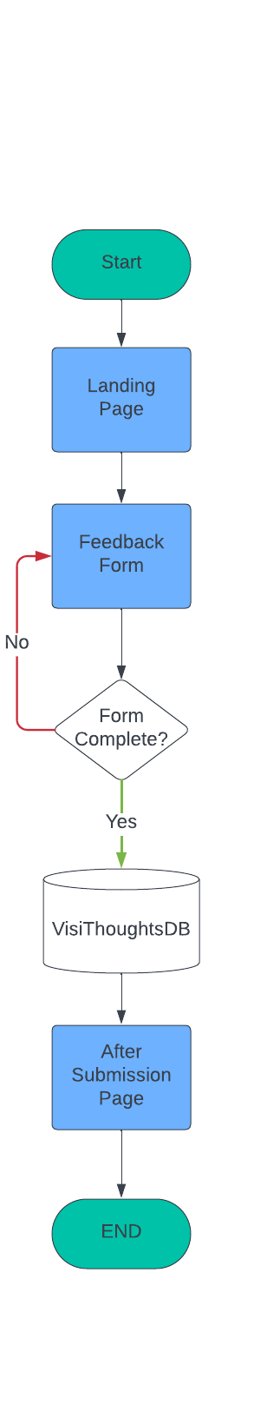

Flow Chart for End-Users

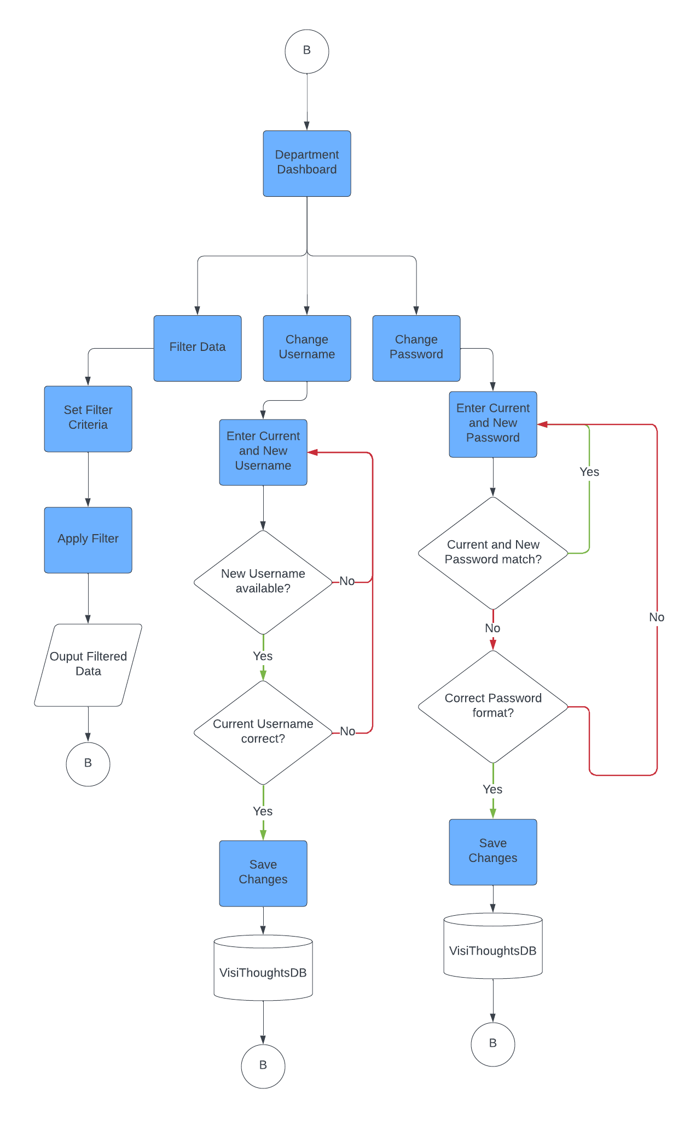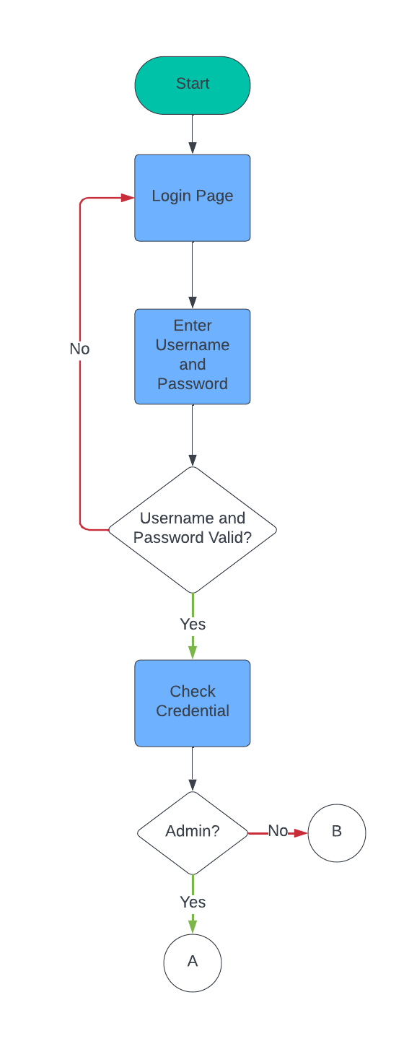

Flow Chart for Administrator and Department Head

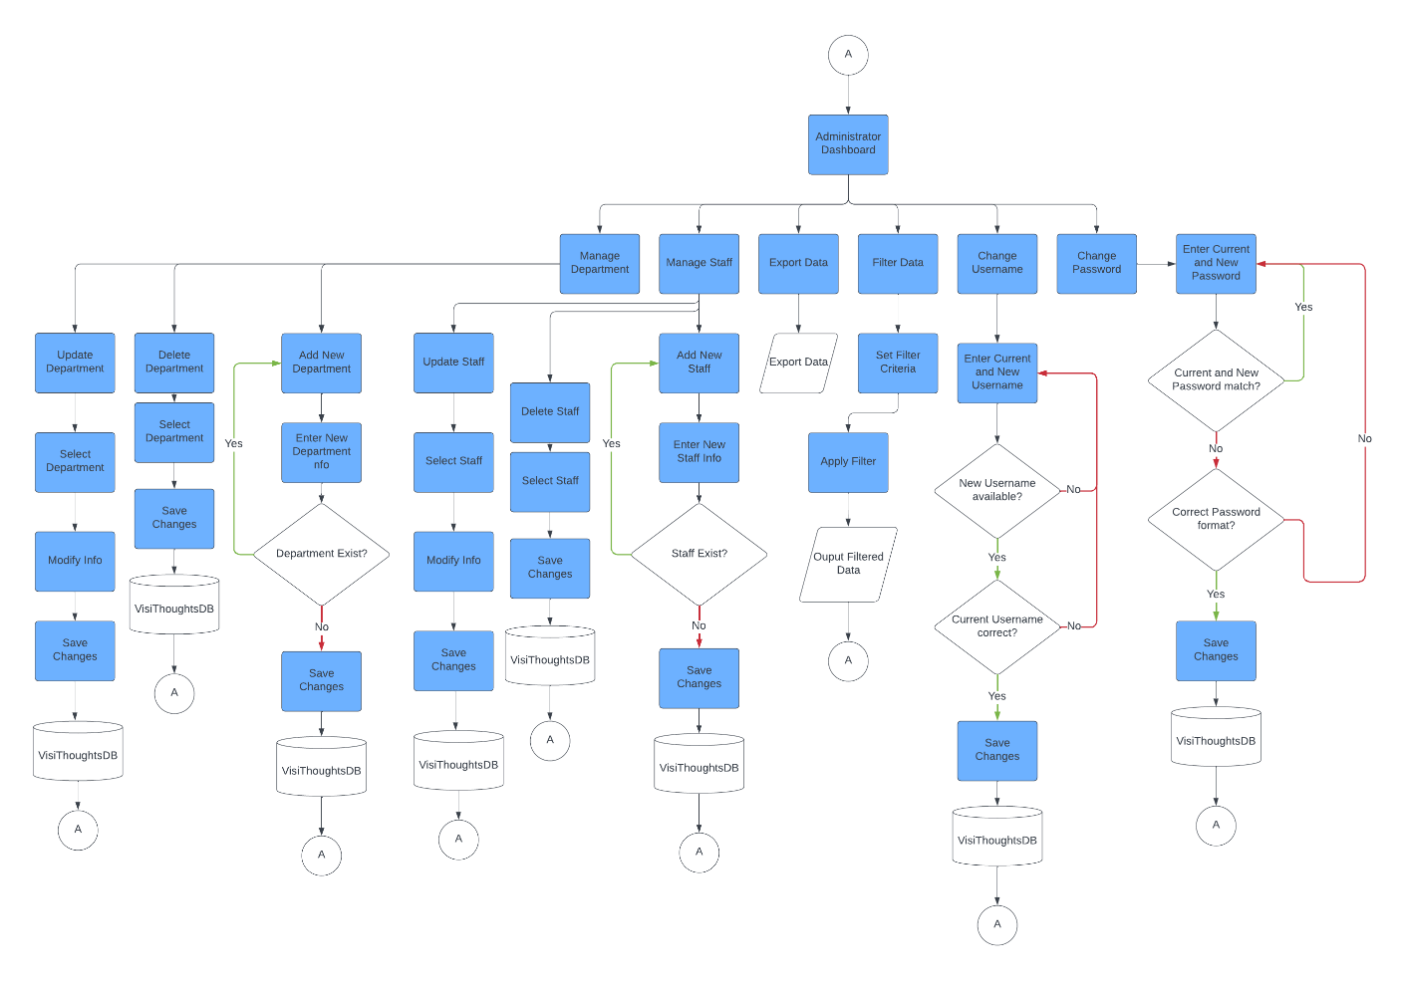

Flow Chart for Administrator and Department Head

**APPENDIX G**

**EVALUATION OF DEVELOPERS**

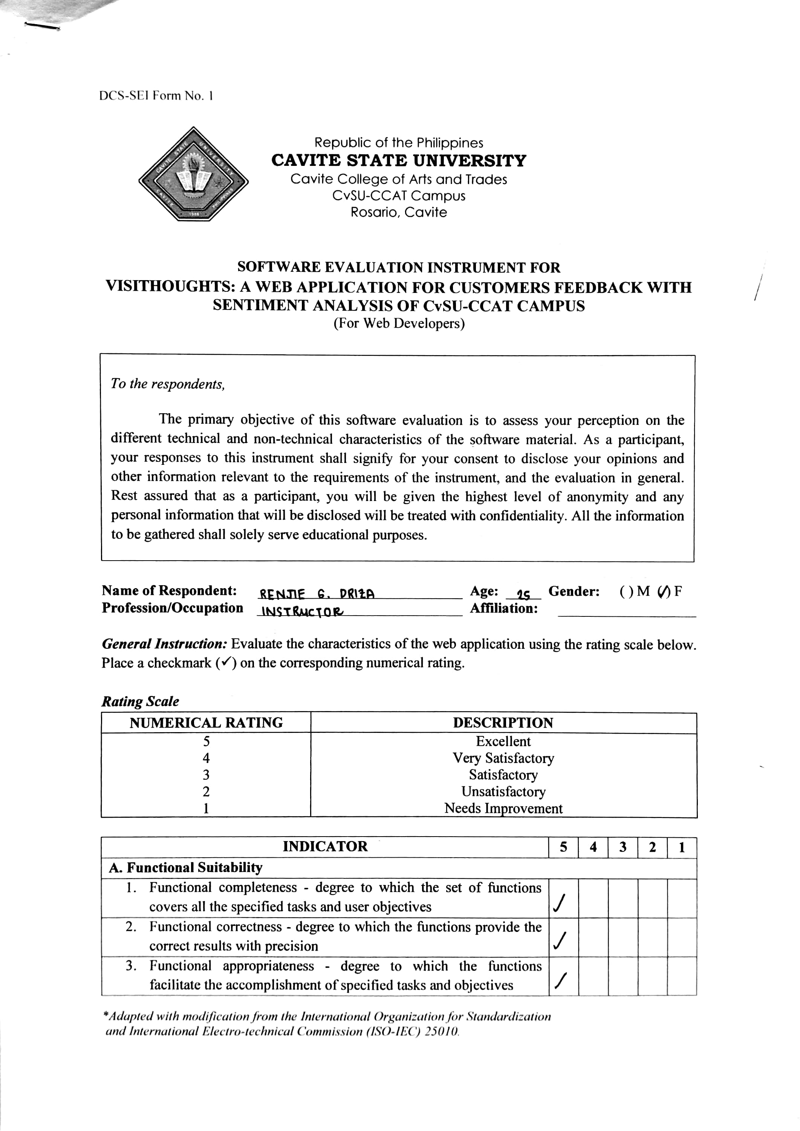

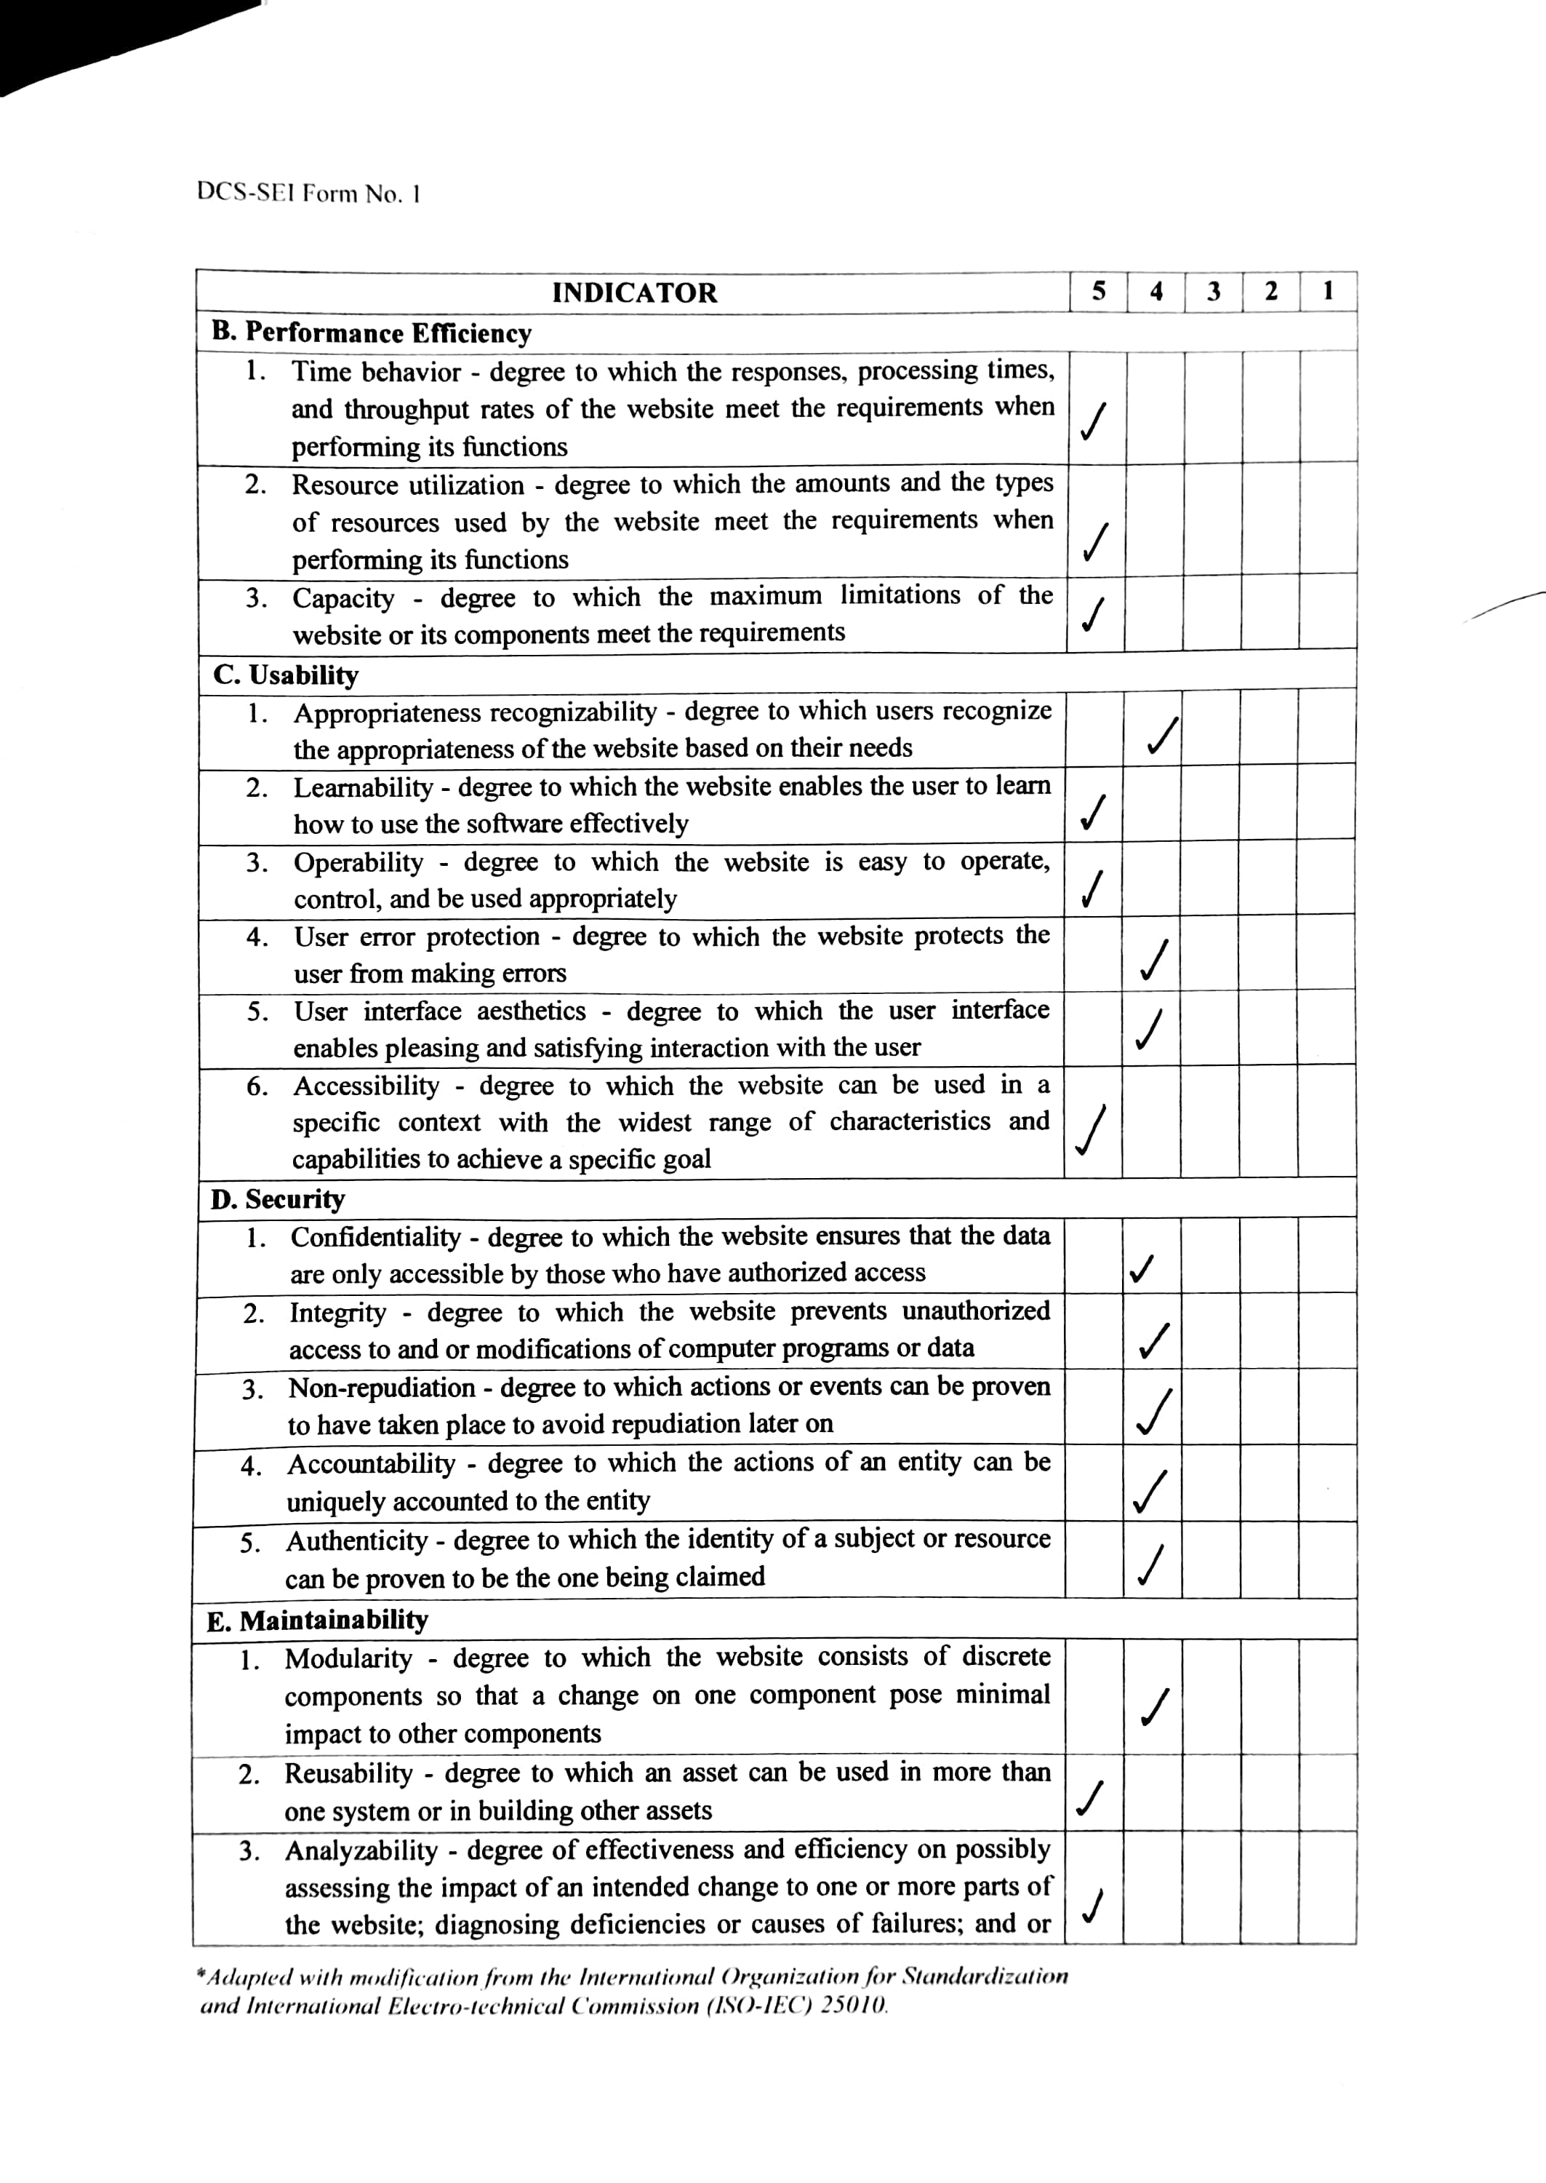

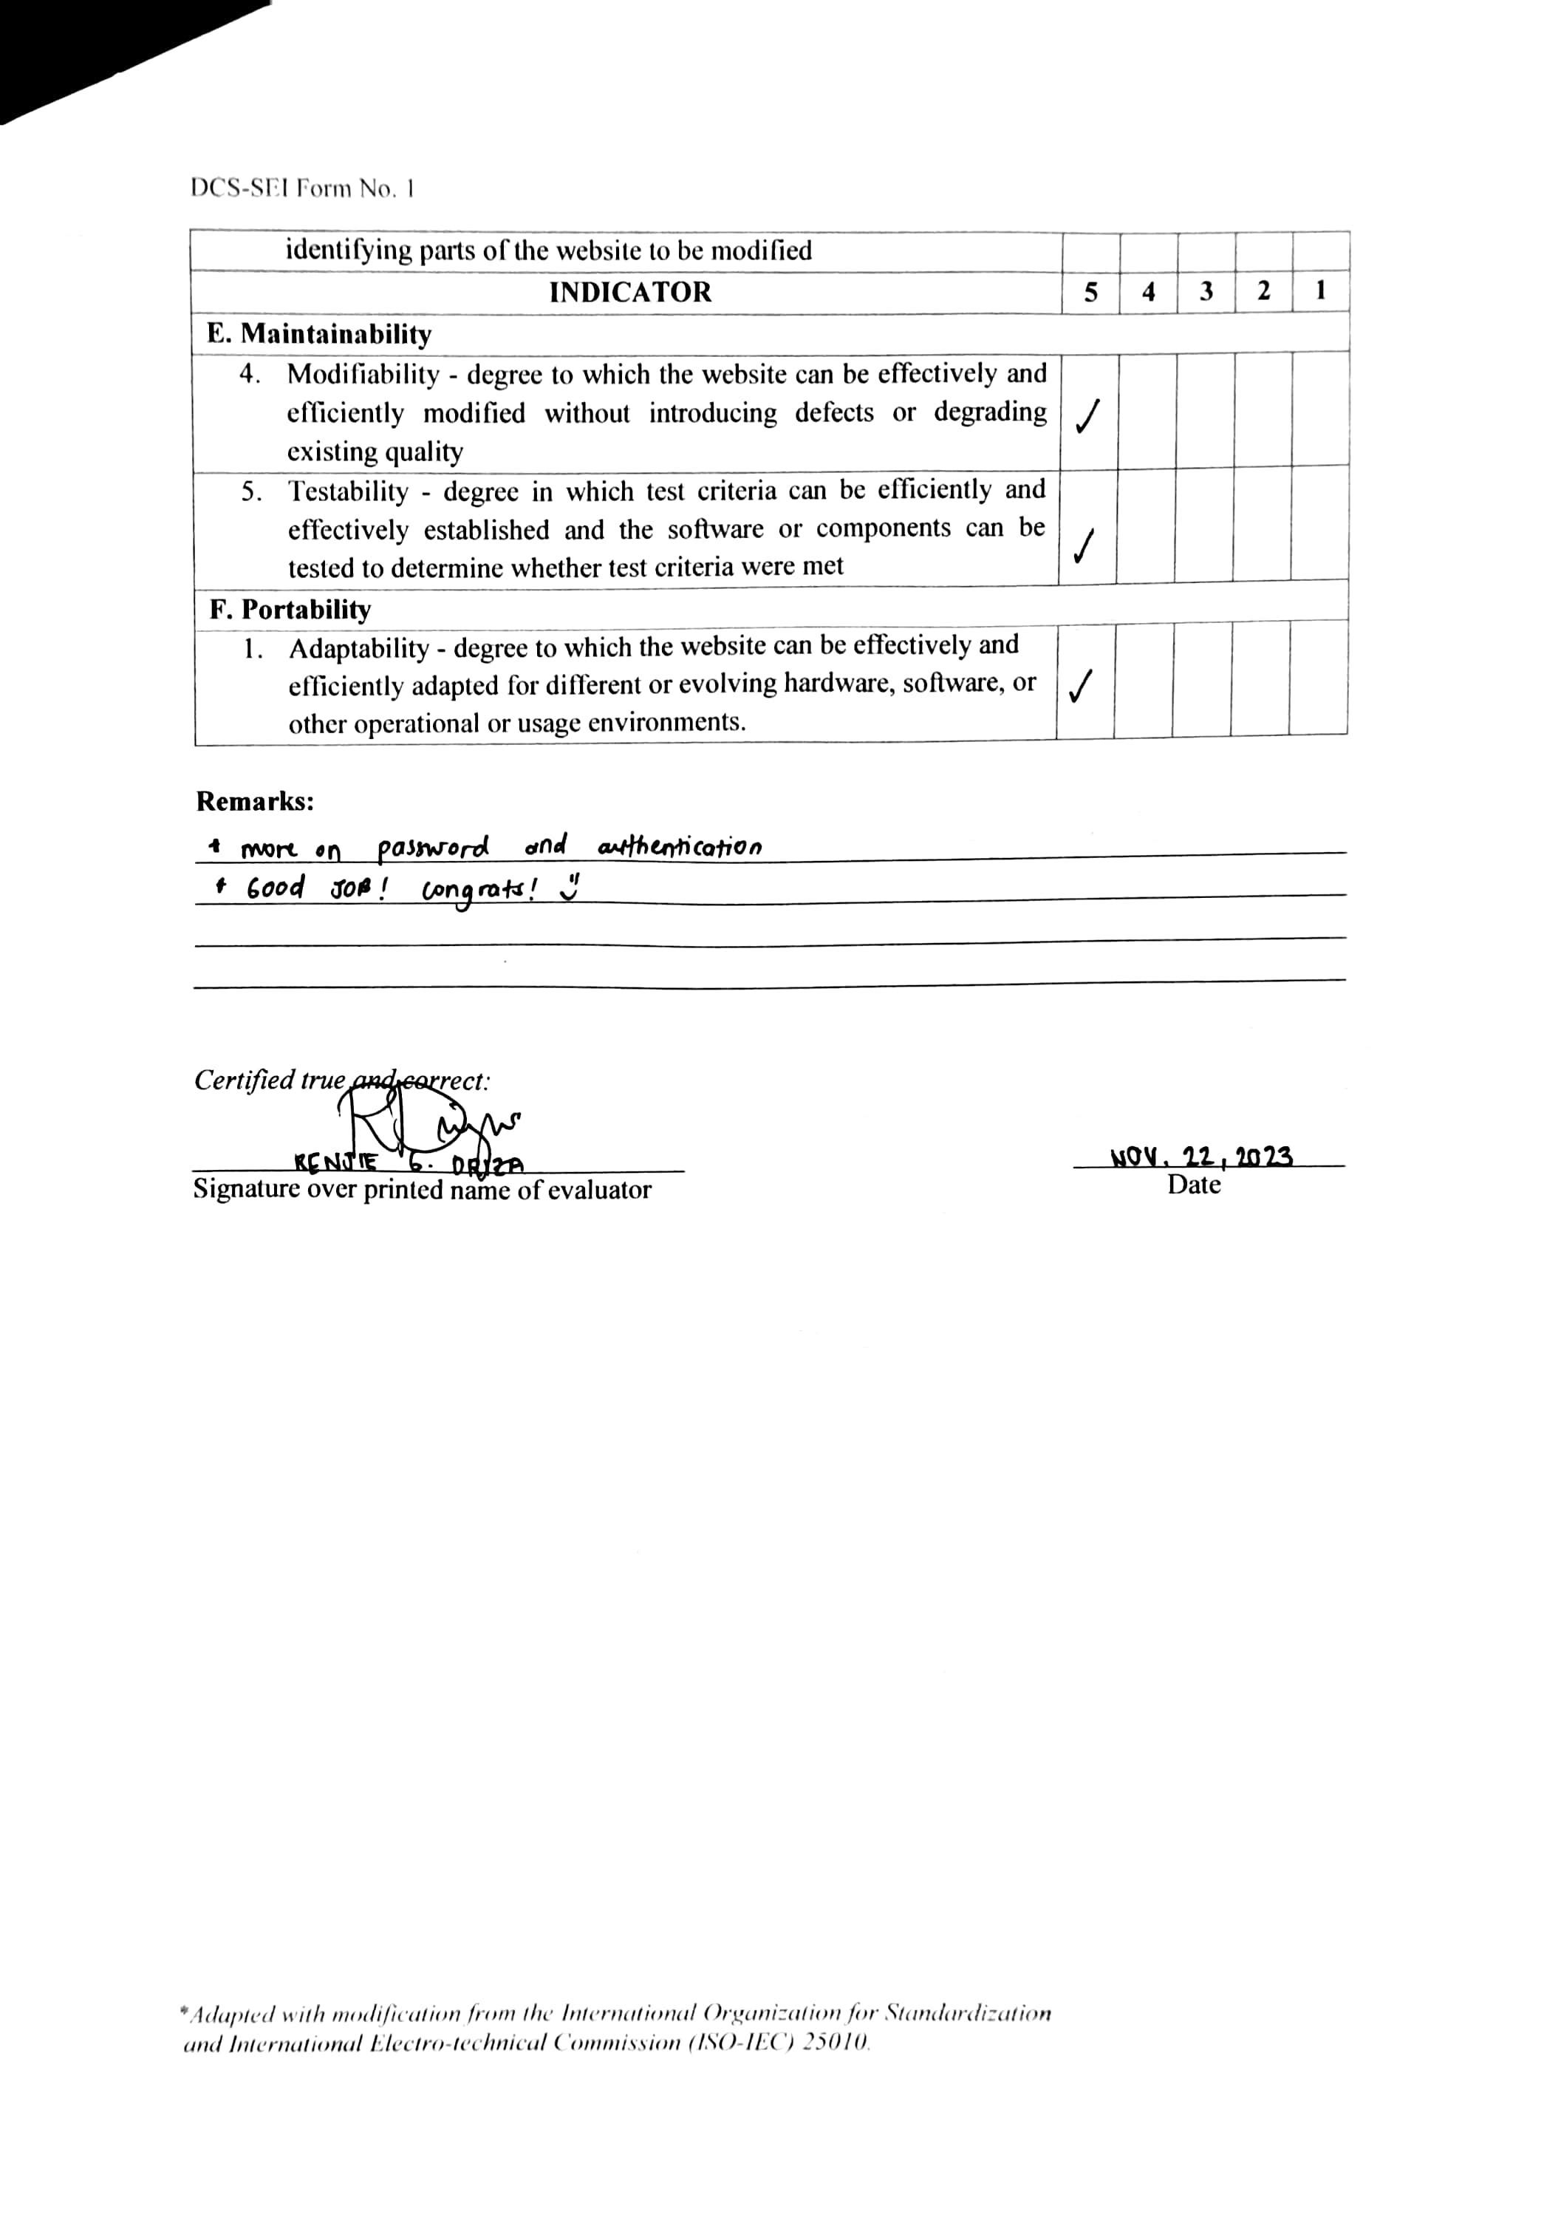

**APPENDIX H**

**SAMPLE EVALUTION OF DEVELOPERS**



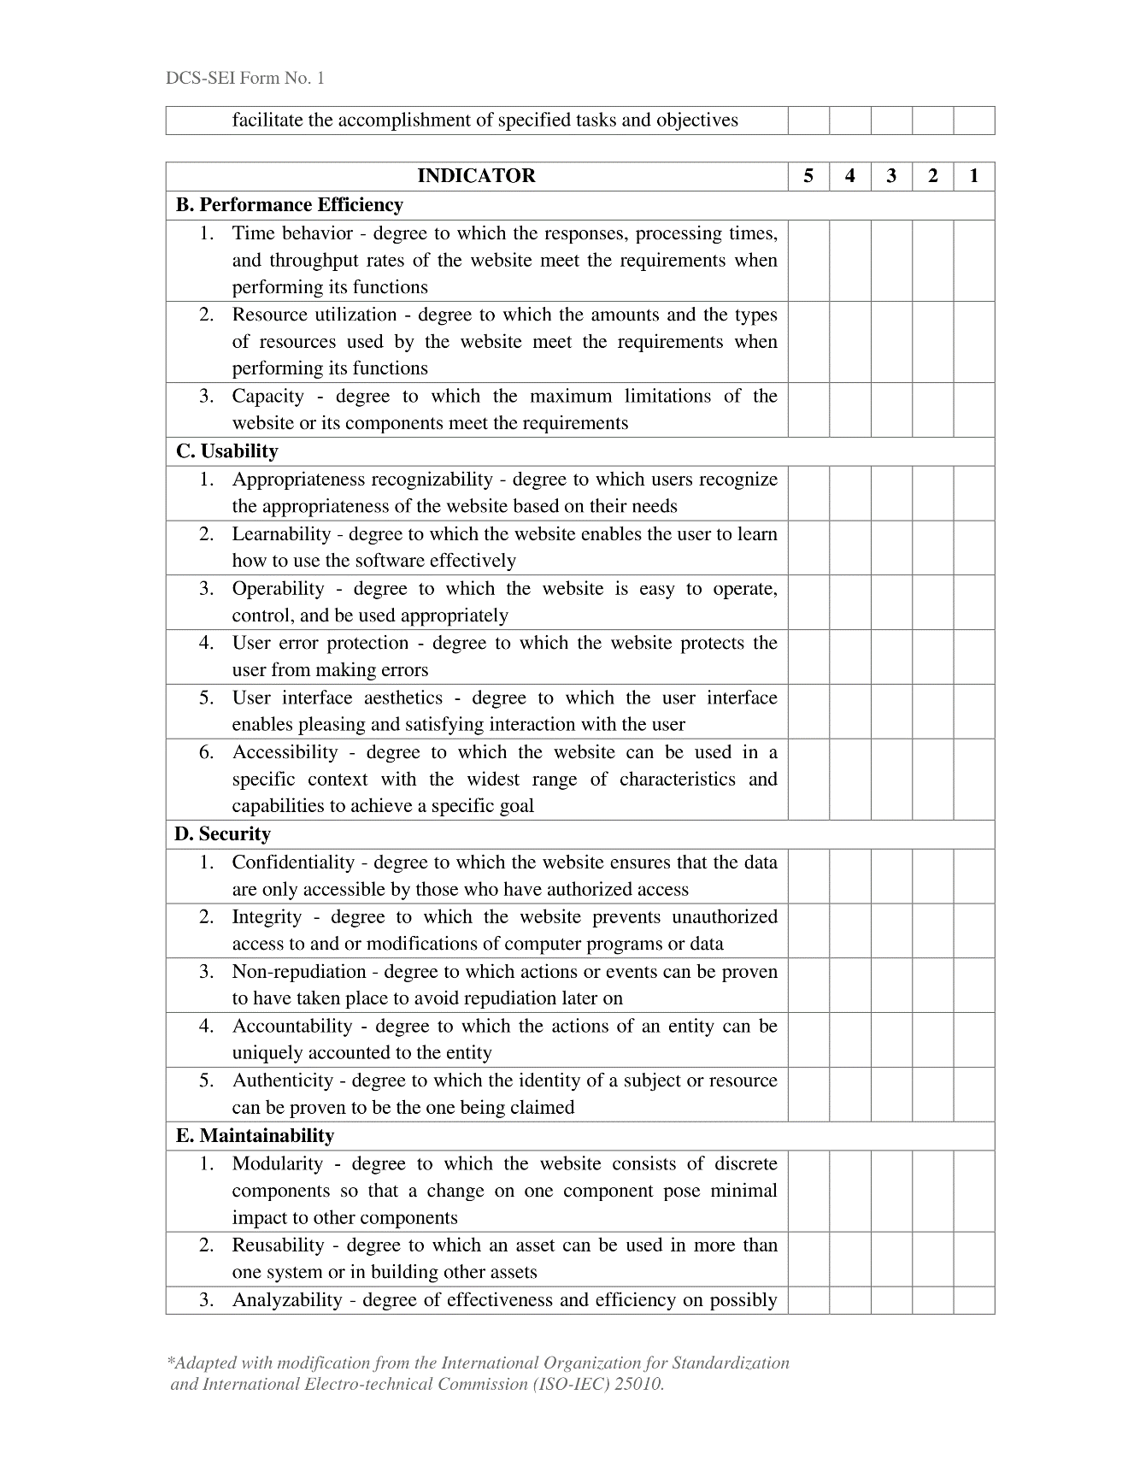



**APPENDIX I**

**EVALUATION FOR END USERS**

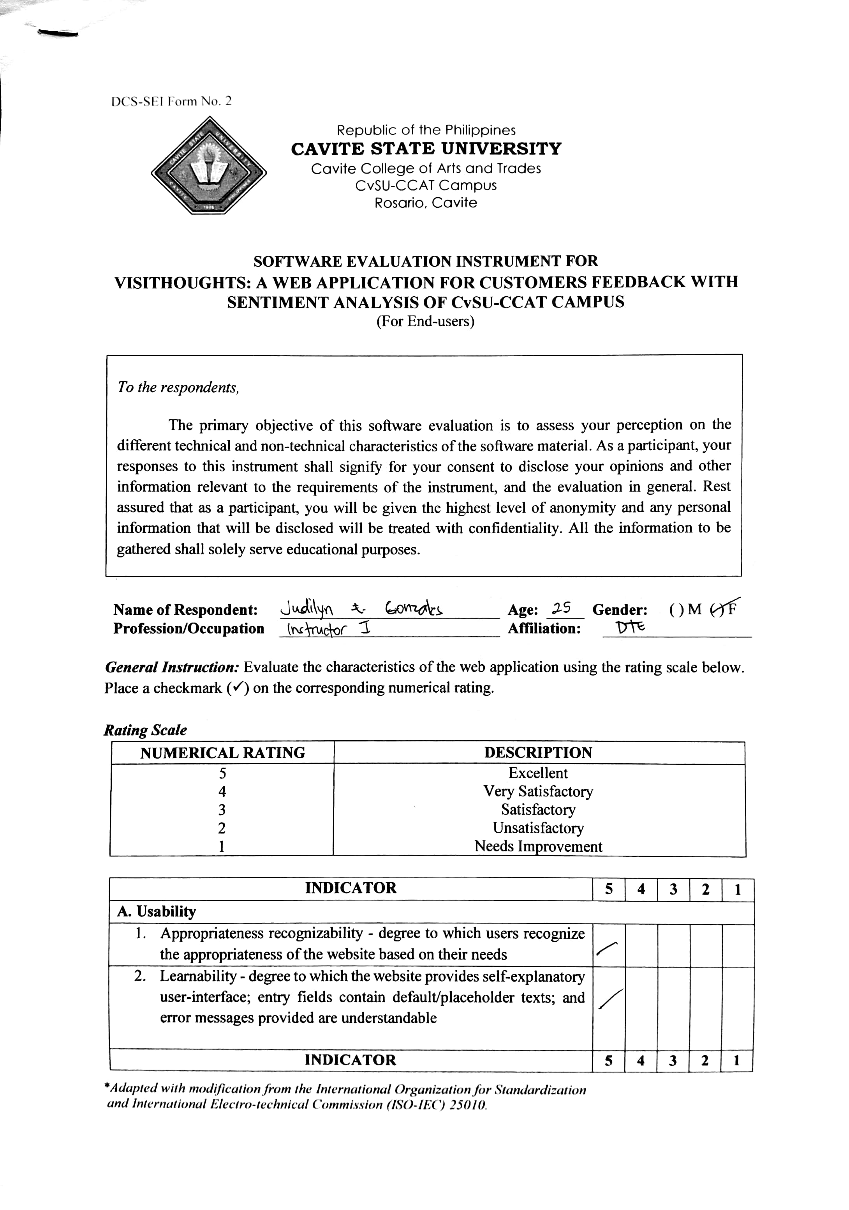

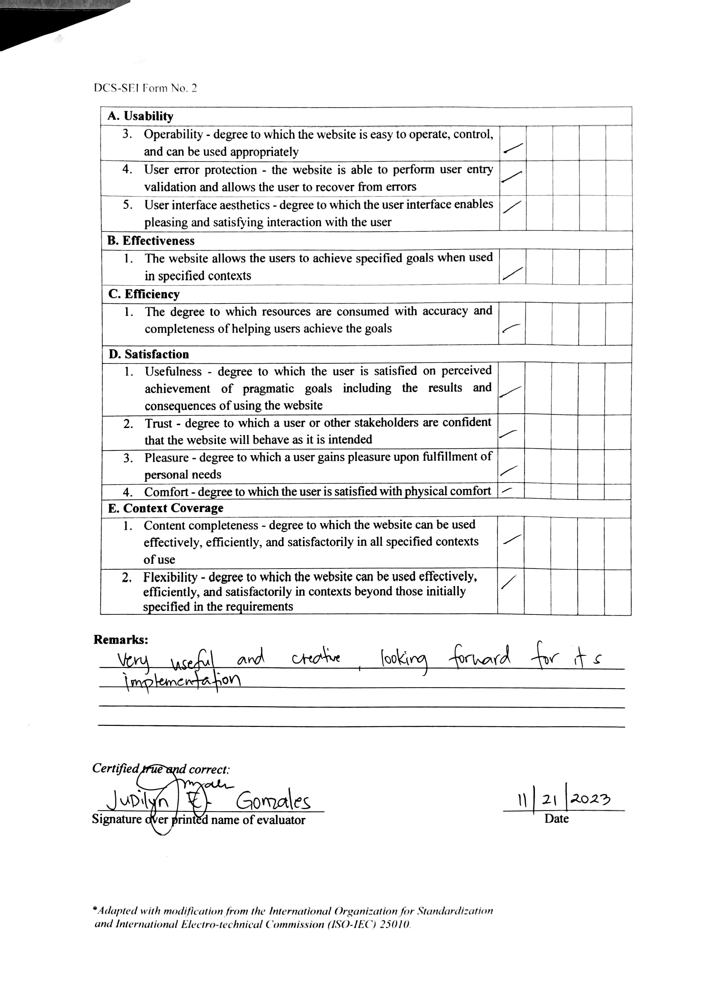

**APPENDIX J**

**SAMPPLE EVALUATION FOR END USERS**



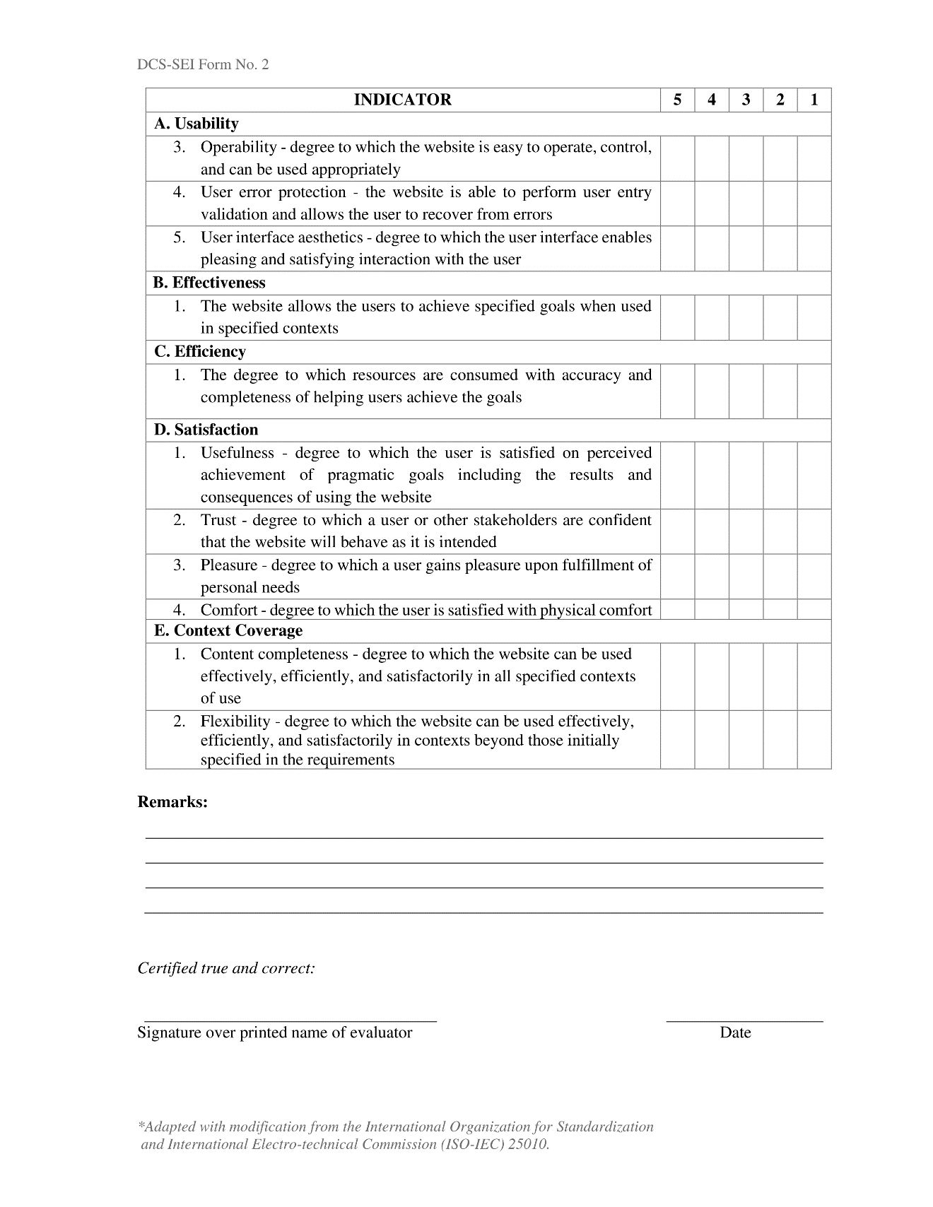

**APPENDIX K**

**USER’S MANUAL**

Welcome to the discussion on the step-by-step procedure on how you can set up the VISITHOUGHTS: A Web Application for Customers feedback with Sentiment Analysis of CvSU-CCAT Campus.

For Administration

Step 1: Open the Link for the Admin page provided by the system.

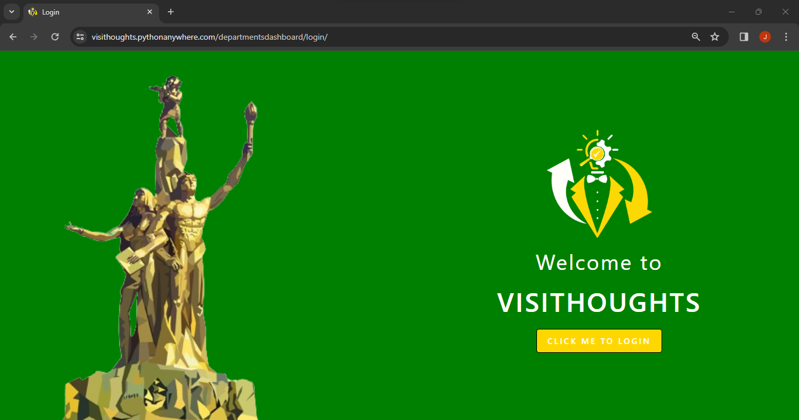

Landing page for Admin

Step 2: Input the predefined account given by the super admin.

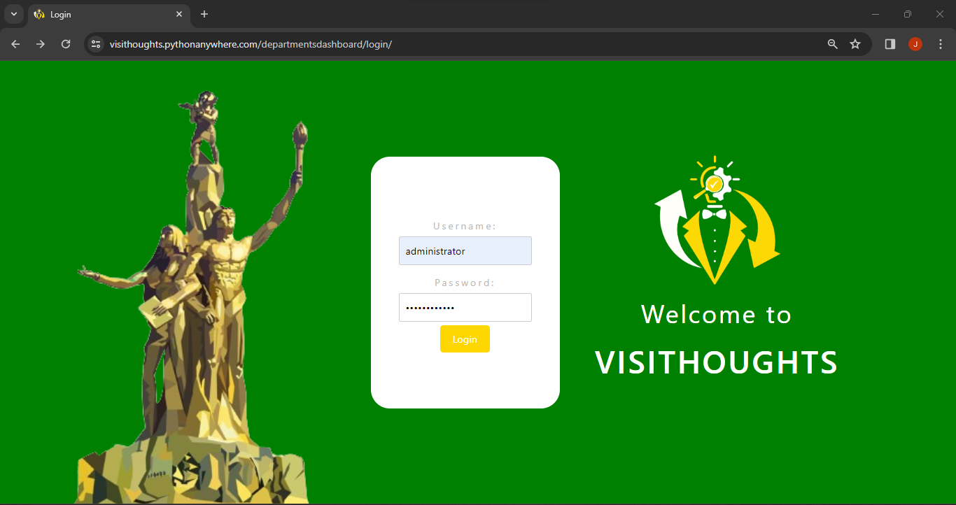

Login page

Step 3: After logging in, it will direct to admin dashboard page.

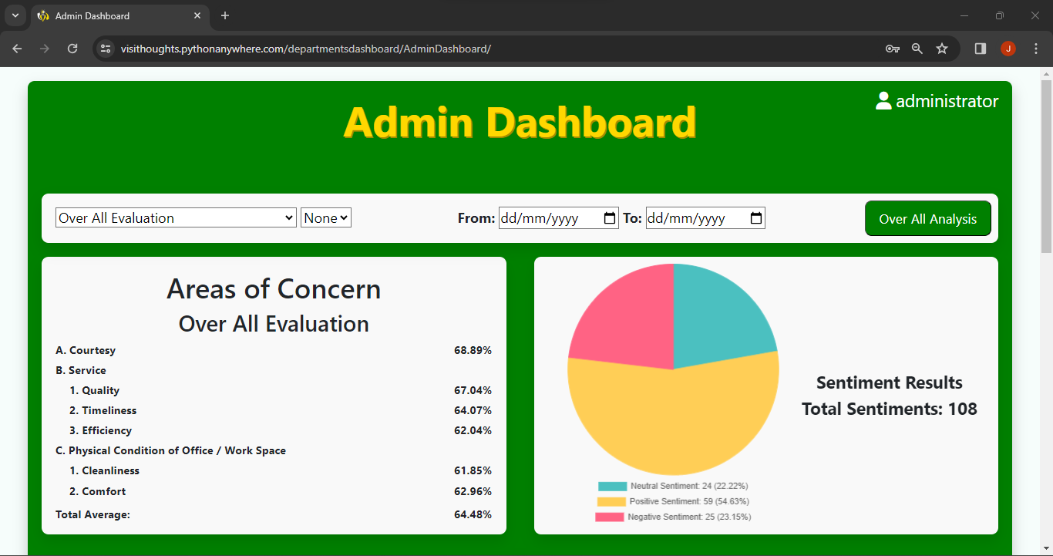

Admin dashboard page

Step 4: Administrator can choose the data that they want to filter.

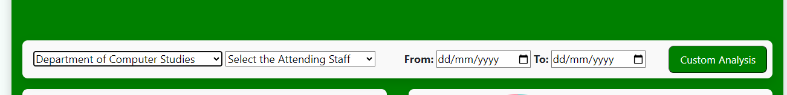

Admin dashboard filtering data

Step 5: Administrator can search the data of the overall users feedbacks.

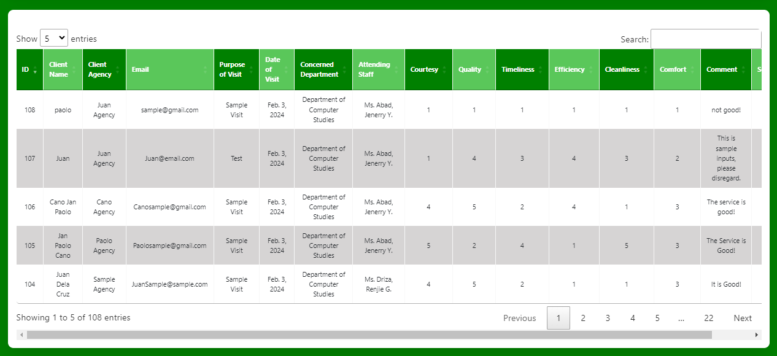

Admin Dash Board tables of user’s information and feedbacks

Step 6: Administrator can change the username and password.

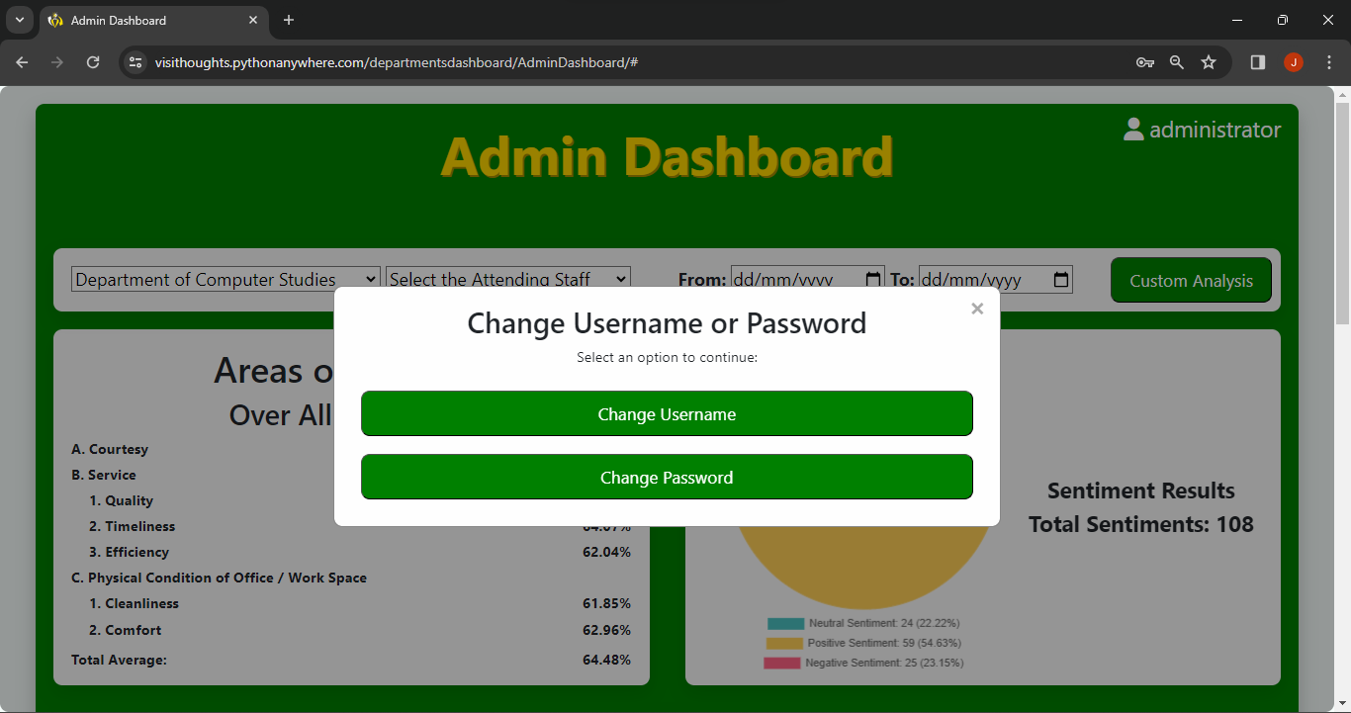

Change username and password prompt

Step 7: Administrator can export the existing statistical result.

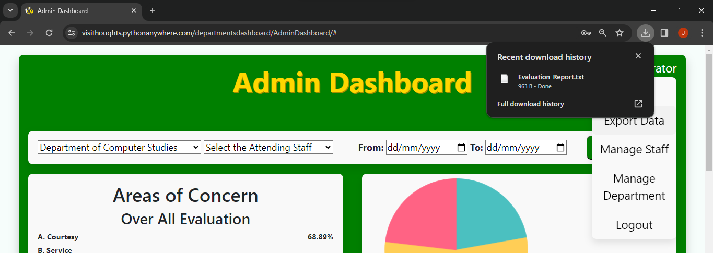

Administrator Exporting data

Step 8: Administrator can manage staff members in terms of changes.

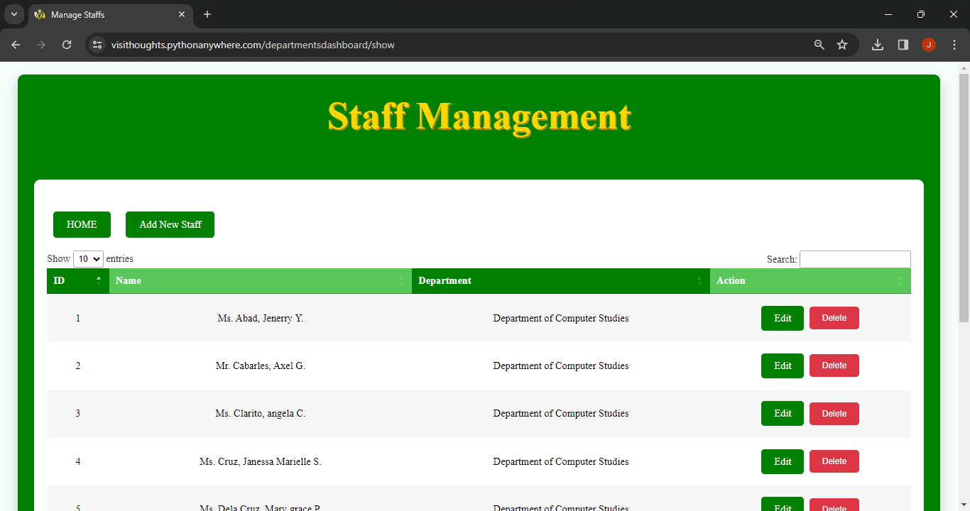

Administrator edit, delete, add staff details

Step 9: Administrator can manage Department and Offices in terms of changes.

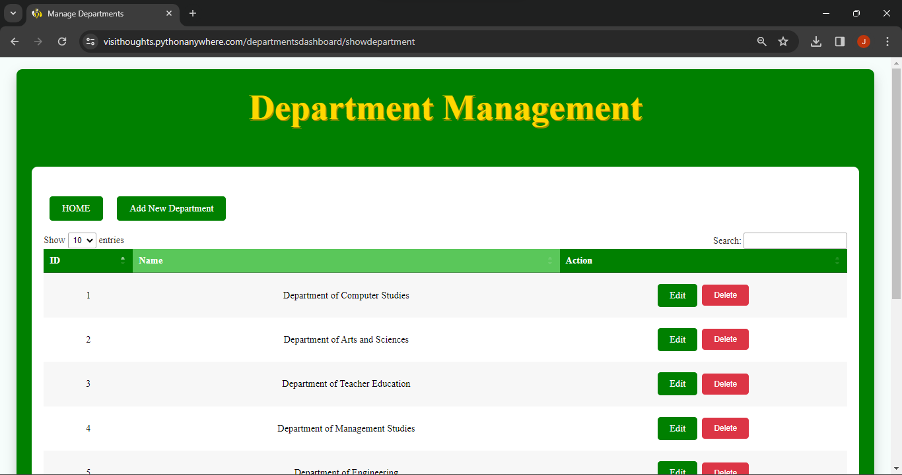

Administrator edit, delete, add Department and Offices details

For Department Head

Step 1: Open the Link for the Department Head page provided by the system.

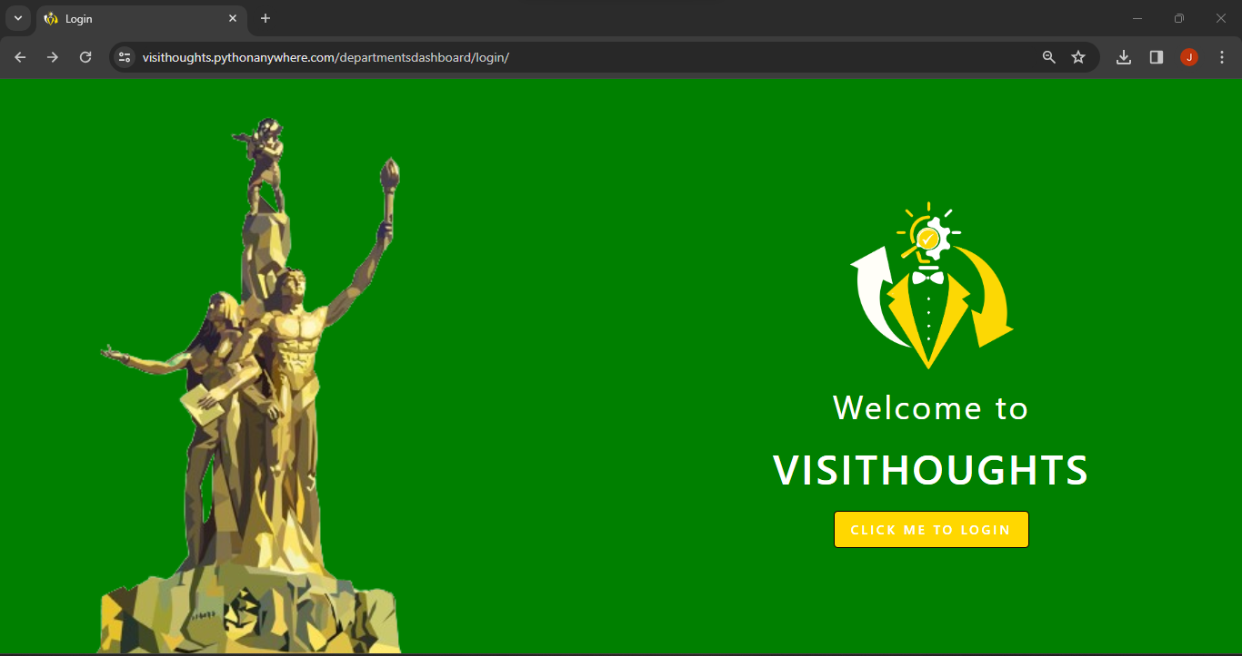

Landing page for Department Head

Step 2: Input the predefined account given by the super admin.

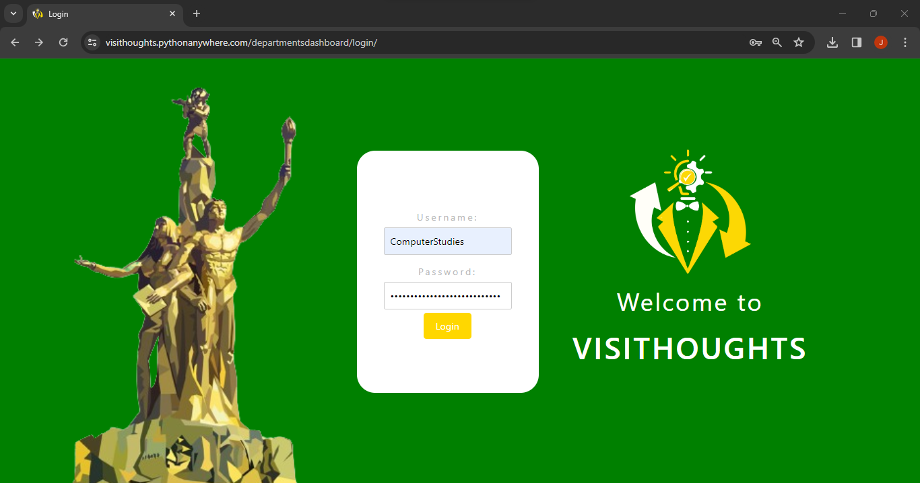

Login page

Step 3: After logging in, it will direct to Department Head dashboard page.

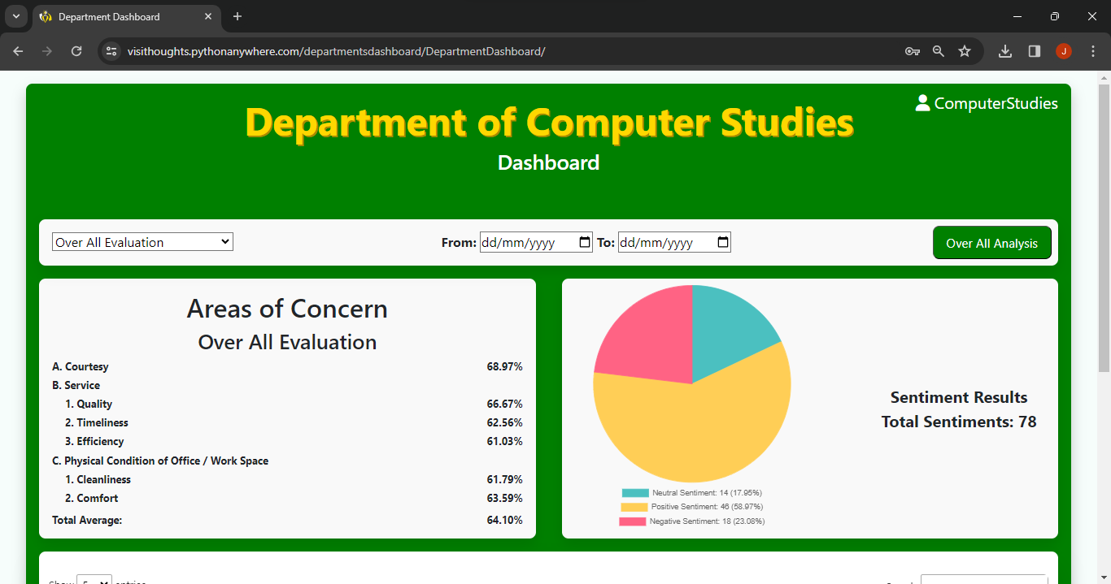

Department Head dashboard page

Step 4: Department Head can choose the data that they want to filter.

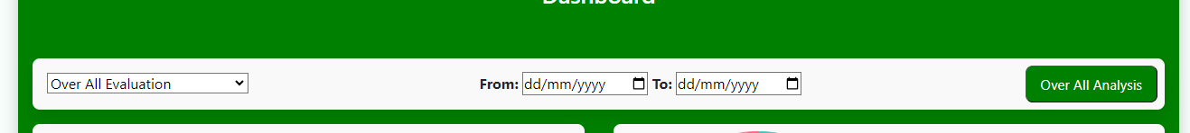

Department Head dashboard filtering data

Step 5: Department Head can search the data of the overall users feedbacks.

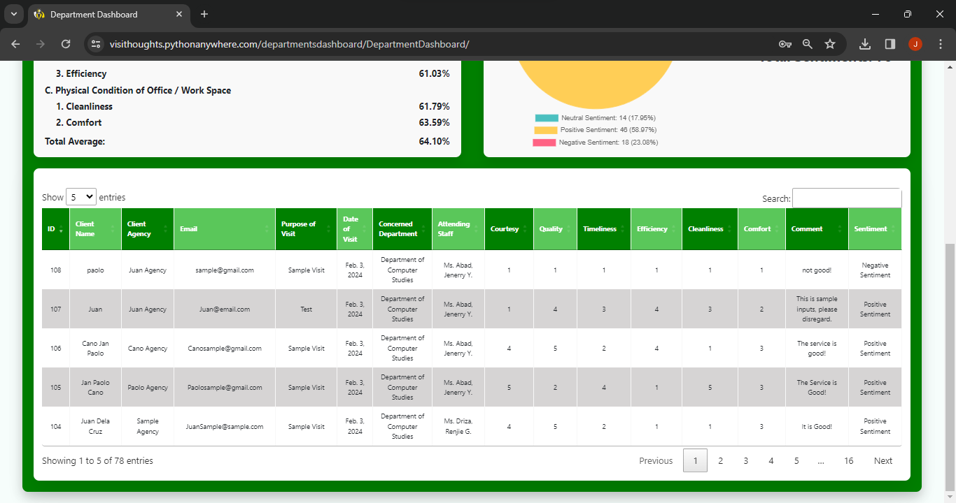

Department Head Dash Board tables of user’s information and feedbacks

Step 6: Department Head can change the username and password.

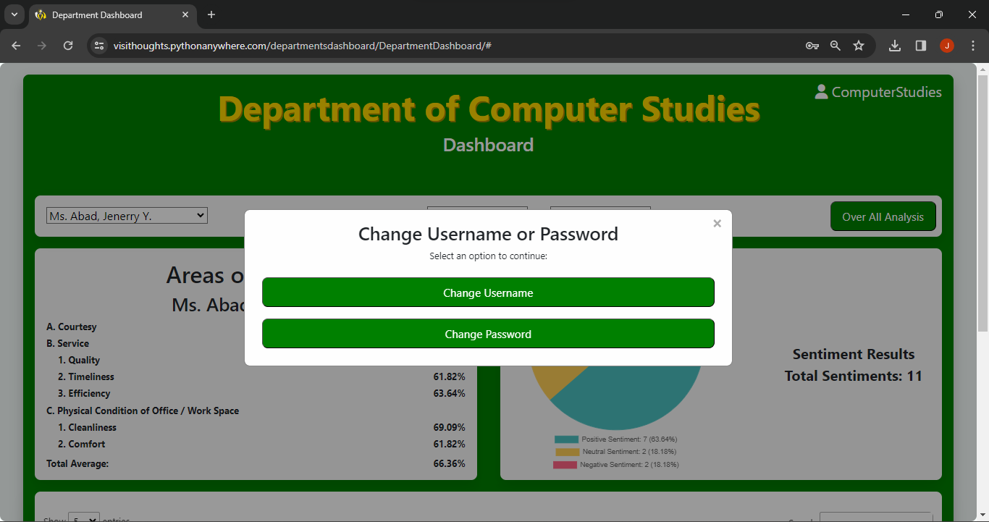

Change username and password prompt

For User

Step 1: Open the Link for the Admin page provided by the system.

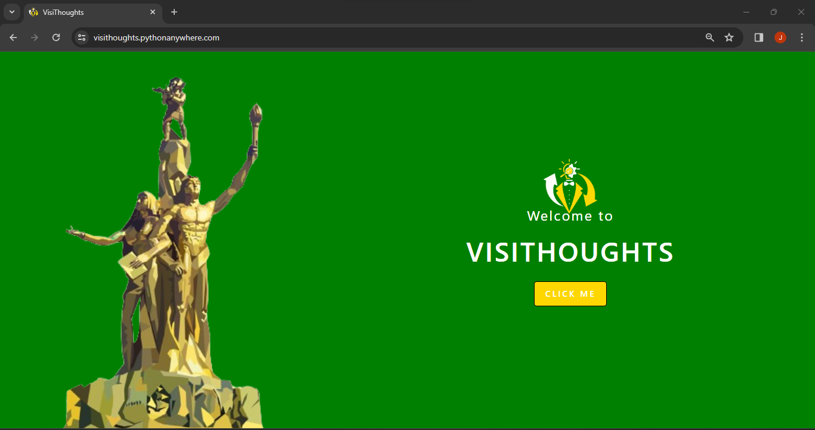

User Form Landing Page

Step 2: Users are required to check the check box before proceeding to Form.

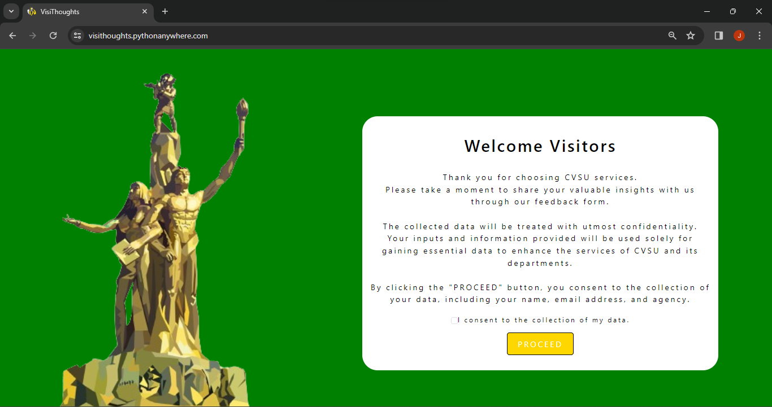

User’s Form Terms and Conditions

Step 3: Users are required to fill in the information from the form.

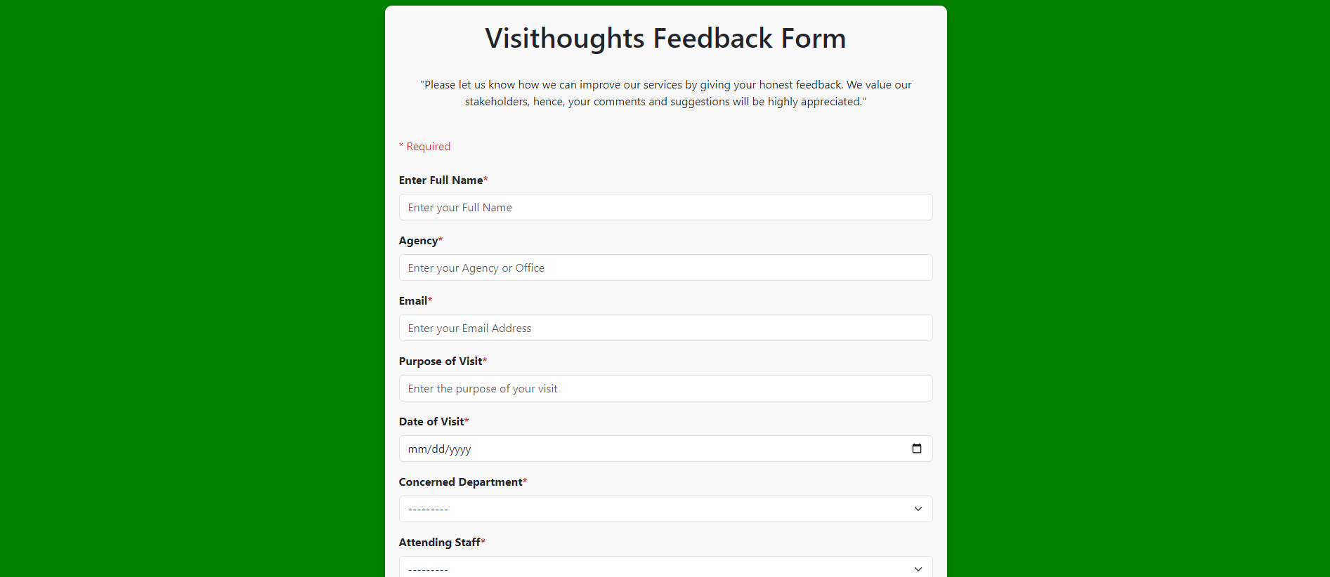

Users Form

Step 4: Users are required to slide the corresponding rates from the form.

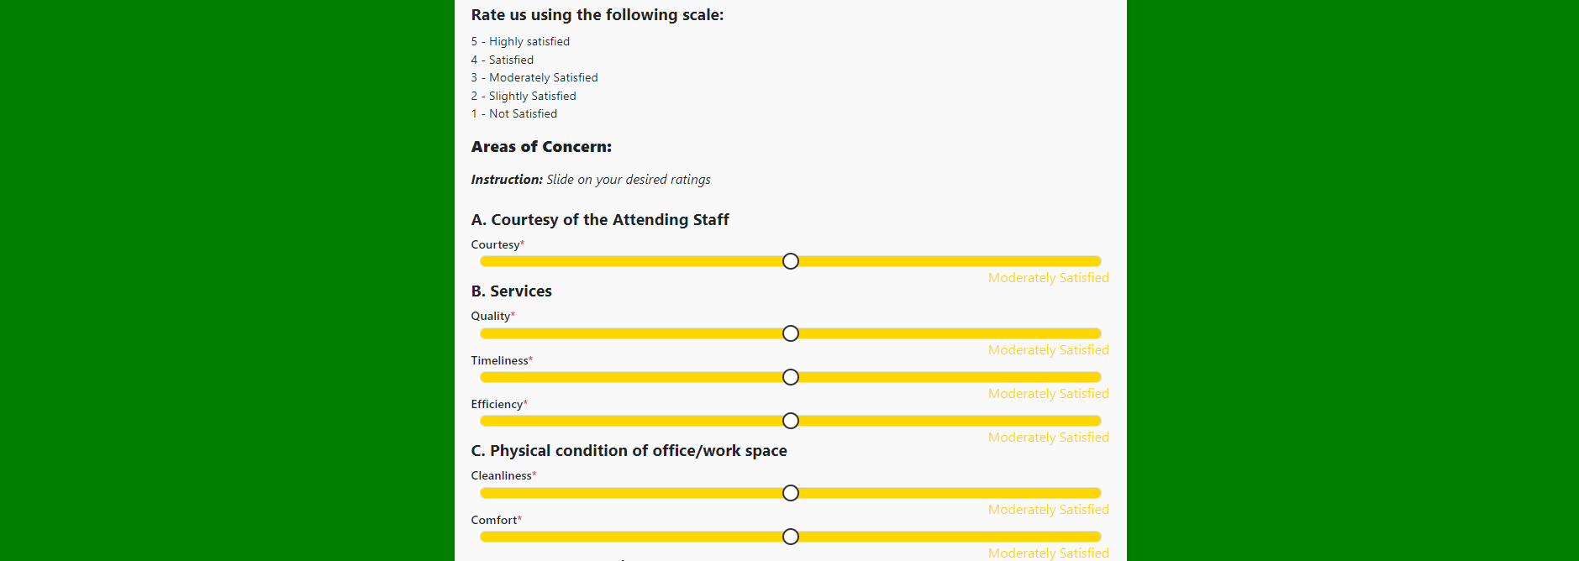

Users Form Slider

Step 5: Users are required to write down their thoughts or feedbacks from the form.



Users Form Comments/Suggestions

**APPENDIX L**

**CURRICULUM VITAE**





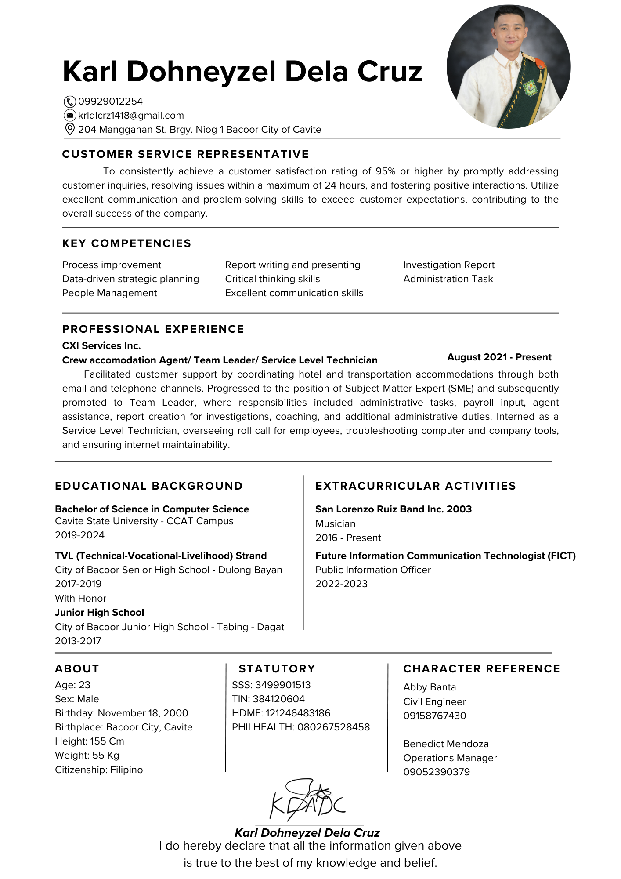

**APPENDIX M**

**SOURCE CODE**

**CLIENT SIDE**

**LANDING PAGE**

{% load static %}

<!DOCTYPE html>

<html>

<head>

<meta charset="utf-8">

<meta name="viewport" content="width=device-width, initial-scale=1">

<title>VisiThoughts</title>

<link href="https://cdn.jsdelivr.net/npm/bootstrap@5.3.2/dist/css/bootstrap.min.css" rel="stylesheet" integrity="sha384-T3c6CoIi6uLrA9TneNEoa7RxnatzjcDSCmG1MXxSR1GAsXEV/Dwwykc2MPK8M2HN" crossorigin="anonymous">

<script src="https://cdn.jsdelivr.net/npm/bootstrap@5.3.2/dist/js/bootstrap.bundle.min.js" integrity="sha384-C6RzsynM9kWDrMNeT87bh95OGNyZPhcTNXj1NW7RuBCsyN/o0jlpcV8Qyq46cDfL" crossorigin="anonymous"></script>

<link rel="stylesheet" href="{% static 'CSS/landing.css' %}">

<!-- favicon <dev elgene -->

<link rel="icon" href="{% static 'elgene.png' %}" type="image/x-icon">

<link rel="shortcut icon" href="{% static 'favicon.ico' %}" type="image/x-icon">

</head>

<body>

<img src="{% static 'layadiwa.png' %}" alt="Background Image" class="background-image">

<img src="{% static 'elgene.png' %}" alt="Logo" class="logo">

<div class="wrapper">

<span class="button-text">

<p>Welcome to</p>

<h1>VisiThoughts</h1>

</span>

<div class="button" onclick="document.body.classList.add('active')">

<span class="button-style2">

<p>Click Me</p>

</span>

<!-- <div class="button-backgrounds">

<div class="button-circle button-circle1"></div>

<div class="button-circle button-circle2"></div>

<div class="button-circle button-circle3"></div>

<div class="button-circle button-circle4"></div>

</div> -->

</div>

</div>

<div class="wrapper">

<div class="popup">

<div class="popup-inside">

<div class="backgrounds">

<div class="background"></div>

<div class="background background2"></div>

<div class="background background3"></div>

<div class="background background4"></div>

<div class="background background5"></div>

<div class="background background6"></div>

</div>

</div>

<div class="content">

<div class="content-wrapper">

<h2>Welcome Visitors</h2>

<p class="second-part-paragraph">

<br>Thank you for choosing CVSU services.

<br>Please take a moment to share your valuable insights with us through our feedback form.

<br>

<br>The collected data will be treated with utmost confidentiality.

<br>Your inputs and information provided will be used solely for gaining essential data to enhance the services of CVSU and its departments.

<br>

<br>By clicking the "PROCEED" button, you consent to the collection of your data, including your name, email address, and agency.

</p>

<!-- Checkbox added here -->

<div class="form-check d-flex justify-content-center align-items-center" style="font-size: smaller; margin-bottom: 25px;">

<input class="form-check-input" type="checkbox" id="consentCheckbox" required>

<label class="form-check-label" for="consentCheckbox">

I consent to the collection of my data.

</label>

</div>

<a href="{% url 'add' %}" id="proceedButton" class="button-style" disabled>PROCEED</a>

</div>

</div>

</div>

</div>

<script>

// Get the checkbox and "PROCEED" button

var checkbox = document.getElementById('consentCheckbox');

var proceedButton = document.getElementById('proceedButton');

// Add an event listener to the checkbox

checkbox.addEventListener('change', function () {

// Enable/disable the "PROCEED" button based on checkbox state

proceedButton.disabled = !checkbox.checked;

});

// Add an event listener to the "PROCEED" button to check if the checkbox is checked before proceeding

proceedButton.addEventListener('click', function (event) {

if (!checkbox.checked) {

event.preventDefault(); // Prevent the default click action if the checkbox is not checked

alert('Please consent to the collection of your data before proceeding.');

}

});

</script>

</body>

</html>  
  
**FORM**  
{% load static %}

<!doctype html>

<html lang="en">

<head>

<meta charset="UTF-8">

<meta name="viewport" content="width=device-width, user-scalable=no, initial-scale=1.0, maximum-scale=1.0, minimum-scale=1.0">

<meta http-equiv="X-UA-Compatible" content="ie=edge">

<link href="https://cdn.jsdelivr.net/npm/bootstrap@5.3.2/dist/css/bootstrap.min.css" rel="stylesheet" integrity="sha384-T3c6CoIi6uLrA9TneNEoa7RxnatzjcDSCmG1MXxSR1GAsXEV/Dwwykc2MPK8M2HN" crossorigin="anonymous">

<script src="https://cdn.jsdelivr.net/npm/bootstrap@5.3.2/dist/js/bootstrap.bundle.min.js" integrity="sha384-C6RzsynM9kWDrMNeT87bh95OGNyZPhcTNXj1NW7RuBCsyN/o0jlpcV8Qyq46cDfL" crossorigin="anonymous"></script>

<link rel="stylesheet" href="{% static 'CSS/Form_style.css' %}">

<script src="https://cdnjs.cloudflare.com/ajax/libs/jquery/3.6.0/jquery.min.js"></script>

<title>Visithoughts Feedback Form</title>

<!-- favicon <dev elgene -->

<link rel="icon" href="{% static 'elgene.png' %}" type="image/x-icon">

<link rel="shortcut icon" href="{% static 'favicon.ico' %}" type="image/x-icon">

</head>

<body>

<div class="container mt-4">

<form method="post" id="FeedbackForm" data-staffs-url="{% url 'ajax_load_staffs' %}" class="form-horizontal" role="form">

{% csrf_token %}

<center>

<h1>Visithoughts Feedback Form</h1>

<br>

<p>

<italic>

"Please let us know how we can improve our services by giving your honest feedback. We value our stakeholders, hence,

your comments and suggestions will be highly appreciated."

</italic>

</p>

</center>

<br>

<span class="text-danger">* Required</span>

<br>

<br>

<div class="mb-3">

<label for="fullName" class="form-label">Enter Full Name<span class="text-danger">*</span></label>

{{ form.name }}

</div>

<div class="mb-3">

<label for="agency" class="form-label">Agency<span class="text-danger">*</span></label>

{{ form.agency }}

</div>

<div class="mb-3">

<label for="email" class="form-label">Email<span class="text-danger">*</span></label>

{{ form.email }}

</div>

<div class="mb-3">

<label for="purposeOfVisit" class="form-label">Purpose of Visit<span class="text-danger">*</span></label>

{{ form.purposeOfVisit }}

</div>

<div class="mb-3">

<label for="dateOfVisit" class="form-label">Date of Visit<span class="text-danger">*</span></label>

{{ form.dateOfVisit }}

</div>

<div class="mb-3">

<label for="concernedDepartment" class="form-label">Concerned Department<span class="text-danger">*</span></label>

{{ form.department }}

</div>

<div class="mb-3">

<label for="attendingStaff" class="form-label">Attending Staff<span class="text-danger">*</span></label>

{{ form.staff }}

</div>

<div class="mb-3">

<h1 class="subtext">Rate us using the following scale:</h1>

<p class="paragraph">

5 - Highly satisfied<br>

4 - Satisfied<br>

3 - Moderately Satisfied<br>

2 - Slightly Satisfied<br>

1 - Not Satisfied

</p>

</div>

<div class="mb-3">

<h1 class="subtext1"><strong>Areas of Concern:</strong></h1>

</div>

<div>

<i><b>Instruction:</b> Slide on your desired ratings<br><br></i>

</div>

<div class="mb-3">

<h2 class="subtext1">A. Courtesy of the Attending Staff</h2>

<h2 class="rating-text">Courtesy<span class="text-danger">*</span></h2>

<div class="rating">

{{ form.courtesy }}

</div>

<div class="satisfactionText" style="float: right;"></div>

</div>

<div class="mb-3">

<h2 class="subtext1">B. Services</h2>

<h2 class="rating-text">Quality<span class="text-danger">*</span></h2>

<div class="rating">

{{ form.quality }}

</div>

<div class="satisfactionText2" style="float: right;"></div>

</div>

<div class="mb-3">

<h2 class="rating-text">Timeliness<span class="text-danger">*</span></h2>

<div class="rating">

{{ form.timeless }}

</div>

<div class="satisfactionText3" style="float: right;"></div>

</div>

<div class="mb-3">

<h2 class="rating-text">Efficiency<span class="text-danger">*</span></h2>

<div class="rating">

{{ form.efficiency }}

</div>

<div class="satisfactionText4" style="float: right;"></div>

</div>

<div class="mb-3">

<h2 class="subtext1">C. Physical condition of office/work space</h2>

<h2 class="rating-text">Cleanliness<span class="text-danger">*</span></h2>

<div class="rating">

{{ form.cleanliness }}

</div>

<div class="satisfactionText5" style="float: right;"></div>

</div>

<div class="mb-3">

<h2 class="rating-text">Comfort<span class="text-danger">*</span></h2>

<div class="rating">

{{ form.comfort }}

</div>

<div class="satisfactionText6" style="float: right;"></div>

</div>

<div class="mb-3">

<h2 class="subtext1">Comments/Suggestions<span class="text-danger">*</span></h2>

<div class="comment-box">

{{ form.comment }}

</div>

<p style="font-size: 13px; font-style: italic;">NOTE: Please use English only. Please Do not use metaphors.</p>

</div>

<div class="d-flex justify-content-center mt-4">

<input type="submit" class="btn-custom" value="Submit">

</div>

</form>

</div>

<script>

$("#id_department").change(function () {

const url = $("#FeedbackForm").attr("data-staffs-url"); // get the url of the `load_staffs` view

const departmentId = $(this).val(); // get the selected country ID from the HTML input

// <deve elgene>

$.ajax({ // initialize an AJAX request

url: url, // set the url of the request (= /feedback/ajax/load-staffs/ )

data: {

'department_id': departmentId // GET parameters

},

success: function (data) {

$("#id_staff").html(data);

}

});

});

$(document).ready(function() {

var rating1Slider = $('#Rating1');

var rating2Slider = $('#Rating2');

var rating3Slider = $('#Rating3');

var rating4Slider = $('#Rating4');

var rating5Slider = $('#Rating5');

var rating6Slider = $('#Rating6');

// Set the default colors and text on load

setDefaultSliderAppearance();

rating1Slider.on('input', function() {

updateSliderAppearance($(this));

});

rating2Slider.on('input', function() {

updateSliderAppearance($(this));

});

rating3Slider.on('input', function() {

updateSliderAppearance($(this));

});

rating4Slider.on('input', function() {

updateSliderAppearance($(this));

});

rating5Slider.on('input', function() {

updateSliderAppearance($(this));

});

rating6Slider.on('input', function() {

updateSliderAppearance($(this));

});

function setDefaultSliderAppearance() {

// Call updateSliderAppearance for each slider to set the default text

updateSliderAppearance(rating1Slider);

updateSliderAppearance(rating2Slider);

updateSliderAppearance(rating3Slider);

updateSliderAppearance(rating4Slider);

updateSliderAppearance(rating5Slider);

updateSliderAppearance(rating6Slider);

}

});

function updateSliderAppearance(slider) {

var value = slider.val();

var color = getColorForValue(value);

var text = getValueText(value);

slider.css('background-color', color);

slider.siblings('.rating-text').text(text);

}

function getValueText(value) {

switch (value) {

case '1':

return 'Not Satisfied';

case '2':

return 'Slightly Satisfied';

case '3':

return 'Moderately Satisfied';

case '4':

return 'Satisfied';

case '5':

return 'Highly Satisfied';

default:

return '';

}

}

function getColorForValue(value) {

switch (value) {

case '1':

return 'red';

case '2':

return 'orange';

case '3':

return '#FFD700';

case '4':

return '#76BA1B';

case '5':

return 'green';

default:

return 'transparent'; // Handle other values if needed

}

}

</script>

<script src="{% static 'JS\Form_script.js' %}"></script>

</body>

</html>

**DROP DOWN LIST**

<option value="" disabled selected>Select the Attending Staff</option>

{% for staff in staffs %}

<option value="{{ staff.pk }}">{{ staff.name }}</option>

{% endfor %}  
  
**AFTER FORM SUBMISSION**

{% load static %}

<!DOCTYPE html>

<html lang="en">

<head>

<meta charset="UTF-8">

<meta name="viewport" content="width=device-width, initial-scale=1.0">

<link href="https://cdn.jsdelivr.net/npm/bootstrap@5.3.2/dist/css/bootstrap.min.css" rel="stylesheet" integrity="sha384-T3c6CoIi6uLrA9TneNEoa7RxnatzjcDSCmG1MXxSR1GAsXEV/Dwwykc2MPK8M2HN" crossorigin="anonymous">

<script src="https://cdn.jsdelivr.net/npm/bootstrap@5.3.2/dist/js/bootstrap.bundle.min.js" integrity="sha384-C6RzsynM9kWDrMNeT87bh95OGNyZPhcTNXj1NW7RuBCsyN/o0jlpcV8Qyq46cDfL" crossorigin="anonymous"></script>

<title>Feedback Submitted</title>

<link rel="stylesheet" href="{% static 'CSS/formsubmitted.css' %}">

<!-- favicon <dev elgene -->

<link rel="icon" href="{% static 'elgene.png' %}" type="image/x-icon">

<!-- <link rel="shortcut icon" href="{% static 'favicon.ico' %}" type="image/x-icon"> -->

</head>

<body>

<div class="wrapper">

<h1>Thank You!</h1>

<p>

<br>Your input means the world to us. We appreciate you taking the time

<br> to share your thoughts and suggestions.

<br>Your feedback helps us grow, learn, and better serve our community.

<br>

<br>At VisiThoughts, we're committed to making improvements based on your feedback,

<br>and your voice matters.If you have any more ideas or thoughts in the future,

<br>please don't hesitate to reach out. We're here to listen and act on your feedback.

<br>

<br>Thank you for being a valued member of our community.

</p>

</div>

</body>

</html>

**ADMIN.PY**

from django.contrib import admin

# Register your models here.

from visithoughtsForm.models import Staff, Department, Feedback

admin.site.register(Staff)

admin.site.register(Department)

admin.site.register(Feedback)

**FORMS.PY**

from django import forms

from visithoughtsForm.models import Feedback, Staff, Department

class FeedbackCreationForm(forms.ModelForm):

name = forms.CharField(

widget=forms.TextInput(attrs={'class': 'form-control', 'placeholder': 'Enter your Full Name'}),

)

agency = forms.CharField(

widget=forms.TextInput(attrs={'class': 'form-control', 'placeholder': 'Enter your Agency or Office'}),

)

email = forms.EmailField(

widget=forms.EmailInput(attrs={'class': 'form-control', 'placeholder': 'Enter your Email Address'}),

)

purposeOfVisit = forms.CharField(

widget=forms.TextInput(attrs={'class': 'form-control', 'placeholder': 'Enter the purpose of your visit'}),

)

dateOfVisit = forms.DateField(

widget=forms.DateInput(attrs={'class': 'form-control', 'type':'date'}),

)

department = forms.ModelChoiceField(

queryset=Department.objects.all(),

label='Concerned Department',

widget=forms.Select(attrs={'class': 'form-select'}),

)

staff = forms.ModelChoiceField(

queryset=Staff.objects.all(),

label='Attending Staff',

widget=forms.Select(attrs={'class': 'form-select'}),

)

courtesy = forms.IntegerField(

widget=forms.NumberInput(attrs={'class': 'form-control', 'type': 'range', 'min': '1', 'max': '5', 'value':'3', 'id':'Rating1'}),

)

quality = forms.IntegerField(

widget=forms.NumberInput(attrs={'class': 'form-control', 'type': 'range', 'min': '1', 'max': '5', 'value':'3', 'id':'Rating2'}),

)

timeless = forms.IntegerField(

widget=forms.NumberInput(attrs={'class': 'form-control', 'type': 'range', 'min': '1', 'max': '5', 'value':'3', 'id':'Rating3'}),

)

efficiency = forms.IntegerField(

widget=forms.NumberInput(attrs={'class': 'form-control', 'type': 'range', 'min': '1', 'max': '5', 'value':'3', 'id':'Rating4'}),

)

cleanliness = forms.IntegerField(

widget=forms.NumberInput(attrs={'class': 'form-control', 'type': 'range', 'min': '1', 'max': '5', 'value':'3', 'id':'Rating5'}),

)

comfort = forms.IntegerField(

widget=forms.NumberInput(attrs={'class': 'form-control', 'type': 'range', 'min': '1', 'max': '5', 'value':'3', 'id':'Rating6'}),

)

comment = forms.CharField(

widget=forms.Textarea(attrs={'class': 'form-control', 'placeholder': 'Write your comment here',}),

)

class Meta:

model = Feedback

fields = '__all__'

def __init__(self, *args, **kwargs):

super().__init__(*args, **kwargs)

self.fields['staff'].queryset = Staff.objects.none()

if 'department' in self.data:

try:

department_id = int(self.data.get('department'))

self.fields['staff'].queryset = Staff.objects.filter(department_id=department_id).order_by('name')

except (ValueError, TypeError):

pass # invalid input from the client; ignore and fallback to empty staff queryset <dev elgene>

elif self.instance.pk:

self.fields['staff'].queryset = self.instance.department.staff_set.order_by('name')

**MODELS.PY**from django.db import models

#structure of department table <dev elgene>

class Department(models.Model):

name = models.CharField(max_length=40)

def __str__(self):

return self.name

class Meta:

db_table = 'visithoughtsform_department'

#structure of staff table <dev elgene>

class Staff(models.Model):

department = models.ForeignKey(Department, on_delete=models.CASCADE)

name = models.CharField(max_length=40)

def __str__(self):

return self.name

class Meta:

db_table = 'visithoughtsform_staff'

#structure of feedback table <dev elgene>

class Feedback(models.Model):

name = models.CharField(max_length=124)

agency = models.CharField(max_length=100)

email = models.CharField(max_length=125)

purposeOfVisit = models.CharField(max_length=125)

dateOfVisit = models.DateField()

department = models.CharField(max_length=40, blank=True, null=True)

staff = models.CharField(max_length=40, blank=True, null=True)

courtesy=models.PositiveIntegerField()

quality=models.PositiveIntegerField()

timeless=models.PositiveIntegerField()

efficiency=models.PositiveIntegerField()

cleanliness=models.PositiveIntegerField()

comfort=models.PositiveIntegerField()

comment=models.TextField()

sentiment=models.CharField(max_length=20, null=True, blank=True)

class Meta:

db_table = 'visithoughtsform_feedback'

**URLS.PY**

from django.urls import path

from . import views

urlpatterns = [

path('', views.landing, name='landing'),

path('form/', views.create_view, name='add'),

path('formsubmitted/', views.formsubmitted, name='formsubmitted'),

path('feedback/ajax/load-staffs/', views.load_staffs, name='ajax_load_staffs'), # AJAX

]

**VIEWS.PY**from django.shortcuts import render, redirect

from .forms import FeedbackCreationForm

from .models import Staff

#landing

def landing(request):

return render(request, 'landing.html')

#landing

# -- Your view for creating Feedback objects -- <dev elgene>

def create_view(request):

form = FeedbackCreationForm()

if request.method == 'POST':

form = FeedbackCreationForm(request.POST)

if form.is_valid():

# Get the selected department and staff objects

department = form.cleaned_data['department']

staff = form.cleaned_data['staff']

# Extract the names of the department and staff

department_name = department.name

staff_name = staff.name

# Extract the comment text from the form

comment_text = form.cleaned_data['comment']

# Perform sentiment analysis on the comment text

sentiment = perform_sentiment_analysis(comment_text)

print("Sentiment:", sentiment) # Add this debug print

# Save the record with department and staff names and sentiment

feedback = form.save(commit=False) # Don't save it to the database yet

feedback.department = department_name

feedback.staff = staff_name

feedback.sentiment = sentiment # Assign the sentiment value

feedback.save() # Now save it to the database

return redirect('formsubmitted')

return render(request, 'home.html', {'form': form})

#--->AJAX <dev elgene>

def load_staffs(request):

department_id = request.GET.get('department_id')

staffs = Staff.objects.filter(department_id=department_id).all()

return render(request, 'staff_dropdown_list_options.html', {'staffs': staffs})

#--->end of AJAX

#--->start of sentiment Analysis <dev elgene>

import string

from nltk.tokenize import word_tokenize

from nltk.corpus import stopwords

from nltk.sentiment.vader import SentimentIntensityAnalyzer

def perform_sentiment_analysis(text):

# Convert the text to lower case

elgene = text.lower()

# Remove punctuation from the text.

reyes = elgene.translate(str.maketrans('', '', string.punctuation))

# Tokenization of the words using the nltk library

tokenized_words = word_tokenize(reyes, "english")

# Remove words that do not add meaning to the sentiment

final_words = [word for word in tokenized_words if word not in stopwords.words('english')]

# Perform sentiment analysis using VADER

score = SentimentIntensityAnalyzer().polarity_scores(reyes)

neg = score['neg']

pos = score['pos']

if neg > pos:

return "Negative Sentiment"

elif pos > neg:

return "Positive Sentiment"

else:

return "Neutral Sentiment"

#--->end of sentiment analysis

#--->after submission <dev elgene>

def formsubmitted(request):

# Your view logic here

return render(request, 'formsubmitted.html')

#--->end after submission

**FORM STYLE CSS**

body{

background-color: green;

}

.container {

max-width: 800px;

margin: auto;

padding: 20px;

background-color: #f9f9f9;

border-radius: 10px;

box-shadow: 0 0 10px rgba(0, 0, 0, 0.1);

margin-bottom: 20px;

}

.comment-box textarea {

resize: none;

}

.text-danger {

color: red;

}

.form-label {

font-weight: bold;

}

.form-control {

margin-bottom: 15px;

}

.form-select {

margin-bottom: 15px;

}

.rating {

display: flex;

align-items: center;

}

.rating input {

flex-grow: 1;

margin: 0 10px;

}

/* Custom Button Style */

.btn-custom {

background-color: rgb(0, 165, 0);

color: #fff;

font-size: 1.2em;

padding: 10px 20px;

border-radius: 10px;

box-shadow: none;

}

.btn-custom:hover {

background-color: rgb(90, 199, 90);

color: #fff;

font-size: 1.2em;

padding: 10px 20px;

border-radius: 10px;

box-shadow: none;

}

/* Additional Custom Styles */

.subtext, .subtext1 {

font-size: 1.2em;

font-weight: bold;

margin-bottom: 10px;

}

.paragraph {

font-size: 0.9em;

}

.line {

border-top: 1px solid #ccc;

margin: 20px 0;

}

.rating-text {

margin-bottom: 5px;

}

.rating-text {

margin-bottom: 5px;

font-size: 0.9em;

}

#Rating1,#Rating2,#Rating3,#Rating4,#Rating5,#Rating6 {

width: 100%;

height: 10px;

}

/* Style the thumb */

input[type="range"]::-webkit-slider-thumb {

-webkit-appearance: none;

appearance: none;

width: 20px;

height: 20px;

background: #fff;

border: 2px solid #333;

border-radius: 50%;

cursor: pointer;

transition: background 0.2s, transform 0.2s;

}

/* Hover effect for the thumb */

input[type="range"]::-webkit-slider-thumb:hover {

border: 2px solid #fff;

background: #333;

transform: scale(1.2); /* Make the thumb slightly bigger on hover */

}

.comment-input {

width: 100%;

height: 100px;

}

/* Responsive Styles */

@media (max-width: 768px) {

.container {

max-width: 100%;

}

}

@media (max-width: 576px) {

.container {

margin-left: auto;

margin-right: auto;

}

.rating-text, .subtext, .subtext1, .paragraph {

font-size: 1em;

}

.comment-input {

height: 150px;

}

}

**AFTER FORM SUBMISSION CSS**

* {

box-sizing: border-box;

}

body {

background: green;

font-family: 'Arial', sans-serif;

user-select: none;

letter-spacing: 1px;

color: #000000;

margin: 0;

}

.color {

background: linear-gradient(to right, #e1e0ff, #d7fadd);

}

.wrapper {

max-width: 800px;

margin: 50px auto;

padding: 20px;

border-radius: 10px;

background-color: #ffffff;

box-shadow: 0 0 20px rgba(0, 0, 0, 0.2);

text-align: center;

}

h1 {

color: green;

font-weight: bold;

}

p {

text-align: center;

line-height: 1.6;

}

@media (max-width: 600px) {

.wrapper {

padding: 15px;

margin: 15px;

}

}

**LANDING PAGE CSS**

@import url('https://fonts.googleapis.com/css?family=Raleway');

*{

box-sizing: border-box;

}

.color{

background: linear-gradient(to right, #e1e0ff, #d7fadd);

}

body{

background: #191919;

background: green;

user-select: none;

letter-spacing: 3px;

color: #b9b9b9;

overflow: hidden;

}

p{

padding-bottom: 15px;

}

p:last-of-type{

padding-bottom: 0;

}

.wrapper {

position: absolute;

left: 20%;

top: 30px;

width: 100%;

height: 100vh;

display: flex;

flex-direction: column;

align-items: center;

justify-content: center;

}

.background-image {

width: auto;

height: 700px;

margin: 25px 10px 10px 10px;

position: absolute;

z-index: -1;

left: 100px;

}

.logo {

width: 100px;

position: absolute;

top: 200px;

left: 70%;

transform: translateX(-50%);

z-index: 2;

}

.button{

cursor: pointer;

position: relative;

z-index: 2;

-webkit-appearance: none;

appearance: none;

background: none;

outline: none;

border: none;

text-transform: uppercase;

letter-spacing: 3px;

border-radius: 2px;

transition: all 0.5s ease;

font-weight: 600;

font-size: 14px;

display: flex;

align-items: center;

justify-content: center;

}

.button-text, .button-text p {

display: inline-block;

position: relative;

z-index: 2;

background: -webkit-linear-gradient(to right, #FFD700, #4cfa63);

background: linear-gradient(to right, #FFD700, #4cfa63);

-webkit-background-clip: text;

background-clip: text;

color: transparent;

font-size: 60px;

text-align: center;

}

.button-text p {

font-size: 25px;

display: flex;

justify-content: center;

align-items: center;

color: white;

}

.button-text h1{

padding-bottom: 20px;

text-transform: uppercase;

letter-spacing: 3px;

font-size: 50px;

color: white;

}

.button:hover .button-text p,

.button:hover .button-text h1 {

color: transparent;

}

.button-style2 {

background-color: #FFD700;

color: #ffffff;

border: none;

padding: 10px 20px;

font-size: 16px;

cursor: pointer;

border: 1px solid rgba(0,0,0,1);

border-radius: 5px;

transition: background-color 0.3s;

text-decoration: none;

}

.button-style2:hover {

background-color: #ffffff;

color: #FFD700;

}

.button-style2 p {

margin: 0;

}

.button-circle{

position: absolute;

left: 0;

top: 0;

height: 6px;

width: 6px;

border-radius: 50%;

box-shadow: 0 0 10px #FFD700, 0 0 20px #FFD700, 0 0 30px #FFD700;

transition: all 0.5s ease;

}

.button-circle2{

top: auto;

bottom: 0;

}

.button-circle3{

left: auto;

right: 0;

box-shadow: 0 0 10px #4cfa63, 0 0 20px #4cfa63, 0 0 30px #4cfa63;

}

.button-circle4{

left: auto;

top: auto;

bottom: 0;

right: 0;

box-shadow: 0 0 10px #4cfa63, 0 0 20px #4cfa63, 0 0 30px #4cfa63;

}

.popup{

opacity: 0;

visibility: hidden;

height: 400px;

width: 400px;

flex-shrink: 0;

border-radius: 3px;

position: relative;

z-index: 3;

display: flex;

align-items: center;

justify-content: center;

transition: all 0.2s ease

}

.popup-inside{

position: absolute;

left: 0;

top: 0;

height: 100%;

width: 100%;

overflow: hidden;

border-radius: 50%;

box-shadow: 0 0 0 black;

transition:

box-shadow 0.5s ease 0.7s,

border-radius 0.35s ease 0.7s;

}

.backgrounds{

position: absolute;

left: 0;

top: 0;

height: 100%;

width: 100%;

overflow: hidden;

}

.background{

--offset: 0;

position: absolute;

left: var(--offset);

right: var(--offset);

bottom: var(--offset);

top: var(--offset);

background: linear-gradient(to right, #ffea00, #4cfa63);

transform: scale(0);

transition: all 0.5s ease 0s;

border-radius: 50%;

}

.background2{

--offset: 10%;

position: absolute;

left: var(--offset);

right: var(--offset);

bottom: var(--offset);

top: var(--offset);

background: linear-gradient(to right, #ffdd00, #69fa7f);

transform: scale(0);

transition: all 0.5s ease 0.1s;

}

.background3{

--offset: 20%;

position: absolute;

left: var(--offset);

right: var(--offset);

bottom: var(--offset);

top: var(--offset);

background: linear-gradient(to right, #ffd000, #85fa99);

z-index: 2;

transition: all 0.5s ease 0.2s;

border-radius: 20px;

}

.background4{

--offset: 30%;

position: absolute;

left: var(--offset);

right: var(--offset);

bottom: var(--offset);

top: var(--offset);

background: linear-gradient(to right, #ffc300, #a7fab7);

z-index: 3;

transition: all 0.5s ease 0.3s;

border-radius: 20px;

}

.background5{

--offset: 40%;

position: absolute;

left: var(--offset);

right: var(--offset);

bottom: var(--offset);

top: var(--offset);

background: linear-gradient(to right, #ffb700, #c3fad1);

z-index: 4;

transition: all 0.5s ease 0.4s;

border-radius: 20px;

}

.background6{

--offset: 40%;

position: absolute;

left: var(--offset);

right: var(--offset);

bottom: var(--offset);

top: var(--offset);

background: white;

z-index: 5;

transition: all 0.8s ease 0.4s;

border-radius: 20px;

}

.content{

--offset: 0;

position: absolute;

left: var(--offset);

right: var(--offset);

bottom: var(--offset);

top: var(--offset);

display: flex;

align-items: center;

justify-content: center;

opacity: 0;

transition: all 0.35s ease 0.75s;

z-index: 10;

border-radius: 20px;

}

body.active .content{

opacity: 1;

transform: none;

}

body.active .popup{

opacity: 1;

visibility: visible;

text-align: center;

width: 700px;

height: 500px;

}

body.active .popup-inside{

border-radius: 30px;

}

body.active .background{

transform: scale(1);

}

body.active .background6{

transform: scale(8);

}

.button-style {

background-color: #FFD700;

color: #ffffff;

border: none;

padding: 10px 20px;

font-size: 16px;

cursor: pointer;

border: 1px solid rgba(0,0,0,1);

border-radius: 5px;

transition: background-color 0.3s;

text-decoration: none;

}

.button-style:hover {

background-color: green;

}

.content-wrapper button.button-style {

display: block;

margin: 0 auto;

}

.content-wrapper{

margin: 10px;

color: black;

}

@media only screen and (max-width: 600px) {

.logo {

width: 100px;

position: absolute;

top: 20%;

left: 50%;

transform: translate(-50%, -50%);

z-index: -1;

}

.background-image {

width: 250px;

height: 400px;

position: absolute;

top: 70%;

left: 47%;

transform: translate(-50%, -50%);

z-index: -1;

}

.wrapper {

height: 100vh;

overflow: hidden;

display: flex;

align-items: center;

justify-content: center;

left: 0%;

top: -50px;

}

.button {

cursor: pointer;

position: relative;

width: 80%;

height: 50px;

overflow: hidden;

left: 0;

z-index: 1;

}

.button-text p {

font-size: 14px;

font-weight: bold;

}

.button-text h1 {

font-size: 30px;

padding-bottom: 10px;

}

.popup {

max-height: 100%;

max-width: 100%;

bottom: 70px;

left: 0;

right: 0;

}

.popup-inside {

height: 130%;

overflow: hidden;

margin: 10px;

width: 95%;

}

.backgrounds {

height: 100%;

}

.content-wrapper {

margin: 10px;

text-align: center;

padding: 5px;

}

h2 {

font-size: 24px;

margin-top: 140px;

padding: 5px;

}

p {

font-size: 14px;

margin-bottom: 0px;

}

.second-part-paragraph {

text-align: center;

margin-bottom: 20px;

}

.button-style {

font-size: 16px;

}

}

**ADMINISTRATOR AND DEPARTMENT**

**LOGIN**

{% load static %}

<!DOCTYPE html>

<html>

<head>

<meta charset="utf-8">

<meta name="viewport" content="width=device-width, initial-scale=1">

<title>Login</title>

<!-- <link rel="stylesheet" type="text/css" href="frontstyle.css"> -->

<link href="https://cdn.jsdelivr.net/npm/bootstrap@5.3.2/dist/css/bootstrap.min.css" rel="stylesheet" integrity="sha384-T3c6CoIi6uLrA9TneNEoa7RxnatzjcDSCmG1MXxSR1GAsXEV/Dwwykc2MPK8M2HN" crossorigin="anonymous">

<script src="https://cdn.jsdelivr.net/npm/bootstrap@5.3.2/dist/js/bootstrap.bundle.min.js" integrity="sha384-C6RzsynM9kWDrMNeT87bh95OGNyZPhcTNXj1NW7RuBCsyN/o0jlpcV8Qyq46cDfL" crossorigin="anonymous"></script>

<link rel="stylesheet" href="{% static 'CSS/login.css' %}">

<!-- favicon <dev elgene -->

<link rel="icon" href="{% static 'elgene.png' %}" type="image/x-icon">

<link rel="shortcut icon" href="{% static 'favicon.ico' %}" type="image/x-icon">

</head>

<body>

<img src="{% static 'layadiwa.png' %}" alt="Background Image" class="background-image">

<img src="{% static 'elgene.png' %}" alt="Logo" class="logo">

<div class="wrapper">

<span class="button-text">

<p>Welcome to</p>

<h1>VisiThoughts</h1>

</span>

</div>

<div class="wrapper">

<div class="button" id="loginButton" onclick="document.body.classList.add('active')">

<span class="button-style2">

<p>Click Me To Login</p>

</span>

</div>

</div>

<div class="wrapper">

<div class="popup">

<div class="popup-inside">

<div class="backgrounds">

<div class="background"></div>

<div class="background background2"></div>

<div class="background background3"></div>

<div class="background background4"></div>

<div class="background background5"></div>

<div class="background background6"></div>

</div>

</div>

<div class="content">

<form method="post" action="{% url 'login' %}">

{% csrf_token %}

<div>

<label for="username">Username:</label>

<input type="text" id="username" name="username" required>

</div>

<div>

<label for="password">Password:</label>

<input type="password" id="password" name="password" required>

</div>

<button type="submit">Login</button>

</form>

</div>

</div>

</div>

<script>

// Get the element by its ID

var loginButton = document.getElementById('loginButton');

// Add a click event listener to the element

loginButton.addEventListener('click', function() {

// Hide the button by setting its display property to "none"

loginButton.style.display = 'none';

// Add the 'active' class to the body (assuming this is part of your intended functionality)

document.body.classList.add('active');

});

</script>

</body>

</html>

**ADMIN DASH BOARD**

{% load static %}

<!DOCTYPE html>

<html lang="en">

<head>

<meta charset="UTF-8">

<meta name="viewport" content="width=device-width, initial-scale=1.0">

<title>Admin Dashboard</title>

<!-- Boothstrap Online -->

<link href="https://cdn.jsdelivr.net/npm/bootstrap@5.3.2/dist/css/bootstrap.min.css" rel="stylesheet" integrity="sha384-T3c6CoIi6uLrA9TneNEoa7RxnatzjcDSCmG1MXxSR1GAsXEV/Dwwykc2MPK8M2HN" crossorigin="anonymous">

<script src="https://cdn.jsdelivr.net/npm/bootstrap@5.3.2/dist/js/bootstrap.bundle.min.js" integrity="sha384-C6RzsynM9kWDrMNeT87bh95OGNyZPhcTNXj1NW7RuBCsyN/o0jlpcV8Qyq46cDfL" crossorigin="anonymous"></script>

<!-- Link para lumabas yung pie chart online -->

<script src="https://cdn.jsdelivr.net/npm/chart.js"></script>

<!-- pang icon ng account online -->

<link rel="stylesheet" href="https://cdnjs.cloudflare.com/ajax/libs/font-awesome/6.4.0/css/all.min.css" />

<script src="https://code.jquery.com/jquery-3.6.0.min.js"></script>

<!-- for history tools <dev elgene> -->

<link rel = "stylesheet" type = "text/css" href = "https://cdn.datatables.net/1.12.0/css/jquery.dataTables.min.css"/>

<meta charset="UTF-8" name="viewport" content="width=device-width, initial-scale=1"/>

<!-- Add this in the head section of your HTML template <dev elgene> for the graphofeachdepartmentrecordcount-->

<script src="https://cdn.jsdelivr.net/npm/chart.js"></script>

<!-- Link of CSS and JS -->

<link rel="stylesheet" href="{% static 'CSS/AdminDashboard.css' %}">

<script src="{% static 'JS\AdminDashboard.js' %}"></script>

<!-- favicon <dev elgene -->

<link rel="icon" href="{% static 'elgene.png' %}" type="image/x-icon">

<link rel="shortcut icon" href="{% static 'favicon.ico' %}" type="image/x-icon">

</head>

<body id="data-container">

<div class="main-container">

<div class="account-icon" id="account-dropdown">

<i class="fas fa-user"></i>

{{ request.user.username }}

<div class="dropdown-content">

<a href="#" id="setting" onclick="openUsernamePasswordModal()">Setting</a>

<a href="#" id="exportButton">Export Data</a>

<a href="{% url 'show' %}" id="manage" >Manage Staff</a>

<a href="{% url 'showdepartment' %}" id="manage" >Manage Department</a>

<a href="{% url 'logout' %}" id="logout">Logout</a>

</div>

</div>

<!-- <dev elgene> -->

<div id="myModal" class="modal">

<div class="modal-content">

<span class="close">&times;</span>

<h2>Change Username or Password</h2>

<p>Select an option to continue:</p>

<button id="changeUsername" onclick="openChangeUsernameModal()">Change Username</button>

<button id="changePassword" onclick="openChangePasswordModal()">Change Password</button>

</div>

</div>

<div id="changeUsernameModal" class="modal2">

<div class="modal-content">

<span class="close">&times;</span>

<h2>Change Username</h2>

<p>Enter your current username and password:</p>

<input type="text" id="currentUsername" placeholder="Current Username" required>

<input type="password" id="currentPassword" placeholder="Current Password" required>

<p>Enter your new username:</p>

<input type="text" id="newUsername" placeholder="New Username" required>

<button id="saveUsername" onclick="saveUsername()">Save</button>

</div>

</div>

<div id="changePasswordModal" class="modal2">

<div class="modal-content">

<span class="close">&times;</span>

<h2>Change Password</h2>

<p>Enter your current username and password:</p>

<input type="text" id="currentUsername1" placeholder="Current Username" required>

<input type="password" id="currentPassword1" placeholder="Current Password" required>

<p>Enter your new password:</p>

<input type="password" id="newPassword" placeholder="New Password" required>

<button id="savePassword" onclick="savePassword()">Save</button>

</div>

</div>

<!-- JavaScript code <dev elgene> -->

<script>

function openUsernamePasswordModal() {

var modal = document.getElementById("myModal");

var close = document.getElementsByClassName("close")[0];

modal.style.display = "block";

close.onclick = function() {

modal.style.display = "none";

}

}

function openChangeUsernameModal() {

var modal1 = document.getElementById("changeUsernameModal");

var close1 = document.getElementsByClassName("close")[1];

var modal = document.getElementById("myModal");

modal.style.display = "none";

modal1.style.display = "block";

close1.onclick = function() {

modal1.style.display = "none";

modal.style.display = "block";

}

}

function openChangePasswordModal() {

var modal2 = document.getElementById("changePasswordModal");

var close2 = document.getElementsByClassName("close")[2];

var modal = document.getElementById("myModal");

modal.style.display = "none";

modal2.style.display = "block";

close2.onclick = function() {

modal2.style.display = "none";

modal.style.display = "block";

}

}

function saveUsername() {

var currentUsername = $("#currentUsername").val();

var newUsername = $("#newUsername").val();

var currentPassword = $("#currentPassword").val();

$.ajax({

type: 'POST',

url: "{% url 'change_username' %}",

data: {

'current_username': currentUsername,

'new_username': newUsername,

'current_password': currentPassword,

'csrfmiddlewaretoken': $('input[name=csrfmiddlewaretoken]').val()

},

success: function (response) {

if (response.success) {

alert('Username successfully changed');

} else {

alert('Error: ' + response.error);

}

},

error: function (xhr, status, error) {

alert('Error: ' + error);

}

});

}

// <dev elgene>

function savePassword() {

var currentUsername = $("#currentUsername1").val();

var currentPassword = $("#currentPassword1").val(); // Updated the ID

var newPassword = $("#newPassword").val();

$.ajax({

type: 'POST',

url: "{% url 'change_password' %}",

data: {

'current_username': currentUsername,

'current_password': currentPassword,

'new_password': newPassword,

'csrfmiddlewaretoken': $('input[name=csrfmiddlewaretoken]').val()

},

success: function (response) {

if (response.success) {

alert('Password successfully changed');

} else {

// Display the error message received from the server

alert('Error: ' + JSON.stringify(response.error));

}

},

error: function (xhr, status, error) {

alert('Error: ' + error);

}

});

}

</script>

<div class="center-text">

<h1>Admin Dashboard</h1>

</div>

<!--filtering tools <dev elgene>-->

<form class="tools">

{% csrf_token %}

<div class="select-staff-container" id="AdminDashboard">

<!-- Staff filter -->

<select class="each-DEpartment" id="eachDepartment" name="eachDepartment">

<option value="">Over All Evaluation</option>

{% for department in department_names %}

<option value="{{ department.id }}" {% if department.id|stringformat:"s" == selected_department_id %}selected{% endif %}>{{ department.name }}</option>

{% endfor %}

</select>

<select class="select-staff" id="attendingStaff" name="attendingStaff">

<option value="">{{ selected_staff_name }}</option>

{% for staff in staffs %}

<option value="{{ staff.pk }}">{{ staff.name }}</option>

{% endfor %}

</select>

<script>

$("#eachDepartment").change(function () {

const url = "{% url 'ajax_load_staffs' %}";

const departmentId = $(this).val();

if (departmentId === '') {

// Clear the content of the "attendingStaff" dropdown when "CCAT Over All" is selected

$("#attendingStaff").html('<option value="">None</option>');

} else {

$.ajax({

url: url,

data: {

'department_id': departmentId

},

success: function (data) {

$("#attendingStaff").html(data);

}

});

}

});

</script>

</div>

<!-- Date filter -->

<div class="date-filter">

<label for="start-date">From:</label>

<input type="date" id="start-date" name="start-date" value="{{ start_date|default:'' }}">

<label for="end-date">To:</label>

<input type="date" id="end-date" name="end-date" value="{{ end_date|default:'' }}">

</div>

<button type="button" id="fetchDataButton" onclick="handleButtonClick()">Over All Analysis</button>

</form>

<!--filtering tools <dev elgene>-->

<!-- Areas of Concern <dev elgene>-->

<div class="left-container">

<h1>Areas of Concern</h1>

<h2>

{% if selected_staff_name != "None" %}

{{ selected_staff_name }}

{% else %}

{{ selected_department_name }}

{% endif %}

</h2>

<div class="receipt-details">

<div class="item">

A. Courtesy

<span>{{ average_courtesy|default_if_none:"N/A"|floatformat:2 }}%</span>

</div>

<div class="item">

B. Service

</div>

<div class="item">

<span>1. Quality</span>

<span>{{ average_quality|default_if_none:"N/A"|floatformat:2 }}%</span>

</div>

<div class="item">

<span>2. Timeliness</span>

<span>{{ average_timeless|default_if_none:"N/A"|floatformat:2 }}%</span>

</div>

<div class="item">

<span>3. Efficiency</span>

<span>{{ average_efficiency|default_if_none:"N/A"|floatformat:2 }}%</span>

</div>

<div class="item">

C. Physical Condition of Office / Work Space

</div>

<div class="item">

<span>1. Cleanliness</span>

<span>{{ average_cleanliness|default_if_none:"N/A"|floatformat:2 }}%</span>

</div>

<div class="item">

<span>2. Comfort</span>

<span>{{ average_comfort|default_if_none:"N/A"|floatformat:2 }}%</span>

</div>

</div>

<div class="total">

<span>Total Average:</span>

<span>{{ total_average|default_if_none:"N/A"|floatformat:2 }}%</span>

</div>

</div>

<!--end of areas of concern <dev elgene>-->

<!--pie chart for sentiment <dev elgene>-->

<div class="pie-chart-container">

<div class="chart-title">

Sentiment Results <br>

Total Sentiments: {{ total_sentiments }}

</div>

<canvas id="sentimentPieChart"></canvas>

</div>

<!--pie chart for sentiment <dev elgene>-->

<!-- Add this where you want the chart to appear in your HTML template -->

<div class="departmentcount-container">

<h2>Department Records</h2>

<p>Feedback Records of Each Department</p>

<canvas id="departmentChart"></canvas>

</div>

<div class="table-container">

<div class="table-wrapper">

<table class="fl-table" id="bootstrapdatatable">

<thead>

<tr>

<th>ID</th>

<th>Client Name</th>

<th>Client Agency</th>

<th>Email</th>

<th>Purpose of Visit</th>

<th>Date of Visit</th>

<th>Concerned Department</th>

<th>Attending Staff</th>

<th>Courtesy</th>

<th>Quality</th>

<th>Timeliness</th>

<th>Efficiency</th>

<th>Cleanliness</th>

<th>Comfort</th>

<th>Comment</th>

<th>Sentiment</th>

</tr>

</thead>

<tbody>

{% for feedback in feedback_records %}

<tr>

<td>{{ feedback.id }}</td>

<td>{{ feedback.name }}</td>

<td>{{ feedback.agency }}</td>

<td>{{ feedback.email }}</td>

<td>{{ feedback.purposeOfVisit }}</td>

<td>{{ feedback.dateOfVisit }}</td>

<td>{{ feedback.department }}</td>

<td>{{ feedback.staff }}</td>

<td>{{ feedback.courtesy}}</td>

<td>{{ feedback.quality}}</td>

<td>{{ feedback.timeless}}</td>

<td>{{ feedback.efficiency}}</td>

<td>{{ feedback.cleanliness}}</td>

<td>{{ feedback.comfort}}</td>

<td>{{ feedback.comment }}</td>

<td>{{ feedback.sentiment }}</td>

<!-- Add other fields you want to display <dev elgene> -->

</tr>

{% empty %}

<tr>

<td colspan="16">No records found.</td>

</tr>

{% endfor %}

</tbody>

</table>

</div>

</div>

</div>

<!-- Add this script at the end of your HTML file or in a <script> tag -->

<script>

// Get the data from the Django context

var departmentNames = {{ department_names_for_plot|safe }};

var positiveSentiments = {{ positive_sentiments|safe }};

var neutralSentiments = {{ neutral_sentiments|safe }};

var negativeSentiments = {{ negative_sentiments|safe }};

var totalRecords = {{ record_counts_for_plot|safe }};

// Prepare the data for the chart

var data = {

labels: departmentNames,

datasets: [{

label: 'Positive Sentiments',

data: positiveSentiments,

backgroundColor: 'rgba(75, 192, 192, 1)',

borderColor: 'rgba(75, 192, 192, 1)',

borderWidth: 1,

stack: 'stack1' // Specify stack name for stacking

}, {

label: 'Neutral Sentiments',

data: neutralSentiments,

backgroundColor: 'rgba(255, 206, 86, 1)',

borderColor: 'rgba(255, 206, 86, 1)',

borderWidth: 1,

stack: 'stack1'

}, {

label: 'Negative Sentiments',

data: negativeSentiments,

backgroundColor: 'rgba(255, 99, 132, 1)',

borderColor: 'rgba(255, 99, 132, 1)',

borderWidth: 1,

stack: 'stack1'

}]

};

// Get the canvas element

var ctx = document.getElementById('departmentChart').getContext('2d');

// Create the chart

var myBarChart = new Chart(ctx, {

type: 'bar',

data: data,

options: {

scales: {

y: {

beginAtZero: true,

stacked: true // Enable stacking for the y-axis

}

},

responsive: true,

maintainAspectRatio: false,

plugins: {

legend: {

display: true

},

tooltip: {

callbacks: {

label: function(context) {

var departmentIndex = context.dataIndex;

var total = totalRecords[departmentIndex];

var positive = positiveSentiments[departmentIndex];

var neutral = neutralSentiments[departmentIndex];

var negative = negativeSentiments[departmentIndex];

return 'Positive: ' + positive + ' | Neutral: ' + neutral + ' | Negative: ' + negative + ' | Total: ' + total;

}

}

}

}

}

});

</script>

<!-- for each department record <dev elgene> -->

<script src = "https://cdn.datatables.net/1.12.0/js/jquery.dataTables.min.js"></script>

<script>

$(document).ready(function() {

$('#bootstrapdatatable').DataTable({

"aLengthMenu": [[5, 10, 20, 50, -1], [5, 10, 20, 50, "All"]],

"iDisplayLength": 5,

"order": [[0, 'desc']] // Assuming the first column is the ID column

}

);

} );

</script>

<script>

function fetchData() {

var selectedDepartment = $('#eachDepartment').val();

var selectedStaff = $("#attendingStaff").val();

var startDate = $("#start-date").val(); // Get the selected start date

var endDate = $("#end-date").val(); // Get the selected end date

$.ajax({

type: "POST",

url: "{% url 'AdminDashboard' %}", // Replace 'your_view_name' with the actual URL pattern name for your view

data: {

'department':selectedDepartment,

'attendingStaff': selectedStaff,

'start-date': startDate, // Pass the selected start date

'end-date': endDate, // Pass the selected end date

csrfmiddlewaretoken: "{{ csrf_token }}"

},

success: function(data) {

$("#data-container").html(data);

}

});

}

// handle the button text details

function updateButtonText() {

var selectedStaff = $("#attendingStaff").val();

var startDate = $("#start-date").val();

var endDate = $("#end-date").val();

var selectedDepartment = $('#eachDepartment').val();

var buttonText = "Over All Analysis";

if (selectedStaff || selectedDepartment || (startDate && endDate)) {

buttonText = "Custom Analysis";

}

$("#fetchDataButton").text(buttonText);

}

// Handle change event of the staff

$("#attendingStaff").on("change", function () {

updateButtonText();

});

// Handle change event of the department

$("#eachDepartment").on("change", function () {

updateButtonText();

});

// Handle change event of the date inputs

$("#start-date, #end-date").on("change", function () {

if ($("#start-date").val() && $("#end-date").val()) {

updateButtonText();

}

});

function resetFilters() {

// Check if the attending staff dropdown has a value selected

if ($("#eachDepartment").val() !== "") {

$("#eachDepartment").val(""); // Reset the dropdown to "Over All"

}

// Check if the start date and end date inputs are not empty

if ($("#start-date").val() !== "" || $("#end-date").val() !== "") {

$("#start-date").val(""); // Clear the start date

$("#end-date").val(""); // Clear the end date

}

}

function handleButtonClick() {

var buttonText = $("#fetchDataButton").text();

if (buttonText === "Over All Analysis") {

resetFilters(); // Call resetFilters only when the button text is "Over All Analysis"

}

fetchData(); // Always call fetchData

}

var sentimentCounts = {{ sentiment_counts|safe }};

var sentimentLabels = Object.keys(sentimentCounts);

var sentimentData = Object.values(sentimentCounts);

var totalSentiments = sentimentData.reduce((a, b) => a + b, 0);

// Calculate percentages

var sentimentPercentages = sentimentData.map(count => ((count / totalSentiments) * 100).toFixed(2));

// Create labels with percentages

var labelsWithPercentages = sentimentLabels.map((label, index) => `${label}: ${sentimentData[index]} (${sentimentPercentages[index]}%)`);

var sentimentPieChartCanvas = document.getElementById('sentimentPieChart').getContext('2d');

var sentimentPieChart = new Chart(sentimentPieChartCanvas, {

type: 'pie',

data: {

labels: labelsWithPercentages, // Use the labels with percentages

datasets: [{

data: sentimentData,

backgroundColor: ['rgba(75, 192, 192, 1)', 'rgba(255, 206, 86, 1)', 'rgba(255, 99, 132, 1)'],

borderColor: ['rgba(75, 192, 192, 1)', 'rgba(255, 206, 86, 1)', 'rgba(255, 99, 132, 1)'],

borderWidth: 1

}]

},

options: {

responsive: true,

plugins: {

legend: {

display: true,

position: 'bottom',

aligned: 'start',

},

tooltips: {

callbacks: {

label: function (tooltipItem, data) {

return data.labels[tooltipItem.index]; // Show labels with percentages in tooltips

}

}

}

}

}

});

function decodeHtmlEntities(text) {

var txt = document.createElement("textarea");

txt.innerHTML = text;

return txt.value;

}

// <dev elgene>

document.getElementById("exportButton").addEventListener("click", function() {

// Create a JSON object with your data

var data = `DEPARTMENT NAME: ${"{{selected_department_name}}"}\n` +

`Staff ID: ${"{{selected_staff_id}}"}\n` +

`Staff Name: ${"{{selected_staff_name}}"}\n` +

`Start Date: ${"{{start_date}}"}\n` +

`End Date: ${"{{end_date}}"}\n\n` +

`Average Courtesy: ${parseFloat("{{average_courtesy}}").toFixed(2)}\n` +

`Average Quality: ${parseFloat("{{average_quality}}").toFixed(2)}\n` +

`Average Timeliness: ${parseFloat("{{average_timeless}}").toFixed(2)}\n` +

`Average Efficiency: ${parseFloat("{{average_efficiency}}").toFixed(2)}\n` +

`Average Cleanliness: ${parseFloat("{{average_cleanliness}}").toFixed(2)}\n` +

`Average Comfort: ${parseFloat("{{average_comfort}}").toFixed(2)}\n\n` +

`Total Average: ${parseFloat("{{total_average}}").toFixed(2)}\n` +

`Total Records: ${"{{total_records}}"}\n` +

`Positive Sentiment: ${sentimentCounts['Positive Sentiment']}\n` +

`Neutral Sentiment: ${sentimentCounts['Neutral Sentiment']}\n` +

`Negative Sentiment: ${sentimentCounts['Negative Sentiment']}\n\n`;

var departmentNames = {{ department_names_for_plot|safe }};

var recordCounts = {{ record_counts_for_plot|safe }};

var positiveSentiments = {{ positive_sentiments|safe }};

var negativeSentiments = {{ negative_sentiments|safe }};

var neutralSentiments = {{ neutral_sentiments|safe }};

console.log("Department Names:", departmentNames);

console.log("Record Counts:", recordCounts);

console.log("Positive Sentiments:", positiveSentiments);

console.log("Negative Sentiments:", negativeSentiments);

console.log("Neutral Sentiments:", neutralSentiments);

for (var i = 0; i < departmentNames.length; i++) {

var departmentName = departmentNames[i];

var recordCount = recordCounts[i];

var positiveSentiment = positiveSentiments[i];

var negativeSentiment = negativeSentiments[i];

var neutralSentiment = neutralSentiments[i];

data += `${departmentName}: Total Records: ${recordCount || 0}, Positive: ${positiveSentiment || 0}, Negative: ${negativeSentiment || 0}, Neutral: ${neutralSentiment || 0}\n`;

}

data = decodeHtmlEntities(data);

// Check and set values to "None" if they are empty strings

for (var key in data) {

if (data[key] == "") {

data[key] = "None";

}

}

var blob = new Blob([data], { type: "text/plain" });

// Create a link element to trigger the download

var a = document.createElement("a");

a.href = URL.createObjectURL(blob);

a.download = "Evaluation_Report.txt";

// Simulate a click on the link to initiate the download

a.click();

});

</script>

</body>

</html>

**STAFF DROPDOWN**

{% for staff in staffs %}

<option value="{{ staff.pk }}">{{ staff.name }}</option>

{% endfor %}

**BASE HTML**

{% load static %}

<!DOCTYPE html>

<html lang="en">

<head>

<meta charset="UTF-8">

<title>{% block title %}{% endblock %}</title>

<!-- <link rel="stylesheet" type="text/css" href="https://cdn.jsdelivr.net/npm/bootstrap@5.0.2/dist/css/bootstrap.min.css"/> -->

<link rel = "stylesheet" type = "text/css" href = "https://cdn.datatables.net/1.12.0/css/jquery.dataTables.min.css"/>

<link rel="stylesheet" type="text/css" href="{% static 'CSS/crud.css' %}">

<meta charset="UTF-8" name="viewport" content="width=device-width, initial-scale=1"/>

<!-- favicon <dev elgene -->

<link rel="icon" href="{% static 'elgene.png' %}" type="image/x-icon">

<link rel="shortcut icon" href="{% static 'favicon.ico' %}" type="image/x-icon">

<!-- Add these lines to your head section in base.html or the template <dev elgene> -->

<script src="https://code.jquery.com/jquery-3.5.1.slim.min.js"></script>

<script src="https://cdn.jsdelivr.net/npm/@popperjs/core@2.5.3/dist/umd/popper.min.js"></script>

<script src="https://stackpath.bootstrapcdn.com/bootstrap/4.5.2/js/bootstrap.min.js"></script>

</head>

<body>

<div class="main-container">

<div class="row">

<div class="center-text">

<h1>Staff Management</h1>

</div>

{% block content %}{% endblock %}

</div>

</div>

<script src="https://cdn.jsdelivr.net/npm/jquery@3.6.0/dist/jquery.min.js"></script>

<script src="https://cdn.jsdelivr.net/npm/bootstrap@5.0.2/dist/js/bootstrap.bundle.min.js"></script>

<script src = "https://cdn.datatables.net/1.12.0/js/jquery.dataTables.min.js"></script>

<script>

$(document).ready(function() {

$('#bootstrapdatatable').DataTable({

"aLengthMenu": [[10, 20, 30, 40, 50, -1], [10, 20, 30, 40, 50, "All"]],

"iDisplayLength": 10

}

);

} );

</script>

</body>

</html>

**EDIT HTML**

{% extends "base.html" %}

{% block title %}Edit Staff{% endblock title %}

{% block content %}

<div class="col-md-12-edit">

<form method="POST" class="post-form" action="{% url 'update' employee.id %}">

{% csrf_token %}

<div class="container">

<div class="col-12">

<h1>Update Details</h1>

</div>

<div class="mb-3">

<label>Name:</label>

<input type="text" class="form-control" name="name" id="id_name" required maxlength="100" value="{{ employee.name }}" />

</div>

<div class="mb-3">

<label for="id_department">Department:</label>

<select class="form-select" name="department" id="id_department" required>

<option value="" {% if not staff_department %}selected{% endif %}>Choose a department</option>

{% for department in department_names %}

<option value="{{ department.id }}" {% if staff_department and staff_department.id == department.id %}selected{% endif %}>

{{ department.name }}

</option>

{% endfor %}

</select>

</div>

<div class="mb-3 button-container">

<span class="btn-add-new-2">

<a href="{% url 'show' %}" style="font-weight: normal; font-family:'Times New Roman', Times, serif; font-size: 15px;">Back</a>

</span>

<button type="submit" class="btn btn-success btn-lg" style="font-weight: normal; font-family:'Times New Roman', Times, serif; font-size: 15px;">Update</button>

</div>

</div>

</form>

{% endblock content %}

**INDEX HTML**

{% extends "base.html" %}

{% block title %}Add New Staff{% endblock title %}

{% block content %}

<div class="col-md-12-add">

<form method="POST" class="post-form" action="/departmentsdashboard/addnew">

{% csrf_token %}

<div class="container">

<div class="col-12">

<h3>Enter Staff Details</h3>

</div>

<div class="mb-3">

<label for="fullName" class="form-label">Enter Full Name:</label>

{{ form.name }}

</div>

<div class="mb-3">

<label for="concernedDepartment" class="form-label">Select Department:</label>

{{ form.department }}

</div>

<div class="mb-3 button-container">

<span class="btn-add-new-2">

<a href="{% url 'show' %}" style="font-weight: normal; font-family:'Times New Roman', Times, serif; font-size: 15px;">Back</a>

</span>

<button type="submit" class="btn btn-success btn-lg" style="font-weight: normal; font-family:'Times New Roman', Times, serif; font-size: 15px;">Submit</button>

</div>

</div>

</form>

</div>

{% endblock content %}

**SHOW HTML**

{% extends "base.html" %}

{% block title %}Manage Staffs{% endblock title %}

{% block content %}

<div class="col-md-12">

<div class="button-container">

<span class="btn-add-new">

<a href="{% url 'AdminDashboard' %}">HOME</a>

<a href="{% url 'addnew' %}">Add New Staff</a>

</span>

</div>

<div class="table-responsive">

<table id="bootstrapdatatable" class="table table-striped table-bordered" width="100%">

<thead>

<th>ID</th>

<th>Name</th>

<th>Department</th>

<th>Action</th>

</thead>

<tbody>

{% for staff in staffs %}

<tr>

<td>{{ staff.id }}</td>

<td>{{ staff.name }}</td>

<td>{{ staff.department_name }}</td>

<td>

<div style="display: flex; flex-flow: row; align-items: center; justify-content: center; flex-wrap: wrap; width: 100%;">

<a href="{% url 'edit' staff.id %}" class="btn btn-primary">Edit</a>

<div style="margin: 0 2px 0 2px;">&nbsp;</div>

<button class="btn btn-danger" data-toggle="modal" data-target="#deleteModal{{ staff.id }}">Delete</button>

</div>

</td>

</tr>

<!-- Modal -->

<div class="modal fade" id="deleteModal{{ staff.id }}" tabindex="-1" role="dialog" aria-labelledby="deleteModalLabel" aria-hidden="true">

<div class="modal-dialog" role="document">

<div class="modal-content">

<div class="modal-header">

<h5 class="modal-title" id="deleteModalLabel">Confirm Delete</h5>

<button type="button" class="close" data-dismiss="modal" aria-label="Close">

<span aria-hidden="true">&times;</span>

</button>

</div>

<div class="modal-body">

Are you sure you want to delete {{ staff.name }}?

</div>

<div class="modal-footer">

<button type="button" class="btn btn-secondary" data-dismiss="modal">Cancel</button>

<a href="{% url 'delete' staff.id %}" class="btn btn-danger">Delete</a>

</div>

</div>

</div>

</div>

<!-- End Modal -->

{% endfor %}

</tbody>

</table>

</div>

</div>

{% endblock content %}

**DEPARTMENT DASHBOARD**

{% load static %}

<!DOCTYPE html>

<html lang="en">

<head>

<meta charset="UTF-8">

<meta name="viewport" content="width=device-width, initial-scale=1.0">

<title>Department Dashboard</title>

<!-- Boothstrap Online -->

<link href="https://cdn.jsdelivr.net/npm/bootstrap@5.3.2/dist/css/bootstrap.min.css" rel="stylesheet" integrity="sha384-T3c6CoIi6uLrA9TneNEoa7RxnatzjcDSCmG1MXxSR1GAsXEV/Dwwykc2MPK8M2HN" crossorigin="anonymous">

<script src="https://cdn.jsdelivr.net/npm/bootstrap@5.3.2/dist/js/bootstrap.bundle.min.js" integrity="sha384-C6RzsynM9kWDrMNeT87bh95OGNyZPhcTNXj1NW7RuBCsyN/o0jlpcV8Qyq46cDfL" crossorigin="anonymous"></script>

<!-- Link para lumabas yung pie chart online -->

<script src="https://cdn.jsdelivr.net/npm/chart.js"></script>

<!-- pang icon ng account online -->

<link rel="stylesheet" href="https://cdnjs.cloudflare.com/ajax/libs/font-awesome/6.4.0/css/all.min.css" />

<!-- for history tools <dev elgene> -->

<link rel = "stylesheet" type = "text/css" href = "https://cdn.datatables.net/1.12.0/css/jquery.dataTables.min.css"/>

<script src="https://code.jquery.com/jquery-3.6.0.min.js"></script>

<!-- Link of CSS and JS -->

<link rel="stylesheet" href="{% static 'CSS/dashboardstyle.css' %}">

<script src="{% static 'JS\dashboardscript.js' %}"></script>

<!-- favicon <dev elgene -->

<link rel="icon" href="{% static 'elgene.png' %}" type="image/x-icon">

<link rel="shortcut icon" href="{% static 'favicon.ico' %}" type="image/x-icon">

</head>

<body id="data-container">

<div class="main-container">

<div class="account-icon" id="account-dropdown">

<i class="fas fa-user"></i>

{{ request.user.username }}

<div class="dropdown-content">

<a href="#" id="setting" onclick="openUsernamePasswordModal()">Setting</a>

<a href="{% url 'logout' %}" id="logout">Logout</a>

</div>

</div>

<!-- <dev elgene> -->

<div id="myModal" class="modal">

<div class="modal-content">

<span class="close">&times;</span>

<h2>Change Username or Password</h2>

<p>Select an option to continue:</p>

<button id="changeUsername" onclick="openChangeUsernameModal()">Change Username</button>

<button id="changePassword" onclick="openChangePasswordModal()">Change Password</button>

</div>

</div>

<div id="changeUsernameModal" class="modal2">

<div class="modal-content">

<span class="close">&times;</span>

<h2>Change Username</h2>

<p>Enter your current username and password:</p>

<input type="text" id="currentUsername" placeholder="Current Username" required>

<input type="password" id="currentPassword" placeholder="Current Password" required>

<p>Enter your new username:</p>

<input type="text" id="newUsername" placeholder="New Username" required>

<button id="saveUsername" onclick="saveUsername()">Save</button>

</div>

</div>

<div id="changePasswordModal" class="modal2">

<div class="modal-content">

<span class="close">&times;</span>

<h2>Change Password</h2>

<p>Enter your current username and password:</p>

<input type="text" id="currentUsername1" placeholder="Current Username" required>

<input type="password" id="currentPassword1" placeholder="Current Password" required>

<p>Enter your new password:</p>

<input type="password" id="newPassword" placeholder="New Password" required>

<button id="savePassword" onclick="savePassword()">Save</button>

</div>

</div>

<!-- JavaScript code <dev elgene> -->

<script>

function openUsernamePasswordModal() {

var modal = document.getElementById("myModal");

var close = document.getElementsByClassName("close")[0];

modal.style.display = "block";

close.onclick = function() {

modal.style.display = "none";

}

}

function openChangeUsernameModal() {

var modal1 = document.getElementById("changeUsernameModal");

var close1 = document.getElementsByClassName("close")[1];

var modal = document.getElementById("myModal");

modal.style.display = "none";

modal1.style.display = "block";

close1.onclick = function() {

modal1.style.display = "none";

modal.style.display = "block";

}

}

function openChangePasswordModal() {

var modal2 = document.getElementById("changePasswordModal");

var close2 = document.getElementsByClassName("close")[2];

var modal = document.getElementById("myModal");

modal.style.display = "none";

modal2.style.display = "block";

close2.onclick = function() {

modal2.style.display = "none";

modal.style.display = "block";

}

}

function saveUsername() {

var currentUsername = $("#currentUsername").val();

var newUsername = $("#newUsername").val();

var currentPassword = $("#currentPassword").val();

$.ajax({

type: 'POST',

url: "{% url 'change_username' %}",

data: {

'current_username': currentUsername,

'new_username': newUsername,

'current_password': currentPassword,

'csrfmiddlewaretoken': $('input[name=csrfmiddlewaretoken]').val()

},

success: function (response) {

if (response.success) {

alert('Username successfully changed');

} else {

alert('Error: ' + response.error);

}

},

error: function (xhr, status, error) {

alert('Error: ' + error);

}

});

}

// <dev elgene>

function savePassword() {

var currentUsername = $("#currentUsername1").val();

var currentPassword = $("#currentPassword1").val(); // Updated the ID

var newPassword = $("#newPassword").val();

$.ajax({

type: 'POST',

url: "{% url 'change_password' %}",

data: {

'current_username': currentUsername,

'current_password': currentPassword,

'new_password': newPassword,

'csrfmiddlewaretoken': $('input[name=csrfmiddlewaretoken]').val()

},

success: function (response) {

if (response.success) {

alert('Password successfully changed');

} else {

// Display the error message received from the server

alert('Error: ' + JSON.stringify(response.error));

}

},

error: function (xhr, status, error) {

alert('Error: ' + error);

}

});

}

</script>

<div class="center-text">

<h1>{{department.name}}</h1>

<h2>Dashboard</h2>

</div>

<!--filtering tools <dev elgene>-->

<form class="tools">

{% csrf_token %}

<div class="select-staff-container">

<!-- Staff filter -->

<select class="select-staff" id="attendingStaff" name="attendingStaff">

<option value="">Over All Evaluation</option>

{% for staff in staff_members %}

<option value="{{ staff.id }}" {% if staff.id|stringformat:"s" == selected_staff_id %}selected{% endif %}>{{ staff.name }}</option>

{% endfor %}

</select>

</div>

<!-- Date filter -->

<div class="date-filter">

<label for="start-date">From:</label>

<input type="date" id="start-date" name="start-date" value="{{ start_date|default:'' }}">

<label for="end-date">To:</label>

<input type="date" id="end-date" name="end-date" value="{{ end_date|default:'' }}">

</div>

<button type="button" id="fetchDataButton" onclick="handleButtonClick()">Over All Analysis</button>

</form>

<!--filtering tools <dev elgene>-->

<!-- Areas of Concern <dev elgene>-->

<div class="left-container">

<h1>Areas of Concern</h1>

<h2>{{selected_staff_name}}</h2>

<div class="receipt-details">

<div class="item">

A. Courtesy

<span>{{ average_courtesy|default_if_none:"N/A"|floatformat:2 }}%</span>

</div>

<div class="item">

B. Service

</div>

<div class="item">

<span>1. Quality</span>

<span>{{ average_quality|default_if_none:"N/A"|floatformat:2 }}%</span>

</div>

<div class="item">

<span>2. Timeliness</span>

<span>{{ average_timeless|default_if_none:"N/A"|floatformat:2 }}%</span>

</div>

<div class="item">

<span>3. Efficiency</span>

<span>{{ average_efficiency|default_if_none:"N/A"|floatformat:2 }}%</span>

</div>

<div class="item">

C. Physical Condition of Office / Work Space

</div>

<div class="item">

<span>1. Cleanliness</span>

<span>{{ average_cleanliness|default_if_none:"N/A"|floatformat:2 }}%</span>

</div>

<div class="item">

<span>2. Comfort</span>

<span>{{ average_comfort|default_if_none:"N/A"|floatformat:2 }}%</span>

</div>

</div>

<div class="total">

<span>Total Average:</span>

<span>{{ total_average|default_if_none:"N/A"|floatformat:2 }}%</span>

</div>

</div>

<!--end of areas of concern <dev elgene>-->

<!--pie chart for sentiment <dev elgene>-->

<div class="pie-chart-container">

<div class="chart-title">

Sentiment Results <br>

Total Sentiments: {{ total_sentiments }}

</div>

<canvas id="sentimentPieChart"></canvas>

</div>

<!--pie chart for sentiment <dev elgene>-->

<div class="table-container">

<div class="table-wrapper">

<table class="fl-table" id="bootstrapdatatable">

<thead>

<tr>

<th>ID</th>

<th>Client Name</th>

<th>Client Agency</th>

<th>Email</th>

<th>Purpose of Visit</th>

<th>Date of Visit</th>

<th>Concerned Department</th>

<th>Attending Staff</th>

<th>Courtesy</th>

<th>Quality</th>

<th>Timeliness</th>

<th>Efficiency</th>

<th>Cleanliness</th>

<th>Comfort</th>

<th>Comment</th>

<th>Sentiment</th>

</tr>

</thead>

<tbody>

{% for feedback in feedback_records %}

<tr>

<td>{{ feedback.id }}</td>

<td>{{ feedback.name }}</td>

<td>{{ feedback.agency }}</td>

<td>{{ feedback.email }}</td>

<td>{{ feedback.purposeOfVisit }}</td>

<td>{{ feedback.dateOfVisit }}</td>

<td>{{ feedback.department }}</td>

<td>{{ feedback.staff }}</td>

<td>{{ feedback.courtesy}}</td>

<td>{{ feedback.quality}}</td>

<td>{{ feedback.timeless}}</td>

<td>{{ feedback.efficiency}}</td>

<td>{{ feedback.cleanliness}}</td>

<td>{{ feedback.comfort}}</td>

<td>{{ feedback.comment }}</td>

<td>{{ feedback.sentiment }}</td>

<!-- Add other fields you want to display <dev elgene> -->

</tr>

{% empty %}

<tr>

<td colspan="16">No records found.</td>

</tr>

{% endfor %}

</tbody>

</table>

</div>

</div>

</div>

<script src = "https://cdn.datatables.net/1.12.0/js/jquery.dataTables.min.js"></script>

<script>

$(document).ready(function() {

$('#bootstrapdatatable').DataTable({

"aLengthMenu": [[5, 10, 20, 50, -1], [5, 10, 20, 50, "All"]],

"iDisplayLength": 5,

"order": [[0, 'desc']] // Assuming the first column is the ID column

}

);

} );

</script>

<script>

function fetchData() {

var selectedStaff = $("#attendingStaff").val();

var startDate = $("#start-date").val(); // Get the selected start date

var endDate = $("#end-date").val(); // Get the selected end date

$.ajax({

type: "POST",

url: "{% url 'DepartmentDashboard' %}", // Replace 'your_view_name' with the actual URL pattern name for your view

data: {

'attendingStaff': selectedStaff,

'start-date': startDate, // Pass the selected start date

'end-date': endDate, // Pass the selected end date

csrfmiddlewaretoken: "{{ csrf_token }}"

},

success: function(data) {

$("#data-container").html(data);

}

});

}

// handle the button text details

function updateButtonText() {

var selectedStaff = $("#attendingStaff").val();

var startDate = $("#start-date").val();

var endDate = $("#end-date").val();

var buttonText = "Over All Analysis";

if ((selectedStaff && !startDate) || (!selectedStaff && startDate) || (selectedStaff && startDate)) {

buttonText = "Custom Analysis";

}

$("#fetchDataButton").text(buttonText);

}

// Handle change event of the dropdown

$("#attendingStaff").on("change", function () {

updateButtonText();

});

// Handle change event of the date inputs

$("#start-date, #end-date").on("change", function () {

updateButtonText();

});

function resetFilters() {

// Check if the attending staff dropdown has a value selected

if ($("#attendingStaff").val() !== "") {

$("#attendingStaff").val(""); // Reset the dropdown to "Over All"

}

// Check if the start date and end date inputs are not empty

if ($("#start-date").val() !== "" || $("#end-date").val() !== "") {

$("#start-date").val(""); // Clear the start date

$("#end-date").val(""); // Clear the end date

}

}

function handleButtonClick() {

var buttonText = $("#fetchDataButton").text();

if (buttonText === "Over All Analysis") {

resetFilters(); // Call resetFilters only when the button text is "Over All Analysis"

}

fetchData(); // Always call fetchData

}

var sentimentCounts = {{ sentiment_counts|safe }};

var sentimentLabels = Object.keys(sentimentCounts);

var sentimentData = Object.values(sentimentCounts);

var totalSentiments = sentimentData.reduce((a, b) => a + b, 0);

// Calculate percentages

var sentimentPercentages = sentimentData.map(count => ((count / totalSentiments) * 100).toFixed(2));

// Create labels with percentages

var labelsWithPercentages = sentimentLabels.map((label, index) => `${label}: ${sentimentData[index]} (${sentimentPercentages[index]}%)`);

var sentimentPieChartCanvas = document.getElementById('sentimentPieChart').getContext('2d');

var sentimentPieChart = new Chart(sentimentPieChartCanvas, {

type: 'pie',

data: {

labels: labelsWithPercentages, // Use the labels with percentages

datasets: [{

data: sentimentData,

backgroundColor: ['rgba(75, 192, 192, 1)', 'rgba(255, 206, 86, 1)', 'rgba(255, 99, 132, 1)'],

borderColor: ['rgba(75, 192, 192, 1)', 'rgba(255, 206, 86, 1)', 'rgba(255, 99, 132, 1)'],

borderWidth: 1

}]

},

options: {

responsive: true,

plugins: {

legend: {

display: true,

position: 'bottom',

aligned: 'start',

},

tooltips: {

callbacks: {

label: function (tooltipItem, data) {

return data.labels[tooltipItem.index]; // Show labels with percentages in tooltips

}

}

}

}

}

});

</script>

</body>

</html>

**BASE HTML**

{% load static %}

<!DOCTYPE html>

<html lang="en">

<head>

<meta charset="UTF-8">

<title>{% block title %}{% endblock %}</title>

<!-- <link rel="stylesheet" type="text/css" href="https://cdn.jsdelivr.net/npm/bootstrap@5.0.2/dist/css/bootstrap.min.css"/> -->

<link rel = "stylesheet" type = "text/css" href = "https://cdn.datatables.net/1.12.0/css/jquery.dataTables.min.css"/>

<link rel="stylesheet" type="text/css" href="{% static 'CSS/crud.css' %}">

<meta charset="UTF-8" name="viewport" content="width=device-width, initial-scale=1"/>

<!-- favicon <dev elgene -->

<link rel="icon" href="{% static 'elgene.png' %}" type="image/x-icon">

<link rel="shortcut icon" href="{% static 'favicon.ico' %}" type="image/x-icon">

<!-- Add these lines to your head section in base.html or the template <dev elgene> -->

<script src="https://code.jquery.com/jquery-3.5.1.slim.min.js"></script>

<script src="https://cdn.jsdelivr.net/npm/@popperjs/core@2.5.3/dist/umd/popper.min.js"></script>

<script src="https://stackpath.bootstrapcdn.com/bootstrap/4.5.2/js/bootstrap.min.js"></script>

</head>

<body>

<div class="main-container">

<div class="row">

<div class="center-text">

<h1>Department Management</h1>

</div>

{% block content %}{% endblock %}

</div>

</div>

<script src="https://cdn.jsdelivr.net/npm/jquery@3.6.0/dist/jquery.min.js"></script>

<script src="https://cdn.jsdelivr.net/npm/bootstrap@5.0.2/dist/js/bootstrap.bundle.min.js"></script>

<script src = "https://cdn.datatables.net/1.12.0/js/jquery.dataTables.min.js"></script>

<script>

$(document).ready(function() {

$('#bootstrapdatatable').DataTable({

"aLengthMenu": [[10, 20, 30, 40, 50, -1], [10, 20, 30, 40, 50, "All"]],

"iDisplayLength": 10

}

);

} );

</script>

</body>

</html>

**EDIT HTML**

{% extends "basedepartment.html" %}

{% block title %}Edit Department{% endblock title %}

{% block content %}

<div class="col-md-12-edit">

<form method="POST" class="post-form2" action="{% url 'updatedepartment' department.id %}">

{% csrf_token %}

<div class="container">

<div class="col-12">

<h1>Update Details</h1>

</div>

<div class="mb-3">

<label>Department Name:</label>

<input type="text" class="form-control" name="name" id="id_name" required maxlength="100" value="{{ department.name }}" />

</div>

{% if messages %}

<div class="mb-3">

{% for message in messages %}

<div class="alert alert-danger" role="alert" style="color: red;">

{{ message }}

</div>

{% endfor %}

</div>

{% endif %}

<div class="mb-3 button-container">

<span class="btn-add-new-2">

<a href="{% url 'showdepartment' %}" style="font-weight: normal; font-family:'Times New Roman', Times, serif; font-size: 15px;">Back</a>

</span>

<button type="submit" class="btn btn-success btn-lg" style="font-weight: normal; font-family:'Times New Roman', Times, serif; font-size: 15px;">Update</button>

</div>

</div>

</form>

{% endblock content %}

**INDEX HTML**

{% extends "basedepartment.html" %}

{% block title %}Add New Department{% endblock title %}

{% block content %}

<div class="col-md-12-add">

<form method="POST" class="post-form2" action="/departmentsdashboard/addnewdepartment">

{% csrf_token %}

<div class="container">

<div class="col-12">

<h3>Enter Department Details</h3>

</div>

<div class="mb-3">

<label for="fullName" class="form-label">Department Name:</label>

{{ form.name }}

<br>

{% if form.errors.name %}

<span class="error" style="color: red;">{{ form.errors.name.0 }}</span>

{% endif %}

</div>

<div class="mb-3 button-container">

<span class="btn-add-new-2">

<a href="{% url 'showdepartment' %}" style="font-weight: normal; font-family:'Times New Roman', Times, serif; font-size: 15px;">Back</a>

</span>

<button type="submit" class="btn btn-success btn-lg" style="font-weight: normal; font-family:'Times New Roman', Times, serif; font-size: 15px;">Submit</button>

</div>

</div>

</form>

</div>

{% endblock content %}

**SHOW HTML**

{% extends "basedepartment.html" %}

{% block title %}Manage Departments{% endblock title %}

{% block content %}

<div class="col-md-12">

<div class="button-container">

<span class="btn-add-new">

<a href="{% url 'AdminDashboard' %}">HOME</a>

<a href="{% url 'addnewdepartment' %}">Add New Department</a>

</span>

</div>

<div class="table-responsive">

<table id="bootstrapdatatable" class="table table-striped table-bordered" width="100%">

<thead>

<th>ID</th>

<th>Name</th>

<th>Action</th>

</thead>

<tbody>

{% for department in departments %}

<tr>

<td>{{ department.id }}</td>

<td>{{ department.name }}</td>

<td>

<div style="display: flex; flex-flow: row; align-items: center; justify-content: center; flex-wrap: wrap; width: 100%;">

<a href="{% url 'editdepartment' department.id %}" class="btn btn-primary">Edit</a>

<div style="margin: 0 2px 0 2px;">&nbsp;</div>

<button class="btn btn-danger btn-confirm-action" data-toggle="modal" data-target="#deleteModal{{ department.id }}" data-url="{% url 'deletedepartment' department.id %}">Delete</button>

</div>

</td>

</tr>

<!-- Modal -->

<div class="modal fade" id="deleteModal{{ department.id }}" tabindex="-1" role="dialog" aria-labelledby="deleteModalLabel" aria-hidden="true">

<div class="modal-dialog" role="document">

<div class="modal-content">

<div class="modal-header">

<h5 class="modal-title" id="deleteModalLabel">Confirm Delete</h5>

<button type="button" class="close" data-dismiss="modal" aria-label="Close">

<span aria-hidden="true">&times;</span>

</button>

</div>

<div class="modal-body">

Are you sure you want to delete {{ department.name }}?

</div>

<div class="modal-footer">

<button type="button" class="btn btn-secondary" data-dismiss="modal">Cancel</button>

<a href="{% url 'deletedepartment' department.id %}" id="confirmDeleteButton" class="btn btn-danger">Delete</a>

</div>

</div>

</div>

</div>

<!-- End Modal -->

{% endfor %}

</tbody>

</table>

</div>

</div>

{% endblock content %}

**LOGIN CSS**

Your cleaned-up CSS code without comments:

```css

@import url('https://fonts.googleapis.com/css?family=Raleway');

*{

box-sizing: border-box;

}

.color{

background: linear-gradient(to right, #e1e0ff, #d7fadd);

}

body{

background: green;

user-select: none;

letter-spacing: 3px;

color: #b9b9b9;

overflow: hidden;

}

p{

padding-bottom: 15px;

}

p:last-of-type{

padding-bottom: 0;

}

.wrapper {

position: absolute;

left: 25%;

top: 100px;

width: 100%;

height: 100vh;

display: flex;

flex-direction: column;

align-items: center;

justify-content: center;

}

.background-image {

width: auto;

height: 700px;

margin: 25px 10px 10px 10px;

position: absolute;

z-index: -1;

left: 100px;

}

.logo {

width: 200px;

position: absolute;

top: 150px;

left: 75%;

transform: translateX(-50%);

z-index: 2;

}

.button {

cursor: pointer;

position: relative;

z-index: 2;

-webkit-appearance: none;

appearance: none;

background: none;

outline: none;

border: none;

text-transform: uppercase;

letter-spacing: 3px;

border-radius: 2px;

transition: all 0.5s ease;

font-weight: 600;

font-size: 14px;

display: flex;

align-items: center;

justify-content: center;

}

.button-text,

.button-text p {

display: inline-block;

position: relative;

z-index: 2;

background: -webkit-linear-gradient(to right, #FFD700, #4cfa63);

background: linear-gradient(to right, #FFD700, #4cfa63);

-webkit-background-clip: text;

background-clip: text;

color: transparent;

font-size: 60px;

text-align: center;

}

.button-text p {

font-size: 40px;

display: flex;

justify-content: center;

align-items: center;

color: white;

}

.button-text h1{

padding-bottom: 20px;

text-transform: uppercase;

letter-spacing: 3px;

font-size: 50px;

color: white;

}

.button:hover .button-text p,

.button:hover .button-text h1 {

color: transparent;

}

.button-style2 {

background-color: #FFD700;

color: #ffffff;

border: none;

padding: 10px 20px;

font-size: 16px;

cursor: pointer;

border: 1px solid rgba(0,0,0,1);

border-radius: 5px;

transition: background-color 0.3s;

text-decoration: none;

margin-top: 200px;

}

.button-style2:hover {

background-color: #ffffff;

color: #FFD700;

}

.button-style2 p {

margin: 0;

}

.button-circle{

position: absolute;

left: 0;

top: 0;

height: 6px;

width: 6px;

border-radius: 50%;

box-shadow: 0 0 10px #FFD700, 0 0 20px #FFD700, 0 0 30px #FFD700;

transition: all 0.5s ease;

}

.button-circle2{

top: auto;

bottom: 0;

}

.button-circle3{

left: auto;

right: 0;

box-shadow: 0 0 10px #4cfa63, 0 0 20px #4cfa63, 0 0 30px #4cfa63;

}

.button-circle4{

left: auto;

top: auto;

bottom: 0;

right: 0;

box-shadow: 0 0 10px #4cfa63, 0 0 20px #4cfa63, 0 0 30px #4cfa63;

}

.popup{

opacity: 0;

visibility: hidden;

height: 400px;

width: 400px;

flex-shrink: 0;

border-radius: 3px;

position: relative;

z-index: 3;

display: flex;

align-items: center;

justify-content: center;

transition: all 0.2s ease;

right: 400px;

bottom: 100px;

}

.popup-inside{

position: absolute;

left: 0;

top: 0;

height: 100%;

width: 100%;

overflow: hidden;

border-radius: 50%;

box-shadow: 0 0 0 black;

transition:

box-shadow 0.5s ease 0.7s,

border-radius 0.35s ease 0.7s;

}

.backgrounds{

position: absolute;

left: 0;

top: 0;

height: 100%;

width: 100%;

overflow: hidden;

}

.background{

--offset: 0;

position: absolute;

left: var(--offset);

right: var(--offset);

bottom: var(--offset);

top: var(--offset);

background: linear-gradient(to right, #ffea00, #4cfa63);

transform: scale(0);

transition: all 0.5s ease 0s;

border-radius: 50%;

}

.background2{

--offset: 10%;

position: absolute;

left: var(--offset);

right: var(--offset);

bottom: var(--offset);

top: var(--offset);

background: linear-gradient(to right, #ffdd00, #69fa7f);

transform: scale(0);

transition: all 0.5s ease 0.1s;

}

.background3{

--offset: 20%;

position: absolute;

left: var(--offset);

right: var(--offset);

bottom: var(--offset);

top: var(--offset);

background: linear-gradient(to right, #ffd000, #85fa99);

z-index: 2;

transition: all 0.5s ease 0.2s;

border-radius: 20px;

}

.background4{

--offset: 30%;

position: absolute;

left: var(--offset);

right: var(--offset);

bottom: var(--offset);

top: var(--offset);

background: linear-gradient(to right, #ffc300, #a7fab7);

z-index: 3;

transition: all 0.5s ease 0.3s;

border-radius

: 20px;

}

.background5{

--offset: 40%;

position: absolute;

left: var(--offset);

right: var(--offset);

bottom: var(--offset);

top: var(--offset);

background: linear-gradient(to right, #ffb700, #c3fad1);

z-index: 4;

transition: all 0.5s ease 0.4s;

border-radius: 20px;

}

.background6{

--offset: 40%;

position: absolute;

left: var(--offset);

right: var(--offset);

bottom: var(--offset);

top: var(--offset);

background: white;

z-index: 5;

transition: all 0.8s ease 0.4s;

border-radius: 20px;

}

.content{

--offset: 0;

position: absolute;

left: var(--offset);

right: var(--offset);

bottom: var(--offset);

top: var(--offset);

display: flex;

align-items: center;

justify-content: center;

opacity: 0;

transition: all 0.35s ease 0.75s;

z-index: 10;

border-radius: 20px;

}

body.active .content{

opacity: 1;

transform: none;

}

body.active .popup{

opacity: 1;

visibility: visible;

text-align: center;

width: 300px;

height: 400px;

}

body.active .popup-inside{

border-radius: 30px;

}

body.active .background{

transform: scale(1);

}

body.active .background6{

transform: scale(8);

}

.button-style {

background-color: #FFD700;

color: #ffffff;

border: none;

padding: 10px 20px;

font-size: 16px;

cursor: pointer;

border-radius: 5px;

transition: background-color 0.3s;

text-decoration: none;

}

.button-style:hover {

background-color: green;

}

.content label {

display: block;

text-align: center;

margin-top: 10px;

}

.content input[type="text"],

.content input[type="password"] {

width: 100%;

padding: 10px;

margin: 5px 0;

border: 1px solid #ccc;

border-radius: 3px;

transition: border 0.3s;

}

.content input[type="text"]:hover,

.content input[type="password"]:hover {

border: 1px solid #555;

background-color: #f2f2f2;

}

.content button {

background-color: #FFD700;

color: #ffffff;

border: none;

padding: 10px 20px;

font-size: 16px;

cursor: pointer;

border-radius: 5px;

transition: background-color 0.3s;

text-decoration: none;

}

.content button:hover {

background-color: green;

}

@media only screen and (max-width: 600px) {

.logo {

width: 100px;

position: absolute;

top: 20%;

left: 50%;

transform: translate(-50%, -50%);

z-index: -1;

}

.background-image {

width: 250px;

height: 400px;

position: absolute;

top: 70%;

left: 47%;

transform: translate(-50%, -50%);

z-index: -1;

}

.button-text p {

font-size: 14px;

font-weight: bold;

}

.button-text h1 {

font-size: 30px;

padding-bottom: 10px;

}

.popup {

max-height: 100%;

max-width: 100%;

bottom: 70px;

left: 0;

right: 0;

}

.popup-inside {

height: 130%;

overflow: hidden;

margin: 10px;

width: 95%;

}

.backgrounds {

height: 100%;

}

.button {

width: 80%;

height: 250px;

overflow: hidden;

}

.button-text p {

font-size: 14px;

}

.button-text h1 {

font-size: 30px;

padding-bottom: 10px;

}

}

**ADMIN DASHBOARD CSS**

Here is the cleaned-up CSS code without comments:

```css

body {

background-color: aqua;

margin: 20px;

background-color: #f6fdfb;

}

.main-container {

background-color: green;

margin: 20px;

padding: 20px;

border-radius: 10px;

box-shadow: 0 10px 20px rgba(0, 0, 0, 0.2);

text-align: center;

}

.center-text {

color: white;

font-weight: bold;

position: relative;

margin-bottom: 70px;

}

.center-text h1 {

font-size: 60px;

color: gold;

font-weight: bold;

text-shadow: 2px 2px rgb(165, 140, 0);

}

.account-icon {

position: absolute;

top: 30px;

right: 60px;

cursor: pointer;

font-size: 25px;

z-index: 1;

color: white;

}

.dropdown-content {

display: none;

position: absolute;

background-color: #f9f9f9;

min-width: 180px;

box-shadow: 0px 8px 16px 0px rgba(0, 0, 0, 0.10);

z-index: 1;

right: 0;

border-radius: 10px;

}

#account-dropdown:hover .dropdown-content {

display: block;

}

.dropdown-content a {

color: black;

padding: 12px 16px;

text-decoration: none;

display: block;

}

.dropdown-content a:hover {

background-color: #f1f1f1;

border-radius: 10px;

}

.tools {

background-color: #f9f9f9;

box-shadow: 0 10px 20px rgba(0, 0, 0, 0.10);

border-radius: 10px;

padding: 10px;

height: auto;

width: 100%;

position: relative;

display: flex;

justify-content: space-between;

align-items: center;

}

.select-staff-container {

text-align: center;

font-size: 20px;

padding: 5px 10px;

font-weight: bold;

display: inline;

}

.date-filter {

text-align: center;

font-size: 20px;

padding: 5px 10px;

font-weight: bold;

display: inline;

}

button {

background-color: green;

color: #fff;

font-size: 1.2em;

padding: 10px 20px;

border-radius: 10px;

box-shadow: none;

}

button:hover {

background-color: rgb(90, 199, 90);

}

.left-container {

width: calc(50% - 20px);

background-color: #f9f9f9;

box-shadow: 0 10px 20px rgba(0, 0, 0, 0.10);

border-radius: 10px;

padding: 20px;

margin: 20px 20px 20px 0;

float: left;

height: 400px;

}

.receipt-details {

margin-bottom: 10px;

font-weight: bold;

}

.item {

display: flex;

justify-content: space-between;

margin-bottom: 5px;

}

.item span {

padding-left: 20px;

}

.total {

display: flex;

justify-content: space-between;

font-weight: bold;

}

.pie-chart-container {

background-color: #f9f9f9;

box-shadow: 0 10px 20px rgba(0, 0, 0, 0.10);

border-radius: 10px;

padding: 10px;

margin: 20px 0 20px 20px;

float: left;

height: 400px;

width: calc(50% - 20px);

position: relative;

}

#sentimentPieChart {

width: 100%;

height: 100%;

}

.chart-title {

position: absolute;

top: 50%;

right: 3%;

transform: translate(0, -50%);

text-align: center;

font-size: 25px;

padding: 5px 10px;

font-weight: bold;

}

.departmentcount-container {

background-color: #f9f9f9;

box-shadow: 0 10px 20px rgba(0, 0, 0, 0.10);

border-radius: 10px;

padding: 10px;

margin: 10px 10px 30px 0;

float: left;

height: auto;

width: 100%;

position: relative;

}

#departmentChart {

display: block;

box-sizing: border-box;

max-width: 100%;

max-height: 400px;

height: auto;

}

.departmentcount-container h2 {

font-size: 1.5em;

color: #333;

margin-bottom: 10px;

}

.table-container {

background-color: #fff;

box-shadow: 0 20px 40px rgba(0, 0, 0, 0.10);

padding: 15px;

max-width: 100%;

margin: auto;

border-radius: 10px;

clear: both;

position: relative;

overflow-x: auto;

}

.table-wrapper {

max-height: 600px;

overflow-y: auto;

border-radius: 8px;

margin-top: 20px;

clear: both;

position: relative;

width: 100%;

}

.fl-table {

border-radius: 5px;

font-size: 12px;

font-weight: normal;

border: none;

border-collapse: collapse;

background-color: white;

table-layout: auto;

}

.fl-table td,

.fl-table th {

text-align: center;

white-space: normal;

word-wrap: break-word;

border-right: 1px solid #f8f8f8;

}

.fl-table td {

border-right: 1px solid #f8f8f8;

font-size: 12px;

}

.fl-table thead th:nth-child(odd) {

color: #ffffff;

background: green;

}

.fl-table tr:nth-child(even) {

background: #d6d4d4;

}

.fl-table thead {

position: sticky;

top: 0;

background: rgb(90, 199, 90);

color: #ffffff;

z-index: 2;

}

.dataTables_wrapper .dataTables_paginate .paginate_button:hover {

color: white !important;

border: 1px solid #006400;

background-color: #006400;

background: -webkit-gradient(

linear,

left top,

left bottom

,

color-stop(0%, #585858),

color-stop(100%, #111)

);

background: -webkit-linear-gradient(top, #006400 0%, #003300 100%);

background: -moz-linear-gradient(top, #006400 0%, #003300 100%);

background: -ms-linear-gradient(top, #006400 0%, #003300 100%);

background: -o-linear-gradient(top, #006400 0%, #003300 100%);

background: linear-gradient(to bottom, #006400 0%, #003300 100%);

}

.modal,

.modal2 {

display: none;

position: fixed;

z-index: 3;

left: 0;

top: 0;

width: 100%;

height: 100%;

overflow: hidden;

background-color: rgba(0, 0, 0, 0.4);

border-radius: 10px;

}

.modal-content {

background-color: #fefefe;

margin: 15% auto;

padding: 20px;

border: 1px solid #888;

width: 50%;

position: relative;

border-radius: 10px;

}

.close {

color: #aaaaaa;

position: absolute;

top: 0;

right: 15px;

font-size: 28px;

font-weight: bold;

cursor: pointer;

}

.close:hover,

.close:focus {

color: red;

text-decoration: none;

cursor: pointer;

}

.modal button {

margin: 10px;

}

@media (max-width: 767px) {

.main-container {

margin: 10px;

}

.left-container,

.pie-chart-container,

.table-container {

width: 100%;

margin: 0;

}

.date-filter label {

margin: 0 5px;

}

.date-filter input {

width: auto;

}

.date-filter button {

margin: 0 5px;

padding: 5px 10px;

}

.fl-table {

font-size: 14px;

}

.chart-title {

top: 350px;

}

}

**DEPARTMENT DASHBOARD CSS**

body {

background-color: aqua;

margin: 20px;

background-color: #f6fdfb;

}

.main-container {

background-color: green;

margin: 20px;

padding: 20px;

border-radius: 10px;

box-shadow: 0 10px 20px rgba(0, 0, 0, 0.2);

text-align: center;

}

.center-text{

color: white;

font-weight: bold;

position: relative;

margin-bottom: 70px;

}

.center-text h1{

font-size: 60px;

color: gold;

font-weight: bold;

text-shadow: 2px 2px rgb(165, 140, 0);

}

/*account logo */

.account-icon {

position: absolute;

top: 30px;

right: 60px;

cursor: pointer;

font-size: 25px; /* Adjust the font size as needed */

z-index: 1;

color: white;

}

.dropdown-content {

display: none;

position: absolute;

background-color: #f9f9f9;

min-width: 180px;

box-shadow: 0px 8px 16px 0px rgba(0,0,0,0.10);

z-index: 1;

right: 0;

border-radius: 10px;

}

#account-dropdown:hover .dropdown-content {

display: block;

}

.dropdown-content a {

color: black;

padding: 12px 16px;

text-decoration: none;

display: block;

}

.dropdown-content a:hover {

background-color: #f1f1f1;

border-radius: 10px;

}

/* end of account logo*/

/*staff/date/filter*/

.tools {

background-color: #f9f9f9;

box-shadow: 0 10px 20px rgba(0, 0, 0, 0.10);

border-radius: 10px;

padding: 10px;

height: auto;

width: 100%;

position: relative;

display: flex;

justify-content: space-between;

align-items: center;

}

.select-staff-container {

text-align: center;

font-size: 20px;

padding: 5px 10px;

font-weight: bold;

display: inline;

}

.date-filter {

text-align: center;

font-size: 20px;

padding: 5px 10px;

font-weight: bold;

display: inline;

}

button {

background-color: green;

color: #fff;

font-size: 1.2em;

padding: 10px 20px;

border-radius: 10px;

box-shadow: none;

}

button:hover {

background-color:rgb(90, 199, 90);

}

/*staff/date/filter*/

/* AREAS OF CONCERN */

.left-container {

width: calc(50% - 20px);

background-color: #f9f9f9;

box-shadow: 0 10px 20px rgba(0, 0, 0, 0.10);

border-radius: 10px;

padding: 20px;

margin: 20px 20px 20px 0;

float: left;

height: 400px;

}

.receipt-details {

margin-bottom: 10px;

font-weight: bold;

}

.item {

display: flex;

justify-content: space-between;

margin-bottom: 5px;

}

.item span {

padding-left: 20px;

}

.total {

display: flex;

justify-content: space-between;

font-weight: bold;

}

/*areas of concern*/

/* pie chart */

.pie-chart-container {

background-color: #f9f9f9;

box-shadow: 0 10px 20px rgba(0, 0, 0, 0.10);

border-radius: 10px;

padding: 10px;

margin: 20px 0 20px 20px;

float: left;

height: 400px;

width: calc(50% - 20px);

position: relative;

}

#sentimentPieChart {

width: 100%;

height: 100%;

}

element.style {

display: block;

box-sizing: border-box;

height: 380px;

width: 500px;

}

.chart-title {

position: absolute;

top: 50%;

right: 3%;

transform: translate(0, -50%);

text-align: center;

font-size: 25px;

padding: 5px 10px;

font-weight: bold;

}

/* pie chart */

/*history*/

.table-container {

background-color: #fff;

box-shadow: 0 20px 40px rgba(0, 0, 0, 0.10);

padding: 15px;

max-width: 100%;

margin: auto;

border-radius: 10px;

clear: both;

position: relative;

overflow-x: auto;

}

.table-wrapper {

max-height: 600px;

overflow-y: auto;

border-radius: 8px;

margin-top: 20px;

clear: both;

position: relative;

width: 100%;

}

.fl-table {

border-radius: 5px;

font-size: 12px;

font-weight: normal;

border: none;

border-collapse: collapse;

background-color: white;

table-layout: auto;

}

.fl-table td,

.fl-table th {

text-align: center;

white-space: normal;

word-wrap: break-word;

border-right: 1px solid #f8f8f8;

}

.fl-table td {

border-right: 1px solid #f8f8f8;

font-size: 12px;

}

.fl-table thead th:nth-child(odd) {

color: #ffffff;

background: green;

}

.fl-table tr:nth-child(even) {

background: #d6d4d4;

}

.fl-table thead {

position: sticky;

top: 0;

background: rgb(90, 199, 90);

color: #ffffff;

z-index: 2;

}

.dataTables_wrapper .dataTables_paginate .paginate_button:hover {

color: white !important;

border: 1px solid #006400; /* Dark green */

background-color: #006400; /* Dark green */

background: -webkit-gradient(linear, left top, left bottom, color-stop(0%, #585858), color-stop(100%, #111));

background: -webkit-linear-gradient(top, #006400 0%, #003300 100%);

background: -moz-linear-gradient(top, #006400 0%, #003300 100%);

background: -ms-linear-gradient(top, #006400 0%, #003300 100%);

background: -o-linear-gradient(top, #006400 0%, #003300 100%);

background: linear-gradient(to bottom, #006400 0%, #003300 100%);

}

/*history*/

/* modal */

.modal, .modal2 {

display: none;

position: fixed;

z-index: 3;

left: 0;

top: 0;

width: 100%;

height: 100%;

overflow: hidden;

background-color: rgba(0,0,0, 0.4);

border-radius: 10px;

}

.modal-content {

background-color: #fefefe;

margin: 15% auto;

padding: 20px;

border: 1px solid #888;

width: 50%;

position: relative;

border-radius: 10px;

}

.close {

color: #aaaaaa;

position: absolute;

top: 0;

right: 15px;

font-size: 28px;

font-weight: bold;

cursor: pointer;

}

.close:hover,

.close:focus {

color: red;

text-decoration: none;

cursor: pointer;

}

.modal button{

margin: 10px;

}

/* modal */

@media (max-width: 767px) {

.main-container {

margin: 10px;

}

.left-container, .pie-chart-container, .table-container {

width: 100%;

margin: 0;

}

.date-filter label {

margin: 0 5px;

}

.date-filter input {

width: auto;

}

.date-filter button {

margin: 0 5px;

padding: 5px 10px;

}

.fl-table {

font-size: 14px;

}

.chart-title{

top: 350px;

}

}

**CRUD CSS**

Here is the cleaned-up CSS code without comments:

```css

body {

background-color: #f6fdfb;

}

.main-container {

background-color: green;

margin: 20px;

padding: 10px;

border-radius: 10px;

box-shadow: 0 10px 20px rgba(0, 0, 0, 0.2);

text-align: center;

}

.center-text h1 {

text-align: center;

font-size: 60px;

color: gold;

font-weight: bold;

margin: 20px 20px 65px 20px;

text-shadow: 2px 2px rgb(165, 140, 0);

}

.col-md-12 {

max-width: 95%;

margin: 0 auto;

background-color: white;

padding: 1px 20px 20px 20px;

border-radius: 10px;

}

.button-container {

display: flex;

justify-content: flex-start;

align-items: center;

margin-top: 0px;

margin-bottom: 10px;

}

.btn-add-new a {

display: inline-block;

padding: 10px 20px;

margin: 0 10px 20px 10px;

text-decoration: none;

background-color: green;

color: #fff;

border: 1px solid green;

border-radius: 5px;

transition: background-color 0.3s, color 0.3s;

}

.btn-add-new a:hover {

background-color: #27ae60;

color: #fff;

}

.btn-primary {

display: inline-block;

padding: 10px 20px;

margin: 10px 0;

text-align: center;

text-decoration: none;

background-color: green;

color: #fff;

border: none;

border-radius: 5px;

transition: background-color 0.2s;

}

.btn-primary:hover {

background-color: rgb(90, 199, 90);

}

.btn-danger {

display: inline-block;

padding: 10px 20px;

margin: 10px 0;

text-align: center;

text-decoration: none;

background-color: red;

color: #fff;

border: none;

border-radius: 5px;

transition: background-color 0.2s;

}

.btn-danger:hover {

background-color: #ff3333;

}

#bootstrapdatatable {

width: 80%;

margin: 0 auto;

}

#bootstrapdatatable thead th:nth-child(odd) {

background-color: green;

color: #fff;

}

#bootstrapdatatable thead th:nth-child(even) {

background-color: rgb(90, 199, 90);

color: #fff;

}

#bootstrapdatatable tbody tr:nth-child(odd) {

background-color: #f7f7f7;

}

#bootstrapdatatable tbody tr:nth-child(even) {

background-color: #fff;

}

.post-form {

background-color: #f5f5f5;

padding: 50px;

border: 1px solid #ddd;

border-radius: 10px;

box-shadow: 0 0 5px rgba(0, 0, 0, 0.2);

max-width: 15%;

margin: 0 auto;

position: relative;

font-weight: bold;

text-align: center;

margin-bottom: 10vh;

}

.post-form2 {

background-color: #f5f5f5;

padding: 50px;

border: 1px solid #ddd;

border-radius: 10px;

box-shadow: 0 0 5px rgba(0, 0, 0, 0.2);

max-width: 15%;

margin: 0 auto;

position: relative;

font-weight: bold;

text-align: center;

margin-bottom: 29vh;

}

.col-12,

.mb-3 {

position: relative;

align-items: center;

margin-bottom: 30px;

}

.post-form label {

display: block;

font-weight: bold;

}

.post-form input[type="text"],

.post-form textarea,

.post-form select {

max-width: 100%;

padding: 10px;

margin-bottom: 10px;

border: 1px solid #ccc;

border-radius: 3px;

}

.post-form button {

background-color: green;

color: #fff;

padding: 10px 20px;

border: none;

border-radius: 3px;

cursor: pointer;

}

.post-form2 button {

background-color: green;

color: #fff;

padding: 10px 20px;

border: none;

border-radius: 3px;

cursor: pointer;

}

.btn-add-new-2 a {

text-decoration: none;

background-color: green;

color: #fff;

padding: 10px 20px;

border: none;

border-radius: 3px;

cursor: pointer;

font-weight: normal;

}

.button-container {

display: flex;

justify-content: space-between;

align-items: center;

margin-top: 50px;

margin-bottom: 0;

}

.dataTables_wrapper .dataTables_paginate .paginate_button:hover {

color: white !important;

border: 1px solid #006400;

background-color: #006400;

background: -webkit-gradient(

linear,

left top,

left bottom,

color-stop(0%, #585858),

color-stop(100%, #111)

);

background: -webkit-linear-gradient(top, #006400 0%, #003300 100%);

background: -moz-linear-gradient(top, #006400 0%, #003300 100%);

background: -ms-linear-gradient(top, #006400 0%, #003300 100%);

background: -o-linear-gradient(top, #006400 0%, #003300 100%);

background: linear-gradient(to bottom, #006400 0%, #003300 100%);

}

.modal {

position: fixed;

top:

0;

right: 0;

bottom: 0;

left: 0;

z-index: 1050;

overflow: hidden;

outline: 0;

display: none;

background-color: rgba(0, 0, 0, 0.5);

}

.modal-dialog {

position: relative;

width: 80%;

max-width: none;

top: 35%;

left: 30%;

}

.modal-content {

position: relative;

display: flex;

flex-direction: column;

width: 50%;

pointer-events: auto;

background-color: #fff;

background-clip: padding-box;

border: 1px solid rgba(0, 0, 0, 0.2);

border-radius: 0.3rem;

outline: 0;

}

.modal-header {

display: flex;

align-items: flex-start;

justify-content: space-between;

padding: 15px;

border-bottom: 1px solid #e9ecef;

border-top-left-radius: 0.3rem;

border-top-right-radius: 0.3rem;

}

.modal-title {

margin-bottom: 0;

line-height: 1.5;

}

.modal-body {

position: relative;

flex: 1 1 auto;

padding: 15px;

}

.modal-footer {

display: flex;

align-items: center;

justify-content: flex-end;

padding: 15px;

border-top: 1px solid #e9ecef;

border-bottom-right-radius: 0.3rem;

border-bottom-left-radius: 0.3rem;

}

.btn-secondary {

display: inline-block;

padding: 10px 20px;

margin: 10px 20px;

text-align: center;

text-decoration: none;

background-color: green;

color: #fff;

border: none;

border-radius: 5px;

transition: background-color 0.2s;

}

.btn-danger {

color: #fff;

background-color: #dc3545;

border-color: #dc3545;

}

**FORMS.PY**

from django import forms

from visithoughtsForm.models import Department, Staff

class StaffForm(forms.ModelForm):

name = forms.CharField(

widget=forms.TextInput(attrs={'class': 'form-control', 'placeholder': 'Enter Staff Full Name'}),

)

department = forms.ModelChoiceField(

queryset=Department.objects.all(),

label='Select Department',

widget=forms.Select(attrs={'class': 'form-select'}),

)

class Meta:

model = Staff

fields = '__all__'

class DepartmentForm(forms.ModelForm):

class Meta:

model = Department

fields = ['name']

def clean_name(self):

name = self.cleaned_data['name']

existing_department = Department.objects.filter(name=name)

if existing_department.exists():

raise forms.ValidationError('A department with this name already exists.')

return name

**URLS.PY**

from django.urls import path

from . import views

urlpatterns = [

# <dev elgene>

path('login/', views.custom_login, name='login'),

path('logout/', views.custom_logout, name='logout'),

path('DepartmentDashboard/', views.DepartmentDashboard, name='DepartmentDashboard'),

path('AdminDashboard/', views.AdminDashboard, name='AdminDashboard'),

path('feedback/ajax/load-staffs/', views.load_staffs, name='ajax_load_staffs'), # AJAX

path('change_username/', views.change_username, name='change_username'),

path('change_password/', views.change_password, name='change_password'),

# <dev elgene>

path('show', views.index, name='show'),

path('addnew',views.addnew, name='addnew'),

path('edit/<int:id>', views.edit, name='edit'),

path('update/<int:id>', views.update, name='update'),

path('delete/<int:id>', views.destroy, name='delete'),

# <dev elgene>

path('showdepartment', views.indexdepartment, name='showdepartment'),

path('addnewdepartment',views.addnewdepartment, name='addnewdepartment'),

path('editdepartment/<int:id>', views.editdepartment, name='editdepartment'),

path('updatedepartment/<int:id>', views.updatedepartment, name='updatedepartment'),

path('deletedepartment/<int:id>', views.destroydepartment, name='deletedepartment'),

]

**VIEWS.PY**

from django.shortcuts import render, redirect

from visithoughtsForm.models import Feedback, Staff, Department

from collections import Counter

from datetime import datetime

from django.contrib.auth import authenticate, login

from django.contrib.auth.decorators import login_required

from django.contrib.auth import logout

from django.http import JsonResponse

from django.contrib.auth import update_session_auth_hash

from django.contrib.auth.forms import PasswordChangeForm

from django.contrib.auth.models import User

from .forms import StaffForm, DepartmentForm

from django.contrib import messages

from django.db.models import Count

from django.shortcuts import get_object_or_404

@login_required

def addnewdepartment(request):

if request.method == "POST":

form = DepartmentForm(request.POST)

if form.is_valid():

try:

form.save()

messages.success(request, 'Department added successfully.')

return redirect('showdepartment')

except Exception as e:

# Log the error for debugging purposes

print(f"An error occurred: {e}")

# Display an error message to the user

messages.error(request, 'An error occurred while adding the department. Please try again.')

else:

form = DepartmentForm()

return render(request, 'indexdepartment.html', {'form': form})

# <dev elgene>

@login_required

def indexdepartment(request):

departments = Department.objects.all().order_by('-id')

return render(request, "showdepartment.html", {'departments': departments})

# <dev elgene>

@login_required

def editdepartment(request, id):

department = Department.objects.get(id=id)

return render(request, 'editdepartment.html', {'department': department})

# <dev elgene>

@login_required

def updatedepartment(request, id):

department = get_object_or_404(Department, id=id)

if request.method == "POST":

form = DepartmentForm(request.POST, instance=department)

if form.is_valid():

new_name = form.cleaned_data['name']

# Check if the new name is the same as the existing names

existing_departments = Department.objects.exclude(id=id).filter(name=new_name)

if existing_departments.exists():

messages.error(request, 'Department with this name already exists. Please choose a different name.')

else:

form.save()

messages.success(request, 'Department updated successfully.')

return redirect('showdepartment')

else:

messages.error(request, 'Department with this name already exists. Please choose a different name.')

else:

form = DepartmentForm(instance=department)

return render(request, 'editdepartment.html', {'department': department, 'form': form})

# <dev elgene>

@login_required

def destroydepartment(request, id):

department = Department.objects.get(id=id)

department.delete()

return redirect('showdepartment')

# <dev elgene>

@login_required

def addnew(request):

if request.method == "POST":

form = StaffForm(request.POST)

if form.is_valid():

try:

form.save()

return redirect('show')

except Exception as e:

# Handle any exceptions here, for example, logging the error

print(f"An error occurred: {e}")

# You might want to display an error message to the user

else:

form = StaffForm()

return render(request, 'index.html', {'form': form})

# <dev elgene>

@login_required

def index(request):

staffs = Staff.objects.all()

for staff in staffs:

department = Department.objects.get(id=staff.department_id)

staff.department_name = department.name # Add department_name attribute to staff

return render(request, "show.html", {'staffs': staffs})

# <dev elgene>

@login_required

def edit(request, id):

department_names = Department.objects.all()

staff = Staff.objects.get(id=id)

staff_department = staff.department

return render(request, 'edit.html', {'employee': staff, 'department_names': department_names, 'staff_department': staff_department})

# <dev elgene>

@login_required

def update(request, id):

staff = Staff.objects.get(id=id)

if request.method == "POST":

form = StaffForm(request.POST, instance=staff)

if form.is_valid():

form.save()

return redirect('show')

else:

form = StaffForm(instance=staff)

department_names = Department.objects.all()

return render(request, 'edit.html', {'staff': staff, 'form': form, 'department_names': department_names})

# <dev elgene>

@login_required

def destroy(request, id):

employee = Staff.objects.get(id=id)

employee.delete()

return redirect('show')

# <dev elgene>

def custom_login(request):

if request.method == 'POST':

username = request.POST['username']

password = request.POST['password']

user = authenticate(request, username=username, password=password)

if user is not None:

first_name = user.first_name

if first_name =='administrator':

login(request, user)

return redirect('AdminDashboard')

elif first_name == 'Department Of Computer Studies':

request.session['gene'] = 1

login(request, user)

return redirect('DepartmentDashboard')

elif first_name == 'Department of Arts and Sciences':

request.session['gene'] = 2

login(request, user)

return redirect('DepartmentDashboard')

elif first_name == 'Department of Teacher Education':

request.session['gene'] = 3

login(request, user)

return redirect('DepartmentDashboard')

elif first_name == 'Department of Management Studies':

request.session['gene'] = 4

login(request, user)

return redirect('DepartmentDashboard')

elif first_name == 'Department of Engineering':

request.session['gene'] = 5

login(request, user)

return redirect('DepartmentDashboard')

elif first_name == 'Department of Industrial Technology':

request.session['gene'] = 6

login(request, user)

return redirect('DepartmentDashboard')

elif first_name == 'Library':

request.session['gene'] = 7

login(request, user)

return redirect('DepartmentDashboard')

elif first_name == 'MIS':

request.session['gene'] = 8

login(request, user)

return redirect('DepartmentDashboard')

elif first_name == 'OCA':

request.session['gene'] = 9

login(request, user)

return redirect('DepartmentDashboard')

elif first_name == 'Human Resource':

request.session['gene'] = 10

login(request, user)

return redirect('DepartmentDashboard')

elif first_name == 'Cashier':

request.session['gene'] = 11

login(request, user)

return redirect('DepartmentDashboard')

elif first_name == 'Accounting':

request.session['gene'] = 12

login(request, user)

return redirect('DepartmentDashboard')

elif first_name == 'Registrar':

request.session['gene'] = 13

login(request, user)

return redirect('DepartmentDashboard')

elif first_name == 'ODI':

request.session['gene'] = 14

login(request, user)

return redirect('DepartmentDashboard')

elif first_name == 'Accreditation':

request.session['gene'] = 15

login(request, user)

return redirect('DepartmentDashboard')

elif first_name == 'GAD':

request.session['gene'] = 16

login(request, user)

return redirect('DepartmentDashboard')

elif first_name == 'Supply':

request.session['gene'] = 17

login(request, user)

return redirect('DepartmentDashboard')

elif first_name == 'PPSS':

request.session['gene'] = 18

login(request, user)

return redirect('DepartmentDashboard')

elif first_name == 'Clinic':

request.session['gene'] = 19

login(request, user)

return redirect('DepartmentDashboard')

elif first_name == 'EBA':

request.session['gene'] = 20

login(request, user)

return redirect('DepartmentDashboard')

elif first_name == 'Research and Extension':

request.session['gene'] = 21

login(request, user)

return redirect('DepartmentDashboard')

elif first_name == 'OJT':

request.session['gene'] = 22

login(request, user)

return redirect('DepartmentDashboard')

elif first_name == 'Planning':

request.session['gene'] = 23

login(request, user)

return redirect('DepartmentDashboard')

elif first_name == 'Tesda':

request.session['gene'] = 24

login(request, user)

return redirect('DepartmentDashboard')

# Add more departments and their respective dashboard views as needed

else:

# Invalid credentials, show error message

return render(request, 'login.html', {'error_message': 'Invalid credentials'})

return render(request, 'login.html')

# <dev elgene>

def custom_logout(request):

logout(request)

return redirect('login') # Redirect to the login page after logging out

# <dev elgene>

@login_required

def AdminDashboard(request):

department_names = Department.objects.all()

staff_members = Staff.objects.all()

feedback_records = Feedback.objects.all()

# You can access the data here

selected_department_id = request.POST.get('department')

selected_staff_id = request.POST.get('attendingStaff')

start_date = request.POST.get('start-date')

end_date = request.POST.get('end-date')

if start_date and end_date:

# Parse the start and end dates as datetime objects

start_date = datetime.strptime(start_date, '%Y-%m-%d')

end_date = datetime.strptime(end_date, '%Y-%m-%d')

# Filter feedback records by date range

feedback_records = feedback_records.filter(dateOfVisit__gte=start_date, dateOfVisit__lte=end_date)

if selected_department_id and selected_department_id != "":

department = Department.objects.get(id=selected_department_id)

feedback_records = feedback_records.filter(department=department)

# Get department name

selected_department_name = department

else:

selected_department_name = "Over All Evaluation"

if selected_staff_id and selected_staff_id != "":

staff = Staff.objects.get(id=selected_staff_id)

feedback_records = feedback_records.filter(staff=staff)

# Get staff name

selected_staff_name = staff

else:

selected_staff_name = "None"

# Initialize variables for calculating averages <dev elgene>

total_records = 0

total_courtesy = 0

total_quality = 0

total_timeless = 0

total_efficiency = 0

total_cleanliness = 0

total_comfort = 0

sentiments = []

for feedback in feedback_records:

total_records += 1

total_courtesy += (feedback.courtesy) * 20 # Convert to a scale of 0 to 100 <dev elgene>

total_quality += (feedback.quality) * 20

total_timeless += (feedback.timeless) * 20

total_efficiency += (feedback.efficiency) * 20

total_cleanliness += (feedback.cleanliness) * 20

total_comfort += (feedback.comfort ) * 20

sentiments.append(feedback.sentiment)

# Calculate average values for areas of concern <dev elgene>

average_courtesy = total_courtesy / total_records if total_records > 0 else 0

average_quality = total_quality / total_records if total_records > 0 else 0

average_timeless = total_timeless / total_records if total_records > 0 else 0

average_efficiency = total_efficiency / total_records if total_records > 0 else 0

average_cleanliness = total_cleanliness / total_records if total_records > 0 else 0

average_comfort = total_comfort / total_records if total_records > 0 else 0

# Calculate the total average <dev elgene>

total_average = (average_courtesy + average_quality + average_timeless + average_efficiency + average_cleanliness + average_comfort) / 6

# Count sentiments

sentiment_counts = dict(Counter(sentiments))

total_sentiments = sum(sentiment_counts.values())

selected_staff_id = request.POST.get('attendingStaff')

start_date = request.POST.get('start-date')

end_date = request.POST.get('end-date')

# Count records for each department

records_per_department = Feedback.objects.values('department').annotate(count=Count('id'))

# Extract data for plotting

department_names_for_plot = [item['department'] for item in records_per_department]

record_counts_for_plot = [item['count'] for item in records_per_department]

# Count sentiments for each department

sentiment_counts_per_department = Feedback.objects.values('department', 'sentiment').annotate(count=Count('id'))

# Print the raw data for debugging

print("Raw Sentiment Data:", sentiment_counts_per_department)

# Initialize dictionaries to store sentiment counts for each department

positive_sentiments_per_department = {}

negative_sentiments_per_department = {}

neutral_sentiments_per_department = {}

for item in sentiment_counts_per_department:

department = item['department']

sentiment = item['sentiment'].strip() # Add strip() to remove leading/trailing spaces

count = item['count']

print("Department:", department, "Sentiment:", sentiment, "Count:", count) # Print for debugging

if sentiment == 'Positive Sentiment':

positive_sentiments_per_department[department] = count

elif sentiment == 'Negative Sentiment':

negative_sentiments_per_department[department] = count

elif sentiment == 'Neutral Sentiment':

neutral_sentiments_per_department[department] = count

# Print the dictionaries to debug

print("Positive Sentiments:", positive_sentiments_per_department)

print("Negative Sentiments:", negative_sentiments_per_department)

print("Neutral Sentiments:", neutral_sentiments_per_department)

# Extract data for plotting

positive_sentiments_for_plot = [positive_sentiments_per_department.get(dep, 0) for dep in department_names_for_plot]

negative_sentiments_for_plot = [negative_sentiments_per_department.get(dep, 0) for dep in department_names_for_plot]

neutral_sentiments_for_plot = [neutral_sentiments_per_department.get(dep, 0) for dep in department_names_for_plot]

# Check if the request expects plain text (for export)

export_data = {

'staff_members': staff_members,

'feedback_records': feedback_records,

'selected_staff_id': selected_staff_id,

'selected_staff_name': selected_staff_name,

'start_date': start_date,

'end_date': end_date,

'selected_department_id': selected_department_id,

'selected_department_name': selected_department_name,

'department_names': department_names,

'average_courtesy': average_courtesy,

'average_quality': average_quality,

'average_timeless': average_timeless,

'average_efficiency': average_efficiency,

'average_cleanliness': average_cleanliness,

'average_comfort': average_comfort,

'total_records': total_records,

'total_average': total_average,

'sentiment_counts': sentiment_counts,

'total_sentiments': total_sentiments,

'department_names_for_plot': department_names_for_plot, # Added for plotting

'record_counts_for_plot': record_counts_for_plot, # Added for plotting

'positive_sentiments': positive_sentiments_for_plot,

'negative_sentiments': negative_sentiments_for_plot,

'neutral_sentiments': neutral_sentiments_for_plot,

}

return render (request, 'AdminDashboard.html', export_data)

#--->AJAX

def load_staffs(request):

department_id = request.GET.get('department_id')

staffs = Staff.objects.filter(department_id=department_id).all()

return render(request, 'staff_dropdown_list_options.html', {'staffs': staffs})

#--->end of AJAX <dev elgene>

# <dev elgene>

@login_required

def change_username(request):

if request.method == 'POST':

current_username = request.POST['current_username']

new_username = request.POST['new_username']

user = User.objects.get(username=current_username)

if user.check_password(request.POST['current_password']):

user.username = new_username

user.save()

return JsonResponse({'success': True})

else:

return JsonResponse({'success': False, 'error': 'Current password is incorrect'})

else:

return JsonResponse({'success': False, 'error': 'Invalid request method'})

# <dev elgene>

@login_required

def change_password(request):

if request.method == 'POST':

current_username = request.POST.get('current_username')

current_password = request.POST.get('current_password')

new_password = request.POST.get('new_password')

user = User.objects.get(username=current_username)

if user.check_password(current_password):

form = PasswordChangeForm(user, {

'new_password1': new_password,

'new_password2': new_password,

'old_password': current_password,

})

if form.is_valid():

form.save()

update_session_auth_hash(request, user)

return JsonResponse({'success': True, 'message': 'Password successfully changed'})

else:

# Form errors include more specific error messages

errors = form.errors

return JsonResponse({'success': False, 'error': errors})

else:

return JsonResponse({'success': False, 'error': 'Current password is incorrect'})

else:

return JsonResponse({'success': False, 'error': 'Invalid request method'})

# <dev elgene>

@login_required

def DepartmentDashboard(request):

gene = request.session.get('gene', '') # Retrieve the data

# this will return the user to the login page if they try to go to the link of the of the dashbaord

# without loging in because there will be no seesion id for department id

if gene=='':

return redirect('login')

# You can access the data here

departmentID = gene

department = Department.objects.get(id=departmentID)

staff_members = Staff.objects.filter(department_id=departmentID)

feedback_records = Feedback.objects.filter(department=department)

selected_staff_id = request.POST.get('attendingStaff')

start_date = request.POST.get('start-date')

end_date = request.POST.get('end-date')

if selected_staff_id and selected_staff_id != "":

staff = Staff.objects.get(id=selected_staff_id)

feedback_records = feedback_records.filter(staff=staff)

#get staff name

selected_staff_name=staff

else:

selected_staff_name="Over All Evaluation"

if start_date and end_date:

# Parse the start and end dates as datetime objects

start_date = datetime.strptime(start_date, '%Y-%m-%d')

end_date = datetime.strptime(end_date, '%Y-%m-%d')

# Filter feedback records by date range

feedback_records = feedback_records.filter(dateOfVisit__gte=start_date, dateOfVisit__lte=end_date)

# Initialize variables for calculating averages <dev elgene>

total_records = 0

total_courtesy = 0

total_quality = 0

total_timeless = 0

total_efficiency = 0

total_cleanliness = 0

total_comfort = 0

sentiments = []

for feedback in feedback_records:

total_records += 1

total_courtesy += (feedback.courtesy) * 20 # Convert to a scale of 0 to 100 <dev elgene>

total_quality += (feedback.quality) * 20

total_timeless += (feedback.timeless) * 20

total_efficiency += (feedback.efficiency) * 20

total_cleanliness += (feedback.cleanliness) * 20

total_comfort += (feedback.comfort ) * 20

sentiments.append(feedback.sentiment)

# Calculate average values for areas of concern <dev elgene>

average_courtesy = total_courtesy / total_records if total_records > 0 else 0

average_quality = total_quality / total_records if total_records > 0 else 0

average_timeless = total_timeless / total_records if total_records > 0 else 0

average_efficiency = total_efficiency / total_records if total_records > 0 else 0

average_cleanliness = total_cleanliness / total_records if total_records > 0 else 0

average_comfort = total_comfort / total_records if total_records > 0 else 0

# Calculate the total average <dev elgene>

total_average = (average_courtesy + average_quality + average_timeless + average_efficiency + average_cleanliness + average_comfort) / 6

# Count sentiments

sentiment_counts = dict(Counter(sentiments))

total_sentiments = sum(sentiment_counts.values())

selected_staff_id = request.POST.get('attendingStaff')

start_date = request.POST.get('start-date')

end_date = request.POST.get('end-date')

return render(request, 'DepartmentDashboard.html', {

'staff_members': staff_members,

'feedback_records': feedback_records,

'selected_staff_id': selected_staff_id,

'average_courtesy': average_courtesy,

'average_quality': average_quality,

'average_timeless': average_timeless,

'average_efficiency': average_efficiency,

'average_cleanliness': average_cleanliness,

'average_comfort': average_comfort,

'total_records': total_records,

'total_average': total_average,

'sentiment_counts': sentiment_counts,

'total_sentiments': total_sentiments,

'selected_staff_name': selected_staff_name,

'start_date':start_date,

'end_date':end_date,

'department':department,

})

# <dev elgene>